SENTINEL: AN INTEGRATED SECURITY OPERATIONS MANAGEMENT SYSTEM FOR DAVAO SECURITY & INVESTIGATION AGENCY, INC.

A Capstone Project
Proposal Presented to the Faculty of the
Information and Communications Technology Program STI College Tagum

In Partial Fulfillment
of the Requirements for the Degree Bachelor of Science in Information Systems

HANZ LOURENZ FRANK J. RIBU
HECTOR PHILLIP P. LACIERDA
APPLE JOHN D. LUMINGKIT
DWIGHT KARL B. GAGA-A
GAD ABRAHAM M. JOSE

October 2026

ENDORSEMENT FORM FOR PROPOSAL DEFENSE

TITLE OF RESEARCH: SENTINEL: An Integrated Security Operations Management System for Davao Security & Investigation Agency, INC.

NAME OF PROPONENTS: Hanz Lourenz Frank J. Ribu
Hector Phillip P. Lacierda
Apple John D. Lumingkit
Dwight Karl B. Gaga-a
Gad Abraham M. Jose

In Partial Fulfilment of the Requirements
for the degree Bachelor of Science in Information Systems
has been examined and is recommended for Proposal Defense.

ENDORSED BY:

Mr. Eldito C. Loquinio, MIT
Capstone Project Adviser

APPROVED FOR PROPOSAL DEFENSE:

Mr. Allimar M. Nuevo, MM, CGSP, CHIA
Capstone Project Coordinator

NOTED BY:

Mr. Eldito C. Loquinio, MIT
Program Head

May 12, 2026

APPROVAL SHEET

This capstone project proposal titled: SENTINEL: An Integrated Security Operations Management System for Davao Security & Investigation Agency, INC. prepared and submitted by Hanz Lourenz Frank J. Ribu, Hector Phillip P. Lacierda, Apple John D. Lumingkit, Dwight Karl B. Gaga-a and Gad Abraham M. Jose, in partial fulfillment of the requirements for the degree of Bachelor of Science in Information Systems, has been examined and is recommended for acceptance and approval.
Mr. Eldito C. Loquinio, MIT
Capstone Project Adviser

Accepted and approved by the Capstone Project Review Panel in partial fulfillment of the requirements for the degree of Bachelor of Science in Information Systems

Ms. Iris Mae Mendoza, MIT | Mr. Allimar M. Nuevo, MM, CGSP, CHIA
Panel Member | Panel Member

Mr. Benjamin M. Mahinay, MIT
Lead Panelist

Noted:

Mr. Allimar M. Nuevo, MM, CGSP, CHIA | Mr. Eldito C. Loquinio, MIT
Capstone Project Coordinator | Program Head

May 12, 2026

TABLE OF CONTENTS

SENTINEL: AN INTEGRATED SECURITY OPERATIONS MANAGEMENT SYSTEM FOR DAVAO SECURITY & INVESTIGATION AGENCY, INC. i
ENDORSEMENT FORM FOR PROPOSAL DEFENSE ii
APPROVAL SHEET iii
TABLE OF CONTENTS iv
INTRODUCTION 1
Project Context 1
Purpose and Description 3
Objectives 4
Scope and Limitations 6
Review of Related Literature/Studies/Systems 10
METHODOLOGY 19
Requirements Analysis 27
Design of Software, System, Product, and/or Processes 34
RESULTS AND DISCUSSION 58
Testing 58
Description of Prototype 58
Implementation Plan 59
Implementation Results 60
Evaluation of System Quality Attributes 76
Respondent Comments and Observed Areas for Improvement 76
Conclusion 78
Recommendation 79
REFERENCES 80

INTRODUCTION

Project Context
The private security global industry is transitioning toward automated, high-integrity digital ecosystems to address the discovery lag inherent in human-led monitoring. Global research in workforce capacity indicates that manual, reactive responses to personnel gaps significantly increase vacancy time, which remains a primary driver of security breaches in critical infrastructure (Shiyanbola et al., 2023). This movement is supported by modern performance management theories which emphasize that transparent, data-driven tracking is essential to maintaining accountability and preventing social loafing, a phenomenon where individual reliability decreases in the absence of structured, real-time monitoring (Aguinis, 2022).
The necessity for these technological advancements is echoed in recent Philippine legislation through the Private Security Services Industry Act, also known as Republic Act No. 11917 (2022). This law introduced a regime of professionalized accountability where agencies face strict liability for administrative negligence. Under the law’s Implementing Rules and Regulations, agencies can be fined up to P5,000,000 or face license revocation for deploying personnel with expired licenses or unauthorized firearms (Jur.ph, 2025). Furthermore, national studies on the effectiveness of Philippine security guards identify that absenteeism and the abandonment of posts are most prevalent in agencies that lack advanced patrol monitoring and digital reporting systems (Abad, 2025).
In the specific context of the Davao Region, the Davao Security and Investigation Agency, Inc. operates in a landscape that has prioritized a culture of security to sustain its position as a leading safe haven in Southeast Asia (PIA, 2025). According to the Davao Regional Development Plan 2023 to 2028, the region's rapid economic growth has increased the demand for advanced technology and innovation to ensure peace and security in high-traffic logistics and commercial hubs like Tagum City (NEDA XI, 2024). Recent local research conducted in the Davao Region specifically highlights that compensation, punctuality, and alertness are the primary determinants of guard performance, yet many regional agencies still struggle with inattentiveness and abandonment of posts due to inconsistent manual oversight (Ondos and Origines, 2025). For DASIA Tagum, this represents a critical vulnerability where site vacancies may go undetected for hours, directly compromising the safety of local clients.
SENTINEL is an integrated security operations platform designed to address these vulnerabilities by centralizing personnel profiles, firearm inventory and custody records, and shift logs into a unified source of operational data. The scheduling workflow validates that guards are approved and checks for conflicting assignments before a schedule is created. Firearm allocation separately validates firearm availability, permit status, and applicable firearms-handling training before normal issuance. When a no-show condition is detected, SENTINEL can notify eligible guards and provide ranked replacement recommendations based on operational factors such as reliability, availability, permit status, and last-known distance. Authorized personnel or an eligible guard then confirm the reassignment. To manage high-concurrency requests from hundreds of guards, SENTINEL utilizes the Rust programming language and the Axum framework, providing native memory safety and asynchronous performance that prevents the data races typical of legacy systems (Scofield, 2025).

Purpose and Description
The primary purpose of this capstone project is to design, implement, and deliver SENTINEL as an integrated security operations and management platform for Davao Security and Investigation Agency, Inc. The study addresses fragmented manual oversight by consolidating core operational processes into a role-governed environment that supports timely command decisions, field coordination, and institutional accountability.
SENTINEL provides unified support for identity and access governance, workforce administration, asset and permit compliance, incident coordination, support and notification workflows, and real-time situational awareness. Role-based and policy-based controls restrict sensitive functions to authorized users and preserve traceable records for institutional review. In the current user-facing product, protected access is administrator-mediated, approval-governed, and policy-gated rather than exposed as open public self-registration through the login experience.
Operationally, the system supports scheduling, attendance, no-show detection, replacement handling, and role-specific dashboard workflows to sustain deployment continuity. For field use, the implemented guard experience includes check-in and check-out actions, emergency contact access, panic escalation, and selected offline continuity for high-priority actions. SENTINEL also manages firearm and vehicle lifecycles, including issuance, return, maintenance, trip visibility, and permit-sensitive checks, to strengthen asset accountability and reduce service disruption.
At the command level, the platform integrates live tracking signals with structured operational records to provide timely visibility of personnel movement, incident status, deployment conditions, and site-aware activity. Geofence monitoring, notifications, quick Inbox timelines, and incident workflows support faster coordination across command and field roles.
Security and governance controls are embedded as core functions, including secure session management, legal-policy acceptance gating, audit and forensic logging, rate limiting, and service-health monitoring. The Web application serves as the currently implemented primary runtime. Windows desktop packaging through Tauri and Android packaging through Capacitor are configured as additional deployment targets. Packaged installer and signed-device validation remain necessary before full cross-platform parity can be established.

Objectives
General Objective
The main objective of this study is to develop SENTINEL, an integrated, role-governed security operations management system for the stakeholders of Davao Security & Investigation Agency, Inc. The system supports workforce continuity, asset accountability, incident coordination, operational monitoring, and governance visibility through an implemented Web application with configured Windows desktop and Android deployment targets.
Specific Objectives
- Provide secure, approval-governed user access with identity verification, session management, account recovery, and legal-policy compliance.
  - Support administrator-mediated account onboarding, verification, approval, secure authentication, and password recovery.
  - Enforce role-based access and account-activation controls for Superadmin, Administrator, Supervisor, and Guard users.
  - Maintain secure session continuity, account protection, sign-out revocation, and legal-policy acceptance with traceable records.
- Automate personnel operations, including scheduling, attendance, DTR generation, check-in/check-out, and replacement coordination.
  - Maintain guard personnel records, human-readable Guard IDs, schedules, client-site assignments, and personnel availability information.
  - Record attendance, check-in and check-out activities, generate DTR records, and identify schedule conflicts and no-show conditions.
  - Support guard replacement coordination through eligible-guard notification, availability checking, ranked replacement recommendations, and confirmed reassignment.
- Strengthen firearm, permit, vehicle, and asset accountability through reports, expiration alerts, issuance tracking, and maintenance monitoring.
  - Maintain centralized records for firearms, firearm permits, vehicles, driver assignments, trips, and related operational assets.
  - Track firearm issuance, custody, return, permit validity, applicable training requirements, and asset availability.
  - Monitor permit expirations, vehicle and firearm maintenance activities, asset status, and accountability records through alerts and operational reports.
- Support field operations through incident reporting, emergency escalation, service requests, notifications, and live monitoring.
  - Enable guards and authorized users to submit incident reports, support requests, emergency alerts, and panic escalations.
  - Provide near-real-time operational visibility through location tracking, movement history, client-site information, geofence monitoring, and operations-map views.
  - Deliver role-appropriate notifications, Inbox workflows, mission information, and selected offline support for priority field actions.
- Provide performance evaluation and analytics through graphical reports on attendance, punctuality, incidents, assignments, and guard performance.
  - Generate graphical reports and operational summaries covering attendance, punctuality, incidents, assignments, and guard-performance indicators.
  - Apply rule-based scoring and analytical methods to support merit evaluation, risk identification, replacement recommendations, and operational alerts.
  - Provide authorized command users with dashboards and filtered analytical information for personnel evaluation and operational decision-making.
- Deliver a traceable security operations system with an implemented Web application and configured Windows desktop and Android deployment targets, supported by audit logs, approval workflows, and operational reports.
  - Provide role-governed access to SENTINEL through Web, Windows desktop, and Android applications using shared application services and centralized operational data.
  - Maintain audit logs, approval histories, security events, and user-action records to support accountability and forensic review.
  - Generate traceable operational reports and maintain system records that support governance, compliance review, and institutional monitoring.

Scope and Limitations
Scope
The SENTINEL system covers the implemented operational, compliance, and governance requirements of a private security agency within the regulatory context of Republic Act No. 11917 (2022). The scope includes role-governed command and field workflows, centralized operational records, quick-action coordination surfaces, near-real-time situational monitoring, decision-support outputs, and forensic audit visibility. The Web application is the implemented primary runtime. Windows desktop packaging through Tauri and Android packaging through Capacitor are configured deployment targets; packaged and signed runtime validation remains required before full platform parity can be established.
Data
- Personnel profiles, human-readable Guard IDs, role and approval data, licensing and permit records, schedules, attendance logs, availability status, merit indicators, and legal-consent records.
- Firearm inventory records, allocations, maintenance history, and permit-compliance data.
- Armored vehicle assets, allocations, driver assignments, trip records, and maintenance history.
- Missions, incidents, support tickets, notifications, operational alerts, emergency alerts, location records, inbox summaries, workflow history, and audit logs.
- Geofence events, site geofence definitions, movement-history records, forensic activity traces, and anomaly evidence for post-incident review.
- Authentication lockout records, session lifecycle records, and audit source-IP traces for security accountability.
- Release and service-health records required for runtime governance and operational monitoring.
Process
- Account lifecycle workflows, including controlled onboarding, verification, authentication, recovery, and profile maintenance.
- Approval workflows for newly onboarded guard accounts before operational access is granted.
- Role-based dashboards for command monitoring, approvals, analytics, scheduling, audit review, and profile management.
- Desktop command dashboards support adjustable navigation density while preserving usable shell behavior across desktop and mobile form factors.
- Role-based inbox and quick-action workflows for prioritized tasks, approvals, incidents, notifications, asset-related actions, shift issues, and workflow history.
- Mission-first guard workflows for field reporting, attendance actions, instructions review, emergency-contact access, panic escalation, selected offline continuity, and map-supported navigation.
- Shift scheduling, attendance validation, no-show detection, replacement coordination, and supervisor oversight.
- Firearm issuance and return workflows with permit validation, maintenance scheduling, and custody traceability.
- Vehicle allocation, driver assignment, trip lifecycle management, and preventive and corrective maintenance tracking.
- Incident reporting, emergency escalation, support ticket handling, notification delivery, and live operational monitoring.
- Guard movement reconstruction, including active roster monitoring, historical trail replay, patrol reconstruction, and geofence escalation.
- Audit forensics workflows, including timeline filtering, actor-specific activity reconstruction, anomaly review, and case sequencing.
- Session security workflows, including renewal control, sign-out revocation, and lockout persistence.
- Legal confirmation workflows, including policy review, mandatory acceptance capture, and access gating until accepted.
People
- Superadmin, Administrator, Supervisor, and Guard roles with distinct permissions and dashboard views.
Technology
- Web-based application accessible on desktop and mobile browsers.
- Configured Windows desktop packaging through Tauri and Android packaging through Capacitor as additional deployment targets, subject to packaged-release validation.
- React + TypeScript frontend and Rust + Axum backend services.
- Centralized PostgreSQL database with relational integrity, auditability, and role-based data control.
- Dockerized deployment and service-based architecture with live tracking synchronization, audit telemetry, and governed release packaging.
Limitation of the Study
The limitations of this study refer to the exclusions and constraints that were beyond the intended scope and implementation coverage of the developed system. These include, but are not limited to: (1) the exclusion of direct integration with external payroll systems, human resource platforms, government licensing databases, and third-party security hardware ecosystems such as CCTV, IoT sensors, and access-control devices; (2) technological constraints related to the system’s dependence on application-generated location updates, device GPS accuracy, network stability, and the provision of only partial offline support for selected high-priority guard actions. While GPS-based tracking provides more accurate and reliable location data for operational monitoring, IP-based location tracking remains less precise and may not consistently reflect the exact real-time position of field personnel; and (3) implementation constraints, wherein certain backend-supported capabilities, such as direct training-record administration and full geofence-zone administration, are not yet fully exposed through complete end-user command surfaces, while some workflows remain consolidated within shared dashboard panels, tabs, and shell overlays rather than being deployed as fully independent standalone modules.

Review of Related Literature/Studies/Systems
Related Literature
The Philippine private security sector is currently navigating its most significant legal transition in over fifty years. The enactment of the Private Security Services Industry Act (Republic Act No. 11917, 2022) effectively repealed the outdated RA 5487, shifting the industry toward a regime of "Professionalized Accountability." According to Jur.ph (2025), the law’s Implementing Rules and Regulations (IRR) mandate that Private Security Agencies (PSAs) maintain highly accurate, digitized records of License to Exercise Security Profession (LESP) and firearm permits. The act introduces a "strict liability" framework where administrative negligence, such as deploying an unlicensed guard, can result in fines ranging from ₱50,000 to ₱100,000 per violation, or up to ₱5,000,000 for agency-wide license failures.
This regulatory pressure has necessitated a move toward Automated Regulatory Compliance Tracking (ARCT). Research by Khinvasara, T., Shankar, A., & Wong, C. (2024) suggests that for organizations managing complex, shifting rules, the use of automated monitoring is a "significant advancement" that eliminates the "discovery lag" inherent in manual audits. By leveraging system-driven triggers for license expirations, PSAs can transition from reactive compliance to a proactive stance, ensuring that no personnel or asset is deployed without valid legal authorization.
Operational continuity in the private security sector is heavily dependent on reliable guard presence. As identified in the operational risks of DASIA Tagum, "No-Show" incidents represent a critical vulnerability where manual processes relying on phone calls and delayed human intervention fail to address "discovery lag." Research in workforce capacity optimization emphasizes that manual, reactive responses to workforce gaps significantly increase "vacancy time," directly correlating with higher security breach probabilities (Shiyanbola et al., 2023).
Modern systems mitigate this by automating the identification and deployment of replacements based on real-time availability, shifting the organizational stance from reactive crisis management to proactive risk mitigation (Al-Khafajiy et al., 2022). Furthermore, automated scheduling alerts now enable "rule-based no-show monitoring", which analyzes historical No-Show data to alert administrators of potential gaps before they occur, drastically reducing the operational vacancy time (TrackTik, 2025).
The transition from inconsistent, manual tracking to a structured, data-driven framework is essential for maintaining Distributive Justice, the perceived fairness of how shifts, rewards, and responsibilities are allocated within an organization. Aguinis (2022) posits that the absence of a structured performance management framework leads to "Social Loafing," a psychological phenomenon where employees decrease effort due to a perceived lack of individual accountability.
For security agencies like DASIA Tagum, implementing centralized performance metrics such as punctuality and client feedback logs ensures that shift allocation is based on objective data rather than subjective selection. This transparency not only increases overall guard reliability but also fosters a culture of accountability, as guards understand that their performance is directly linked to future opportunities (Tan et al., 2024).
The systematic allocation of firearms is a matter of both Chain of Custody (CoC) and legal necessity under the Private Security Services Industry Act (Republic Act No. 11917, 2022). The law mandates strict accountability for firearms, requiring that only authorized, trained, and compliant guards carry weapons. Manual processes often suffer from "data drift," where the status of a weapon and the permit validity of the assigned guard are not reconciled in real-time, leading to potential administrative negligence. Centralized digital tracking is identified as the primary defense against the misallocation of high-risk equipment and is a prerequisite for generating the legally defensible audit logs required by the National Cybersecurity Plan 2022-2028 (DICT, 2024; PNP-SOSIA, 2022).
The selection of the backend technical stack is a core security decision for mission-critical systems. Scofield, M. B. (2025) argues that Rust’s "ownership and borrowing" model provides a fundamental architectural advantage: Memory Safety without a Garbage Collector. This ensures that SENTINEL is natively resistant to buffer overflows and data races, vulnerabilities that often plague systems handling high-concurrency data like real-time firearm tracking.
Complementing the language is the Axum framework, which is built on the Tokio asynchronous runtime. As highlighted by NashTech (2025), Axum is designed for high-performance web services where scalability and raw speed are non-negotiable. For SENTINEL, this means the Attendance Tracking and No-Show Detection modules can handle hundreds of simultaneous "check-in" requests during shift rotations without performance degradation. This "asynchronous-first" design allows the system to remain responsive even when processing complex relational logic across personnel, vehicle, and firearm databases.
In an Integrated Operations Platform, the database must serve as the immutable "Single Source of Truth." PostgreSQL (2025) is recognized as the premier open-source RDBMS for enterprise planning due to its strict adherence to ACID (Atomicity, Consistency, Isolation, Durability) properties. Nguyen, R. (2025) emphasizes that PostgreSQL’s implementation of Foreign Key Constraints and Unique Exclusion Constraints is the primary defense against "data drift."
In the SENTINEL ecosystem, these constraints ensure that a firearm or armored vehicle cannot be logically "double-booked" or assigned to a guard who does not exist in the personnel table. This high level of relational integrity is a prerequisite for generating the legally defensible Audit Logs required by the National Cybersecurity Plan 2023-2028 (DICT, 2024), ensuring that every asset movement is tied to a verifiable digital identity.
Empirical research confirms that automated oversight is a primary driver of operational integrity. A study by Atlam, H. F., & Yang, Y. (2025) found that organizations utilizing unified Access Control and Resource Planning (ERP) systems saw a 27% drop in unauthorized access violations and reclaimed 36% of staff time previously lost to manual verification. These findings suggest that hardwiring compliance into the system architecture, rather than treating it as an afterthought, tightens process integrity and reduces the risk of internal data tampering.
Furthermore, research by Shiyanbola, J. O., et al. (2023) on "Workforce Capacity Optimization" highlights a flaw in traditional security: "discovery lag." This occurs when supervisors only identify a personnel gap after a shift has failed. Their study demonstrates that real-time, asynchronous detection models allow for a proactive 11.8% improvement in site coverage reliability. Locally, ResearchGate (2025) cites a study by Respicio (2023) which found that Philippine security guards operating under digital monitoring exhibited significantly higher levels of alertness and punctuality because the system provided a transparent, inescapable layer of accountability that manual logs could not match. The functional blueprint of SENTINEL is informed by the performance of several industry-leading platforms such as TrackTik and Guardhouse.
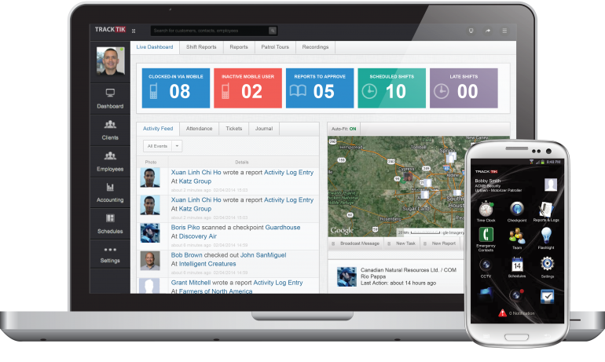
Figure 1. TrackTik
TrackTik (2025) has redefined security workforce management by moving beyond static scheduling toward an integrated, AI-driven operational model. According to the Trackforce 2025 Physical Security Operations Benchmark Report, the industry is currently facing an "AI adoption paradox" where the value of predictive scheduling is recognized, but cost remains a barrier for mid-sized firms. TrackTik’s success is anchored in its ability to consolidate alarm monitoring, guard dispatch, and business administration into a single 24/7 resilient architecture, which users report has increased operational efficiency by approximately 20%. This efficiency is primarily attributed to the reduction of manual administrative burdens through automated compliance tracking and real-time intelligence feeds (TrackTik, 2025).
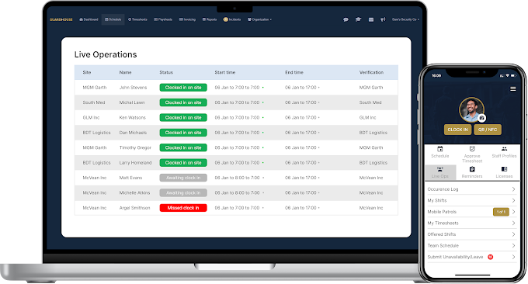

Figure 2. Guardhouse
Guardhouse (2026) addresses the specific administrative "overload" that has become a measurable barrier to performance in the mid-2020s. Research from NODE Magazine (2026) indicates that security employees often lose an average of 15 hours per week to routine administrative tasks, such as re-entering data across fragmented systems. Guardhouse mitigates this by unifying scheduling, GPS tracking, and invoicing into a streamlined workflow, reportedly reducing office-based administrative time by 40–60%. Its "Confidence in Compliance" module provides a specialized framework for daily license verification, a logic that SENTINEL adapts to specifically meet the stringent requirements of RA 11917 (GetApp, 2026).

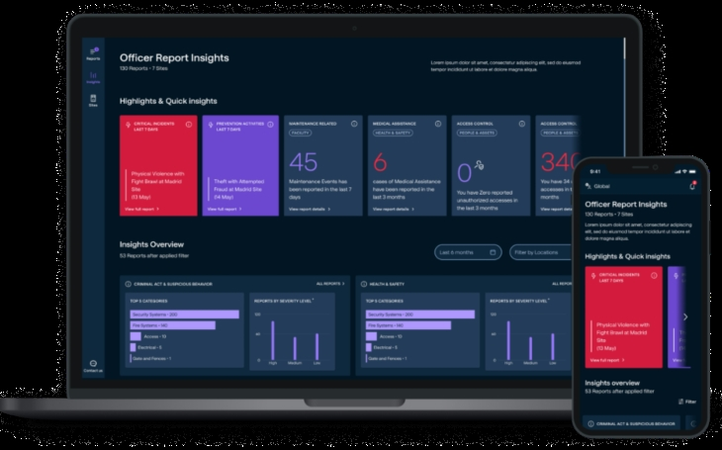
Figure 3. MySecuritas
Securitas "MySecuritas" (2026) represents the industry’s shift toward "Situational Understanding" and proactive risk management. The Securitas 2026 Global Technology Outlook Report identifies that the rapid advancement of generative AI for contextual understanding is now a top priority for 30% of security decision-makers (Securitas Technology, 2025). MySecuritas operationalizes this by providing a unified dashboard that transforms disparate incident reports into actionable statistics and trend highlights. This allows supervisors to identify risk patterns before they escalate, a core design principle mirrored in SENTINEL’s Performance Analytics Dashboard (Securitas, 2026).

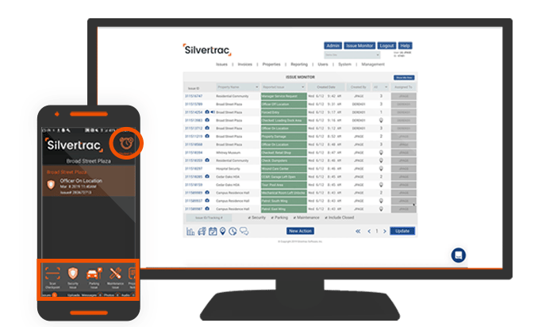

Figure 4. Silvertrac Software
Silvertrac Software (2026) is widely utilized for "Proof of Performance" and on-site accountability, particularly in parking and property management environments. While it excels in field reporting and checkpoint verification via mobile applications, its architectural focus remains on incident management and officer accountability (Silvertrac Software, 2026). Technical evaluations of generic guard management systems suggest a persistent "visibility gap" in specialized asset tracking; most platforms lack the deep relational logic required for a Digital Chain of Custody for high-risk assets like firearms and armored car fleets (Hardcat, 2025). SENTINEL fills this niche by integrating these high-stakes logistics, traditionally managed in siloed armory or fleet software, into the primary workforce management ecosystem.
Across the reviewed literature, several consistent themes emerge. Researchers emphasize the importance of integrating operational data to improve organizational visibility and decision-making. Studies from both Philippine and international contexts highlight the limitations of fragmented monitoring tools and manual processes.
Technological trends such as automated scheduling algorithms, attendance tracking, and operational dashboards are increasingly adopted across industries. However, existing systems often address only a single domain of operations, such as workforce scheduling or surveillance monitoring. Global systems like TrackTik and Guardhouse demonstrate that the industry standard is defined by Real-Time Accountability and Centralized Data Ownership. However, these systems often fail to accommodate the granular administrative nuances of Philippine law.
The reviewed literature therefore reveals a clear research gap in integrated systems that combine workforce management, compliance monitoring, and operational oversight within a unified platform tailored to security agencies. The SENTINEL system addresses this void by combining high-concurrency Rust/Axum architecture with modules specifically for Philippine-specific licensing (RA 11917), Firearm Custody, and Armored Car Fleet Management, allowing local agencies to achieve multinational levels of visibility and compliance. It provides a centralized solution that integrates scheduling automation, regulatory compliance verification, and real-time operational dashboards within a single enterprise system.

METHODOLOGY
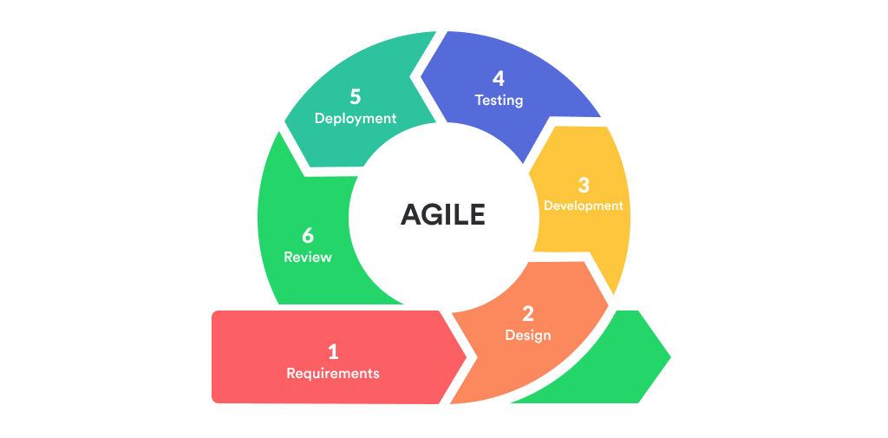
This study adopted Agile methodology, specifically Scrum, to deliver SENTINEL through incremental, testable, and reviewable capability sets.
Figure 5. Agile Model
Development was organized into successive sprints that covered planning, implementation, integration, validation, packaging, review, and refinement. Each sprint used prioritized backlog items tied to operational risk and institutional requirements.
Sprint planning and backlog refinement emphasized high-risk domains, including account governance, workforce continuity, asset compliance, incident coordination, movement monitoring, notification and inbox workflows, guard-safety functions, and decision-support features. Regular integration checkpoints ensured consistency of workflows, system rules, and data behavior.
Validation was embedded throughout the Scrum cycle through scenario-based testing, integration checks, role-permission verification, browser-based acceptance review, and cross-platform runtime review. Sprint reviews documented completed increments, while acceptance checks verified that each increment satisfied defined criteria before carry-forward.
Release readiness was evaluated through structured quality checks, build verification, and governed platform packaging before each major milestone to support controlled rollout decisions and reduce operational disruption. Overall, the methodology shows an Agile approach in which reliability, accountability, security, and usability were developed together with functional scope.

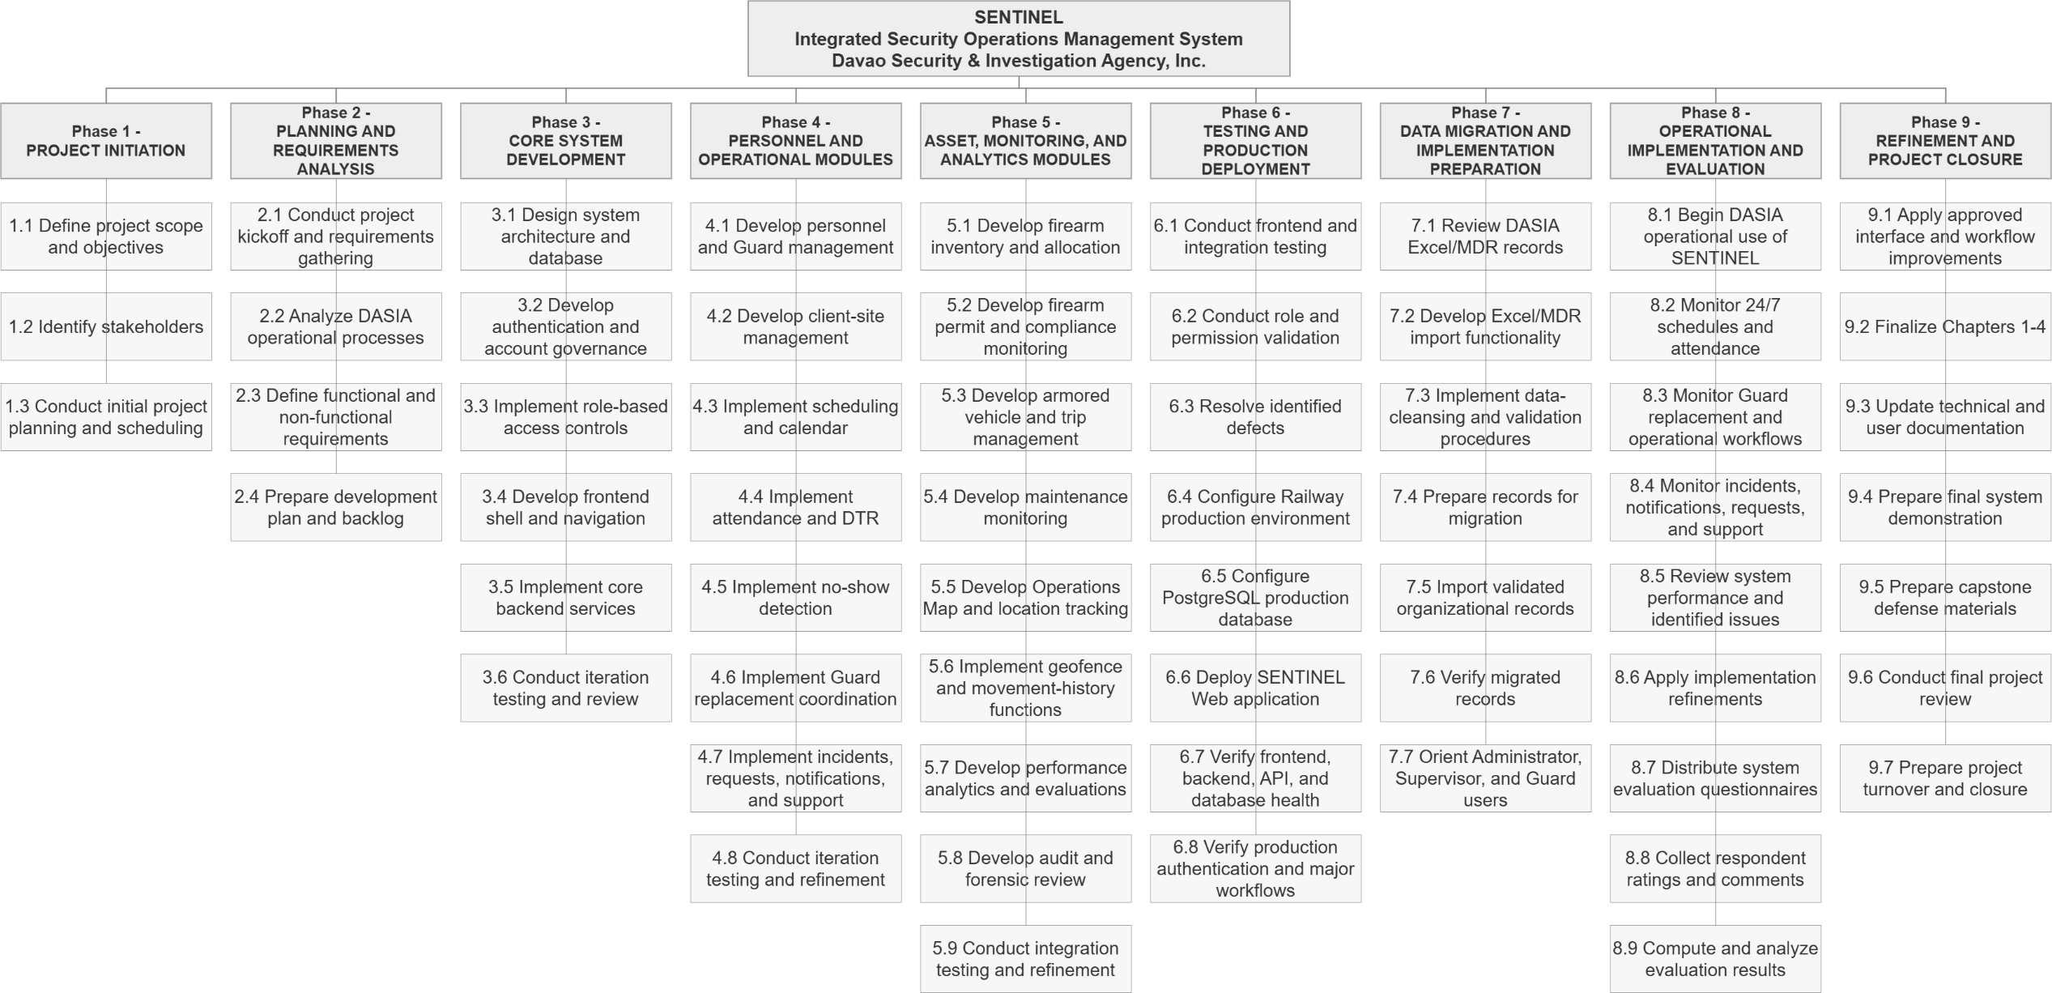
Figure 6. Work Breakdown Structure
Technical Background
Technologies used in the System
SENTINEL is implemented as a web-first integrated security operations platform with desktop and mobile runtime wrappers. Technology selection was based on concrete implementation requirements: role-based dashboards, secure API contracts, high-concurrency backend operations, traceable relational data, near-real-time tracking, and cross-platform delivery without codebase duplication. The proponents used the following technologies in the current implementation:
Hardware specifications play a crucial role in the development of a web-based platform like SENTINEL, as they directly affect system performance and reliability. To ensure smooth operation during development, deployment, and daily use, the system requires a computer or laptop running on Windows 10 or Windows 11. A processor equivalent to at least a Ryzen 3 is recommended to handle basic processing tasks efficiently. The system should have a minimum of 8 GB of RAM, although 16 GB is preferred for better multitasking and performance. In terms of storage, a 250 GB SSD is required to provide faster data access and improved system responsiveness. Integrated graphics are sufficient for the system’s visual requirements, and a screen resolution of at least 1366x768 is needed for proper interface display. Additionally, a stable broadband internet connection is necessary to support the system’s web-based functionalities.
- React + TypeScript: Used to build reusable, role-aware UI components and dashboard modules with strict typing.
- Vite: Used for local development and production build pipelines.
- Tailwind CSS: Used for responsive interface implementation across command-center, operations, and resource modules.
- Leaflet + OpenStreetMap: Used for operational map rendering, live marker visualization, and client-site management.
- Rust + Axum: Used for backend API handlers, middleware, and service orchestration.
- PostgreSQL: Used as the central transactional database for users, approvals, schedules, attendance, firearms, vehicles, incidents, notifications, tracking points, and audit logs.
- Docker + Docker Compose: Used to standardize local backend/database orchestration and deployment parity.
- Secure token-based authentication: Used to enforce protected access and stable session management across user roles.
- Capacitor: Used to package the web frontend for Android field deployment.
- Tauri: Used to package the same frontend for Windows desktop command-center deployment.
- Resend: Used for transactional email delivery such as verification codes, password reset codes, and operational notifications.
- Railway: Used as a cloud deployment platform for backend runtime and managed service hosting.
- Namecheap: Used for domain registration and domain-level DNS management.
- Git and GitHub: Used for version control, collaboration, change tracking, and managing the release of MSI and EXE files.
- Android release signing tooling: Used to generate, encode, and manage the release keystore required for signed APK and AAB distribution, supporting controlled and verifiable release governance for the Android deployment target.

Gantt Chart of Activities
MONTH | FEBRUARY |  |  |  | MARCH |  |  |  | APRIL |  |  |  | MAY |  |  |  | JUNE |  |  |  | JULY |  |  |  | AUGUST |  |  |  | SEPTEMBER |  |  |  | OCTOBER |  |  |  | NOVEMBER |  |  |  | DECEMBER
ACTIVITY
Project Initiation
Planning & Requirements
Core System Development
Personnel & Operational Modules
Asset, Monitoring & Analytics
Testing & Production Deployment
Data Migration & Preparation
Operational Implementation & Evaluation
Questionnaire distribution
Refinement & Documentation
Maintenance & Project Closure
Figure 7. Gantt Chart of Activities
Completed | Ongoing |  | Not Started

Legends:

Calendar of Activities
Figure 7 represents the Gantt chart of activities that summarizes the tasks and their duration. Activities are listed on the left, and the schedule is at the top right. Bars indicate task progress, with each bar representing a week. The calendar of activities summarizes the same phased sequence defined in the WBS and Gantt schedule, including objectives, involved personnel, and required resources.
Table 1. Calendar of Activities
Month | Activity | Purpose
February 2026 | Phase 1 - Project Initiation | Defined the project scope, objectives, stakeholders, and initial development direction.
March 2026 | Phase 2 – Planning and Requirements Analysis | Gathered requirements, organize the backlog, conduct planning activities, and define system requirements.
April - May 2026 | Phase 3 - Core System Development | Developed the system architecture, database, authentication, access controls, and core application structure.
June - July 2026 | Phase 4 – Personnel and Operational Modules | Implemented scheduling, attendance, DTR, replacement coordination, incidents, notifications, and support workflows.
August - September 2026 | Phase 5 – Asset, Monitoring, and Analytics Modules | Completed firearm, vehicle, tracking, analytics, reporting, audit, and related operational features.
September 2026 | Phase 6 – Testing and Production Deployment | Conducted integration testing, resolve defects, configure production services, and deploy SENTINEL to the live environment.
September–October 2026 | Phase 7 – Data Migration and Preparation | Prepared DASIA records for migration and develop the Excel/MDR import and data-cleansing functions.
October 2026 | Phase 8 – Operational Implementation and User Evaluation | Allowed DASIA personnel to use the system during regular operations, monitor system performance, gather feedback, and conduct the system evaluation.
October–November 2026 | Phase 9 – Refinement and Documentation | Analyzed evaluation results, address identified issues, update Capstone papers, and prepare defense documentation.
November–December 2026 | Phase 10 – Maintenance and Project Closure | Performed final refinements, complete turnover documentation, finalize project outputs, and prepare for project closure.
Table 1 presents the scheduled activities for the development of the SENTINEL system.

It outlines the project phases, major activities, and purposes throughout the implementation process.

Requirements Analysis
Table 2. Comparison of the Existing Process and the Proposed Process
Process Area | Existing / Old Process | Proposed Process in SENTINEL | Expected Improvement
Scheduling and workforce continuity | Scheduling, attendance, no-show detection, and replacement coordination depend on manual monitoring and delayed communication. | SENTINEL centralizes schedules, attendance actions, no-show detection, and replacement workflows in a unified operational platform. | Faster response to workforce gaps and improved deployment continuity.
Asset and compliance monitoring | Firearm, permit, vehicle, and trip records are managed through separate or manual records, increasing compliance and traceability risks. | SENTINEL manages firearm, permit, vehicle, trip, and maintenance workflows through centralized and auditable records. | Better compliance visibility, improved accountability, and reduced record fragmentation.
Incident handling and live monitoring | Incident reporting and field monitoring rely on manual updates, weak patrol visibility, and delayed supervisory awareness. | SENTINEL provides structured incident workflows, notifications, live tracking, geofence monitoring, and command dashboards. | Improved situational awareness, faster coordination, and more timely operational intervention.
Auditability and decision support | Operational review depends on scattered records and manual analysis, limiting traceability and data-driven decision-making. | SENTINEL provides audit logs, forensic visibility, operational dashboards, analytics, and analytics, reports, and rule-based alert outputs. | Stronger traceability, improved review capability, and better-informed command decisions.
Table 2 presents the comparison between the existing process and the proposed process in the SENTINEL system. It highlights the major operational areas in which the traditional manual or fragmented procedures are improved through a more centralized, role-governed, and system-supported approach.
The requirements baseline for SENTINEL was defined from actual private-security operational pain points: fragmented coordination, delayed visibility, compliance exposure, and weak traceability of sensitive asset workflows. Based on current implementation, the requirements analysis prioritizes role-governed access, near-real-time operational awareness, and auditable process execution across personnel, equipment, vehicle, incident, and analytics domains.
Technology and software selection was treated as a requirements decision, not only an implementation preference. For the frontend layer, React + TypeScript + Vite was selected to satisfy modular dashboard composition, strict role-based rendering, and rapid iteration. Angular was considered because it provides a full framework with built-in dependency injection and strong conventions; however, its heavier project structure was less aligned with the team's component-by-component delivery pace. Vue was considered for its simpler learning curve and progressive adoption model, but the existing codebase and shared component strategy were already established around React patterns. Plain JavaScript React was also considered, but TypeScript was chosen to reduce contract errors in role logic, API payload mapping, and cross-module state handling.
For backend processing, Rust + Axum was selected to meet concurrency, security, and reliability requirements for authentication, approvals, tracking, and analytics endpoints. Node.js + Express was considered because of rapid API prototyping and broad ecosystem support, but the project prioritized compile-time safety and stricter runtime guarantees for security-sensitive operations. Java + Spring Boot was considered for enterprise-grade structure and mature tooling, yet it introduces a larger operational footprint and greater configuration overhead for this capstone scope. Go + Gin/Fiber was also considered for performance and simplicity, but Rust + Axum better matched the team's objective of memory-safe, middleware-centric API enforcement with fine-grained control.
For persistence, PostgreSQL was selected because SENTINEL requires relational integrity across users, approvals, shifts, attendance, firearms, vehicles, incidents, and audit records. MySQL/MariaDB were considered because they are widely used relational systems, but PostgreSQL was preferred for stronger advanced SQL features, robust JSONB support, and flexible indexing for mixed transactional and analytical workloads. MongoDB was considered because of schema flexibility and rapid document modeling; however, SENTINEL's compliance and cross-entity constraints require strong relational guarantees that are more naturally enforced in PostgreSQL.
For mapping and geospatial visualization, OpenStreetMap + Leaflet was selected to satisfy near-real-time operational map requirements, client-site management, and location marker rendering while retaining implementation control. Google Maps Platform was considered because it provides high-quality basemaps, geocoding, and route services, but usage-based billing and API quota sensitivity are less favorable for continuous monitoring views. Mapbox was considered because it offers strong vector map tooling and customizable styles, yet recurring usage costs and token-governed access create additional operational dependency for long-running dashboards. ArcGIS was considered for enterprise GIS depth, but its platform complexity exceeds current implementation needs. OpenStreetMap + Leaflet was therefore chosen for cost efficiency, integration flexibility, and direct alignment with the implemented web map architecture.
For near-real-time operational visibility, websocket streaming with polling fallback was selected as a hybrid requirement. Server-Sent Events (SSE) was considered because it simplifies one-way streaming, but websocket transport better supports bidirectional session handling and live snapshot exchange patterns used in tracking views. Polling-only models were considered for implementation simplicity, but they introduce higher latency and unnecessary repeated requests for active command-center monitoring. The implemented websocket-plus-polling model balances responsiveness with continuity when persistent connections are interrupted.
For deployment targets, the system uses a web-first core with Tauri (desktop) and Capacitor (Android) wrappers to meet cross-platform access requirements without maintaining separate business logic per platform. Electron was considered for desktop packaging because of mature tooling, but Tauri was preferred for a lighter runtime footprint and tighter security posture. React Native and fully native Android/desktop tracks were considered for platform-specific delivery, but they would require duplicate UI and integration maintenance. The chosen wrapper strategy reuses the Web application codebase across the configured Windows desktop and Android packaging targets, reducing implementation divergence. Full platform parity remains subject to packaged-runtime validation.
For operational tooling, Docker/Compose, managed runtime deployment, and version-controlled release workflows were selected to satisfy reproducibility and maintainability requirements. Manual host-based installation was considered but increases environment drift and onboarding inconsistency. Alternative orchestration-heavy stacks (for example, immediate Kubernetes adoption) were considered excessive for current scale and capstone constraints. The selected tooling stack provides repeatable setup, traceable change history, and controlled release validation that directly supports the implemented system lifecycle.
Requirements Documentation
Serves as the blueprint for the system’s development, defining the specific capabilities and quality standards necessary to modernize security operations for DASIA. It is divided into Functional Requirements, which detail the distinct tools and permissions for each user role (from high-level Superadmin oversight to Guard field actions), and Non-Functional Requirements, which establish the technical benchmarks for security, real-time performance, and legal compliance.
- All Users
  - The system shall support administrator-mediated onboarding, verification, approval, secure authentication, password-reset workflows, role-based access control, mandatory legal-policy acceptance, and access through the implemented Web application, with configured Windows desktop and Android deployment targets.
- Superadmin
  - The system shall provide superadmin users with command-level dashboards, shared quick Inbox workflows, analytics, performance reports, and operational alerts, ticketing and notification visibility, a feedback dashboard for aggregate and record-level review, audit-log visibility, and forensic audit review for investigative review.
- Admin
  - The system shall enable administrator users to govern personnel workflows, support scheduling and workforce coordination, manage firearm and armored vehicle lifecycle records, access command dashboards and quick Inbox workflows, handle operational ticketing and notifications, and submit authenticated feedback through the constrained feedback workflow.
- Supervisor
  - The system shall enable supervisor users to monitor schedules, attendance, no-show conditions, and replacement actions; access near-real-time tracking, movement history, active deployment, and geofence-alert views; manage authorized operational resources including guard accounts, firearms, vehicles, and client sites; create guard accounts subject to administrator approval; access command dashboards, quick Inbox workflows, reports, alerts, and operational summaries; manage ticketing and notification workflows; and submit authenticated feedback. Supervisors shall not create Supervisor, Admin, or Superadmin accounts, delete user accounts, or modify the system's role-permission policy.
- Guard
  - The system shall enable guard users to access personal schedules and assigned resources, perform attendance-related actions, receive and respond to notifications, submit incident and support-related workflows, use self-scoped live tracking and movement-history features subject to policy and consent controls, access mission-critical field actions such as panic escalation, and submit authenticated feedback.
Non-functional Requirements
The non-functional requirements of SENTINEL emphasize security, performance, usability, reliability, scalability, and compliance traceability. In terms of security, the system shall enforce strong authentication, role-based authorization, approval-gated access, auditable security events, account-protection controls, and abuse-resistance measures to preserve the integrity of operational data and workflows. In terms of performance, the system shall maintain responsive dashboards and timely operational updates suitable for near-real-time supervisory decision-making. With respect to usability, the system shall provide role-centered dashboards and modular user-interface navigation that reduce operator context switching, while further minimizing workflow friction through the use of a shared quick Inbox action for urgent operational work and timeline context. In terms of reliability, the system shall maintain secure session continuity, renewal, and termination behaviors to protect ongoing operations. With respect to scalability, the system architecture shall remain API-driven and modular so that additional modules, integrations, and platform targets may be introduced without requiring a full redesign. Finally, for compliance traceability, legal acceptance and policy-governance events shall be recorded with timestamped metadata suitable for institutional review, accountability, and regulatory compliance.

Design of Software, System, Product, and/or Processes
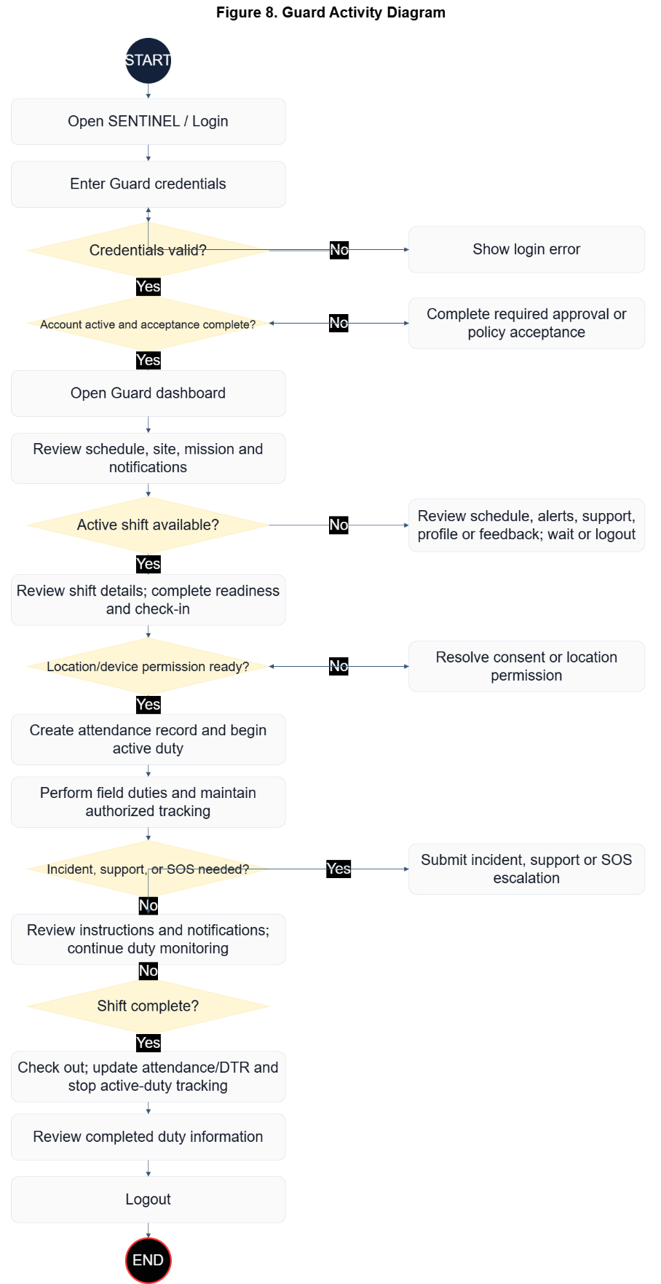
Figure 8. Guard Activity Diagram
Figure 8 illustrates the Guard workflow from authentication to duty completion and secure logout. The flow first validates credentials, then verifies whether account approval and policy acceptance are already in a valid state; if a requirement is missing, the guard completes the required approval or acceptance step before dashboard access proceeds. From the mission-first guard dashboard, the process branches based on whether an active shift is available. If no active shift is assigned, the guard remains on non-duty activities such as reviewing alerts, sending support concerns, and updating profile details. If an active shift exists, the guard performs check-in, confirms location/device access for tracking, executes patrol or assigned field duty, and stays in a duty-monitoring loop. When an incident or urgent support event occurs, the guard submits an incident or panic/support escalation record, then returns to monitoring until check-out and session closure.
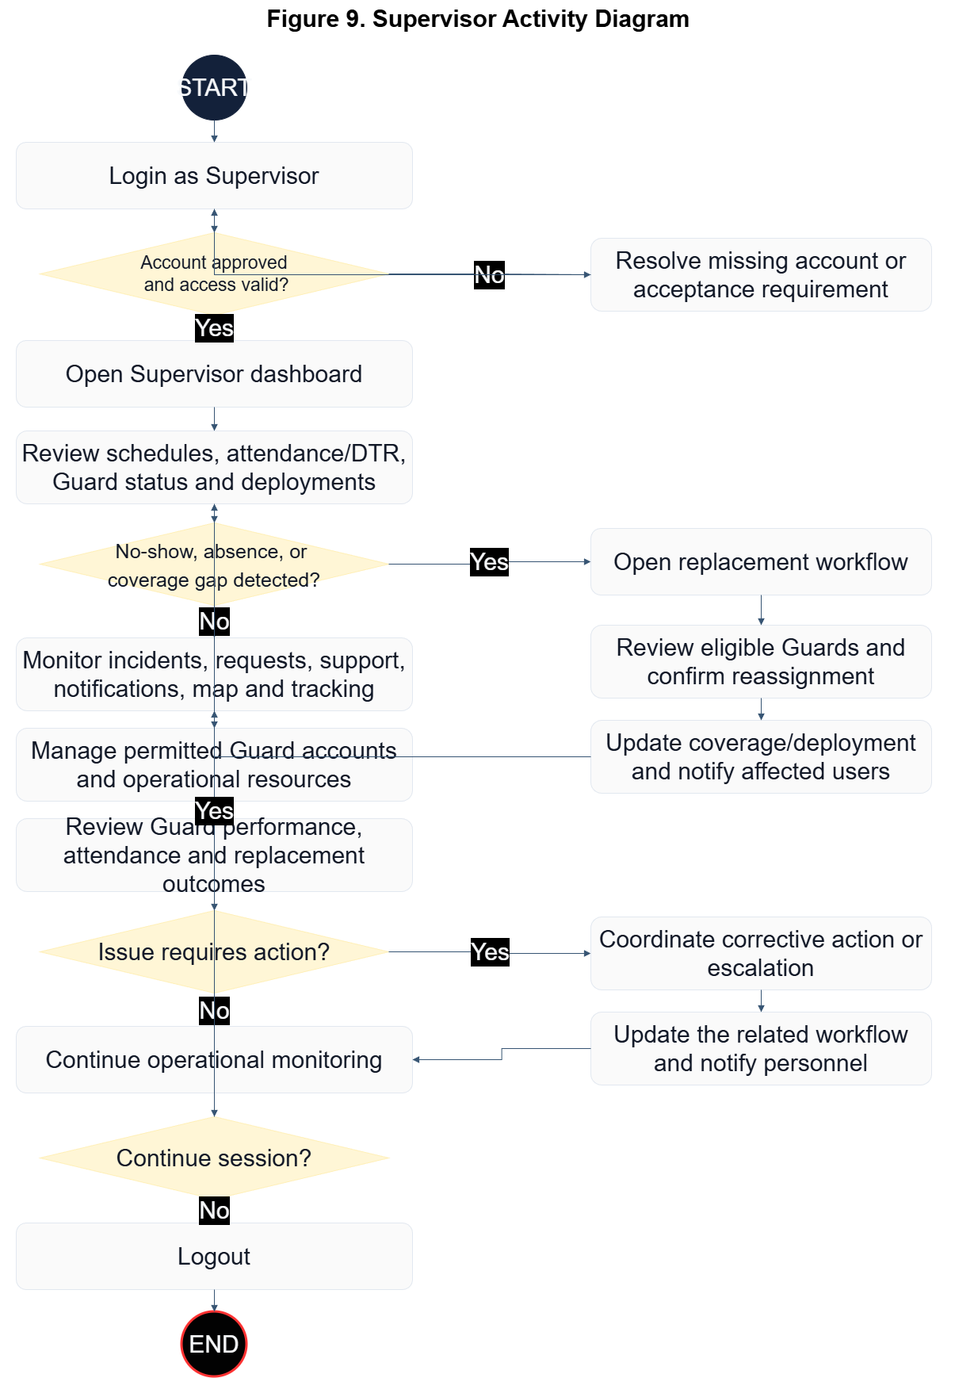
Figure 9. Supervisor Activity Diagram

Figure 9 presents the Supervisor workflow from authenticated access to end-of-session review. After login and access-state validation, the supervisor opens the dashboard to inspect schedules, attendance, and team status. The main control point is staffing-gap detection: when no-show, absence, or coverage gaps are detected, the supervisor initiates replacement coordination by selecting available personnel, issuing reassignment, and confirming deployment before updating operational status. When no immediate gap exists, the supervisor continues command monitoring activities, including incidents, alerts, and support workload. The workflow then moves to live tracking and team-performance review, with an escalation branch for operational issues that requires corrective action logging before returning to monitoring, followed by secure logout.
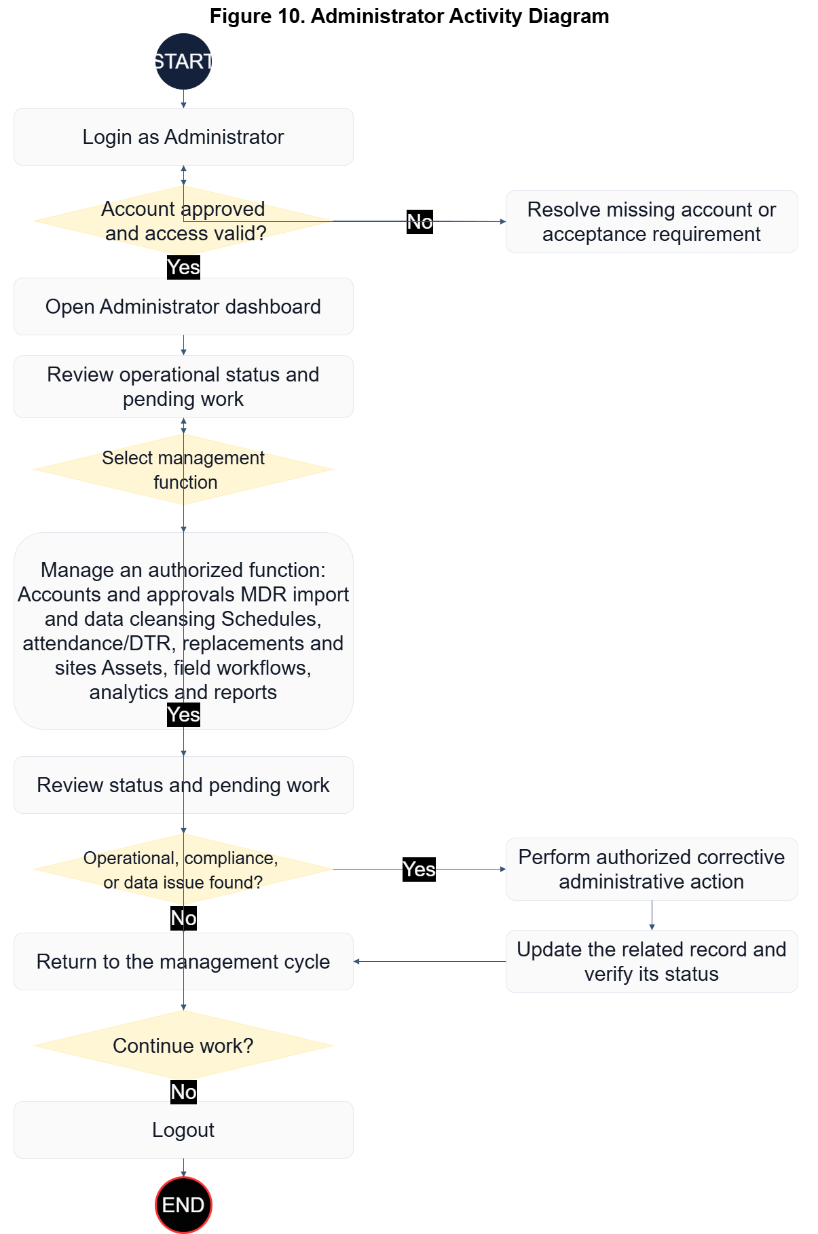
Figure 10. Administrator Activity Diagram

Figure 10 outlines the Administrator workflow as a governed control cycle rather than a single fixed sequence. After successful authentication and access-state checks, the administrator enters the command dashboard and selects the required management function: user/approval records, scheduling and assignment records, or asset/compliance records (firearm, permit, vehicle, and trip). After each management action, updates are reflected in the incident-support-notification queue and in dashboard analytics for operational visibility. If an operational or compliance issue is detected, the administrator applies corrective action, validates updated records, and returns to the management cycle. If no issue is detected, the administrator finalizes the current workset and closes the session through secure logout.
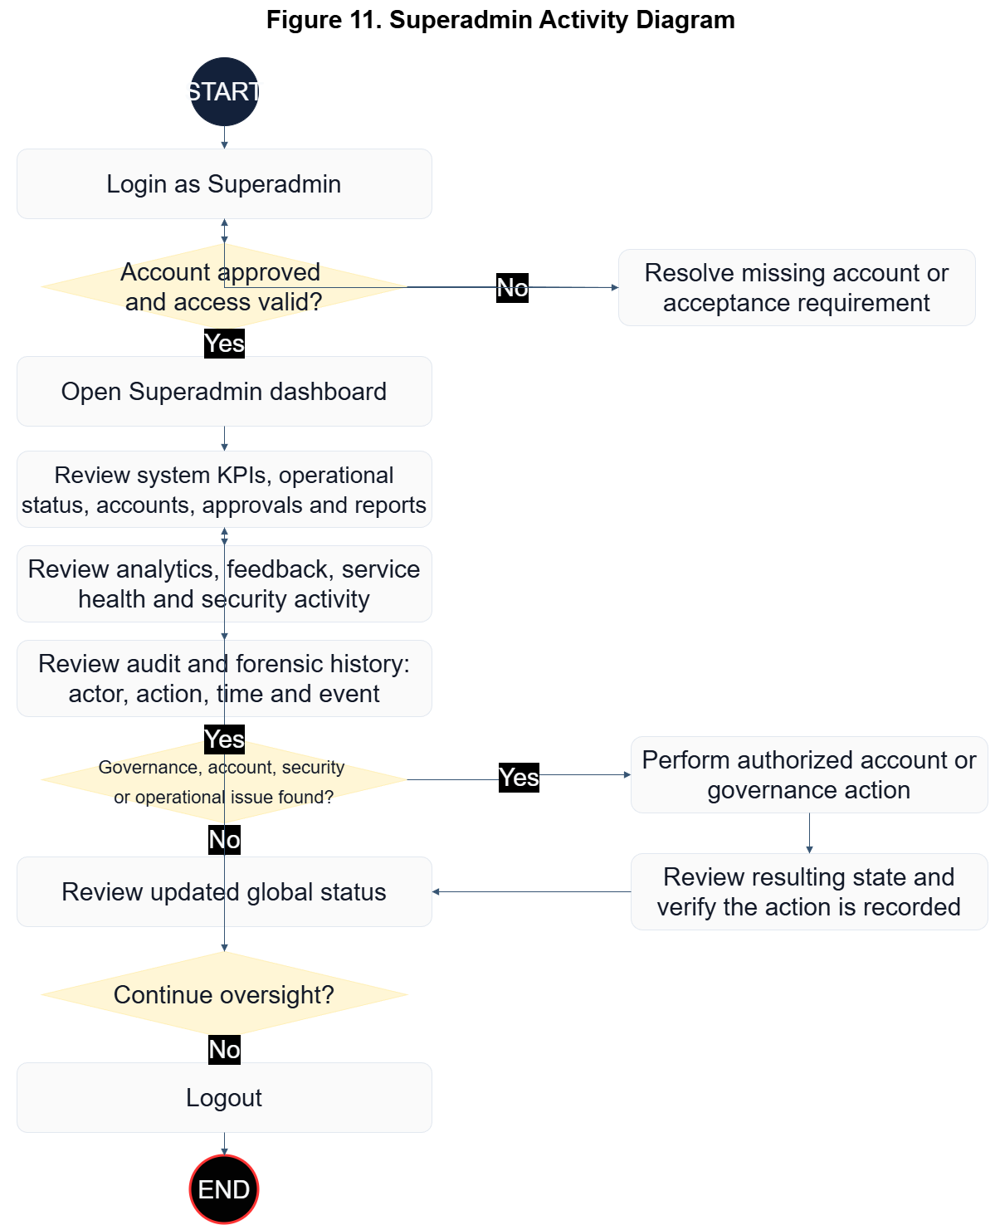
Figure 11. Superadmin Activity Diagram

Figure 11 describes the Superadmin workflow as a system-wide governance loop. After login and access-state validation, the superadmin reviews global KPIs, service health, user and role status, audit records, and governance conditions. When an issue is identified, the superadmin performs authorized user-management or governance actions within the system's predefined role-based access rules, validates the result, and continues oversight. The current implementation does not provide runtime editing of the role-permission policy.
Development
SENTINEL was developed through iterative Agile delivery in which user workflows, governance controls, and operational data services progressed in parallel.
The User Login Module serves as the secure authentication entry point of SENTINEL. It validates user credentials, enforces account and access controls, and directs authenticated users to the operational workspace permitted by their assigned role. The module also supports password recovery and ensures that only approved and active accounts can access protected system functions.
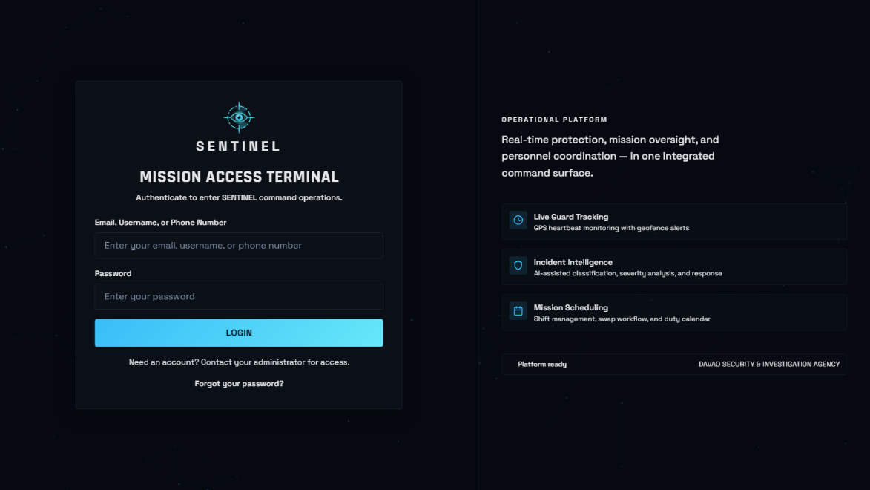
Figure 12. User Login Module

The Superadmin Module serves as the system-wide governance and monitoring workspace of SENTINEL. It provides access to global operational information, analytics, feedback, audit records, reports, service status, and other command-level functions required for overall system oversight. The Superadmin can review platform activity and governance information while remaining subject to the system’s predefined access-control rules.
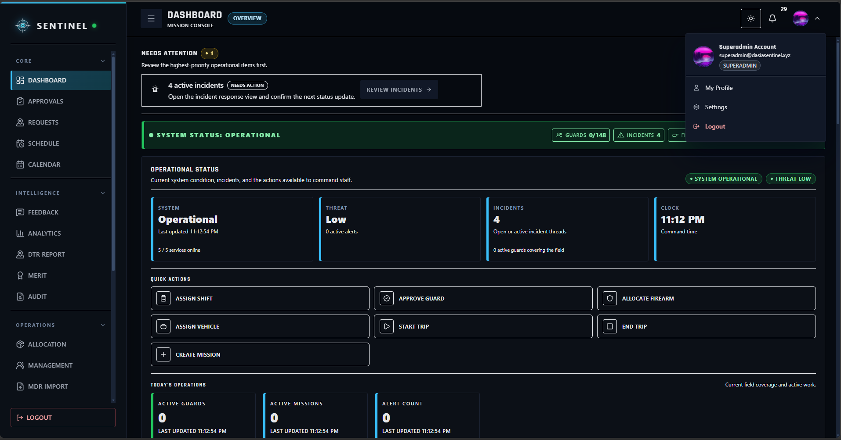
Figure 13. Superadmin Module

The Administrator Module serves as the primary management workspace for day-to-day administrative operations. Administrators can manage users, approvals, schedules, client sites, personnel records, firearms, armored vehicles, permits, and other authorized operational information while monitoring the continuity of agency operations.
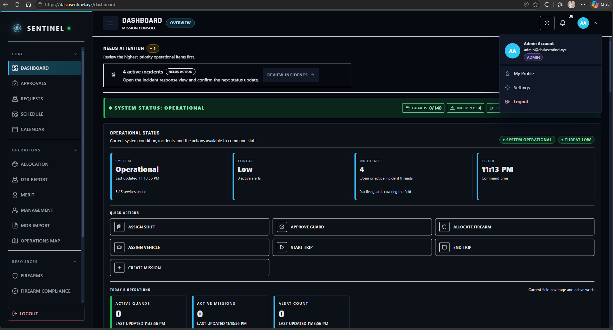
Figure 14. Administrator Module

The Supervisor Module serves as the field-supervision workspace for workforce and deployment coordination. Supervisors can monitor schedules, attendance, Guard availability, replacement activity, field conditions, incidents, and authorized operational resources to help maintain continuous duty coverage and respond to staffing concerns.
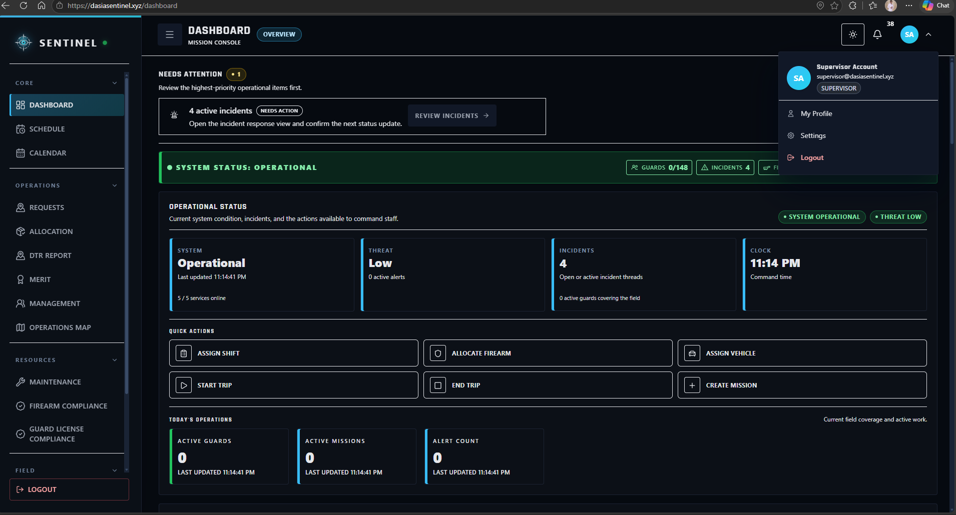
Figure 15. Supervisor Module

The Guard Module serves as the field-user workspace for assigned duty operations. Guards can review their schedules and assignments, perform attendance-related actions, receive operational notifications, submit incidents and support concerns, access authorized map and tracking functions, and use emergency features during active duty.
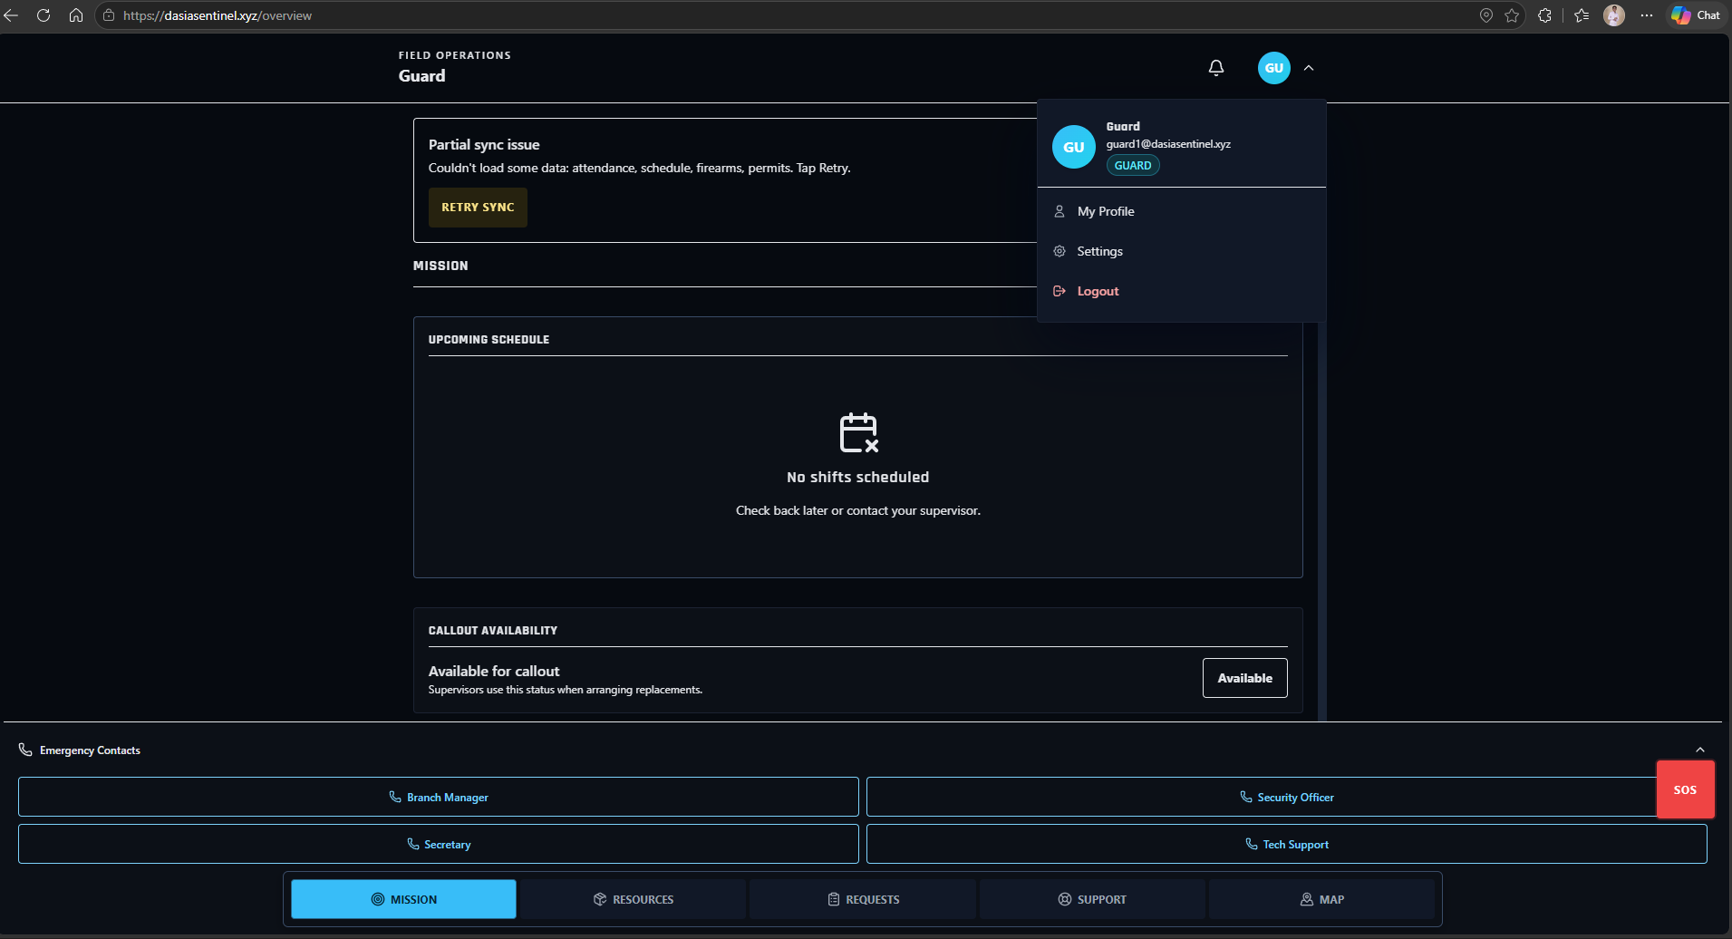
Figure 16. Guard Module

The Approvals Module serves as the controlled authorization workspace for account and access requests that require administrative review. Authorized users can review pending Guard registrations and approve or reject requests before operational access is granted, helping maintain controlled onboarding and account governance.
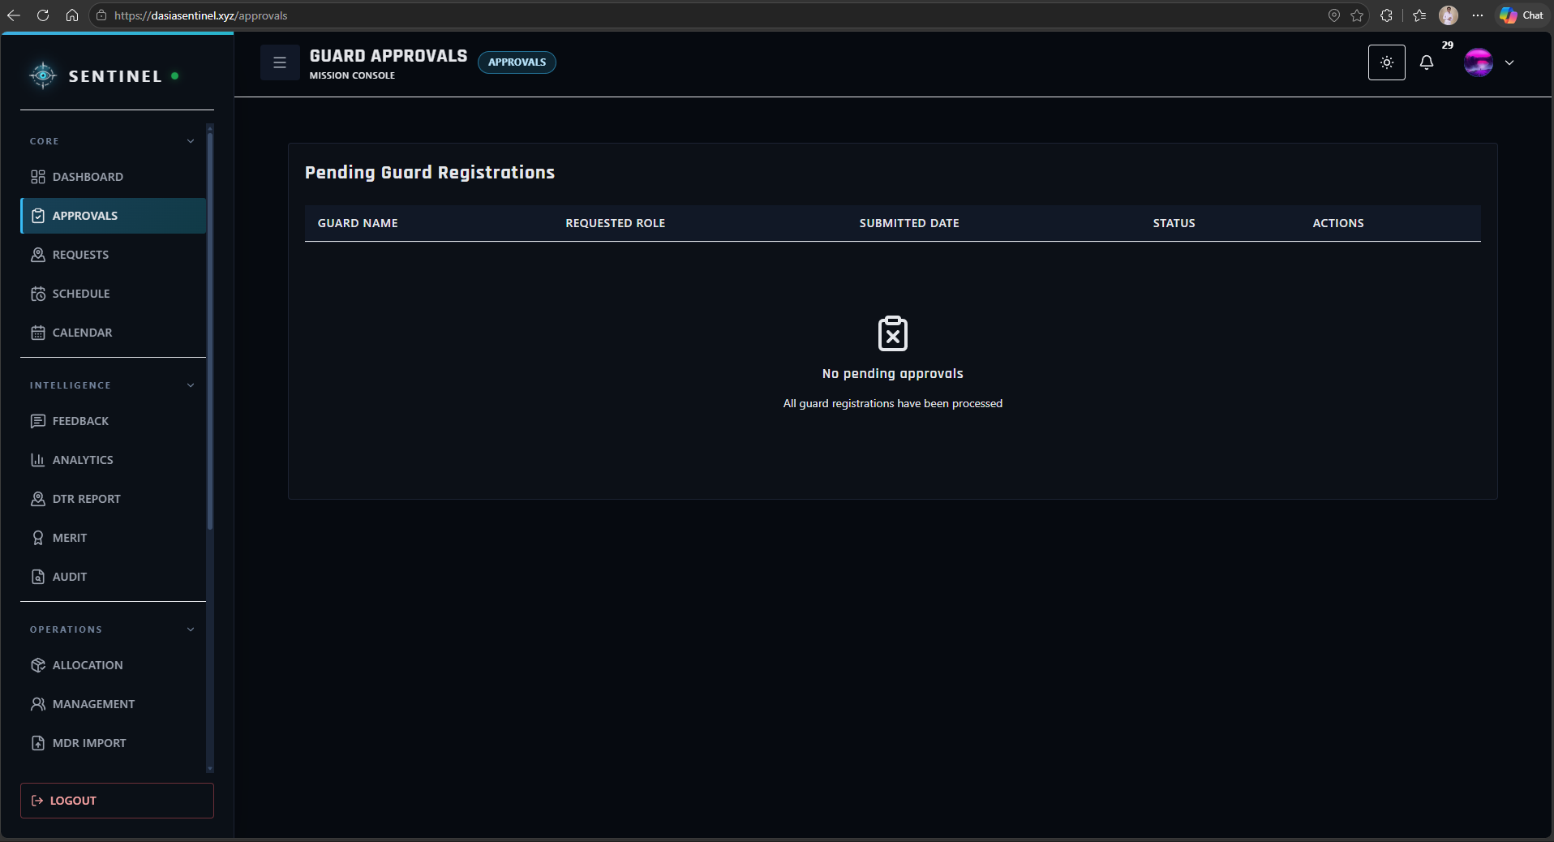
Figure 17. Approvals Module

The Scheduling Module serves as the personnel deployment and shift-planning workspace of SENTINEL. Authorized command users can create, review, and manage Guard assignments according to client site, date, duty period, and availability while reducing scheduling conflicts and maintaining personnel coverage.
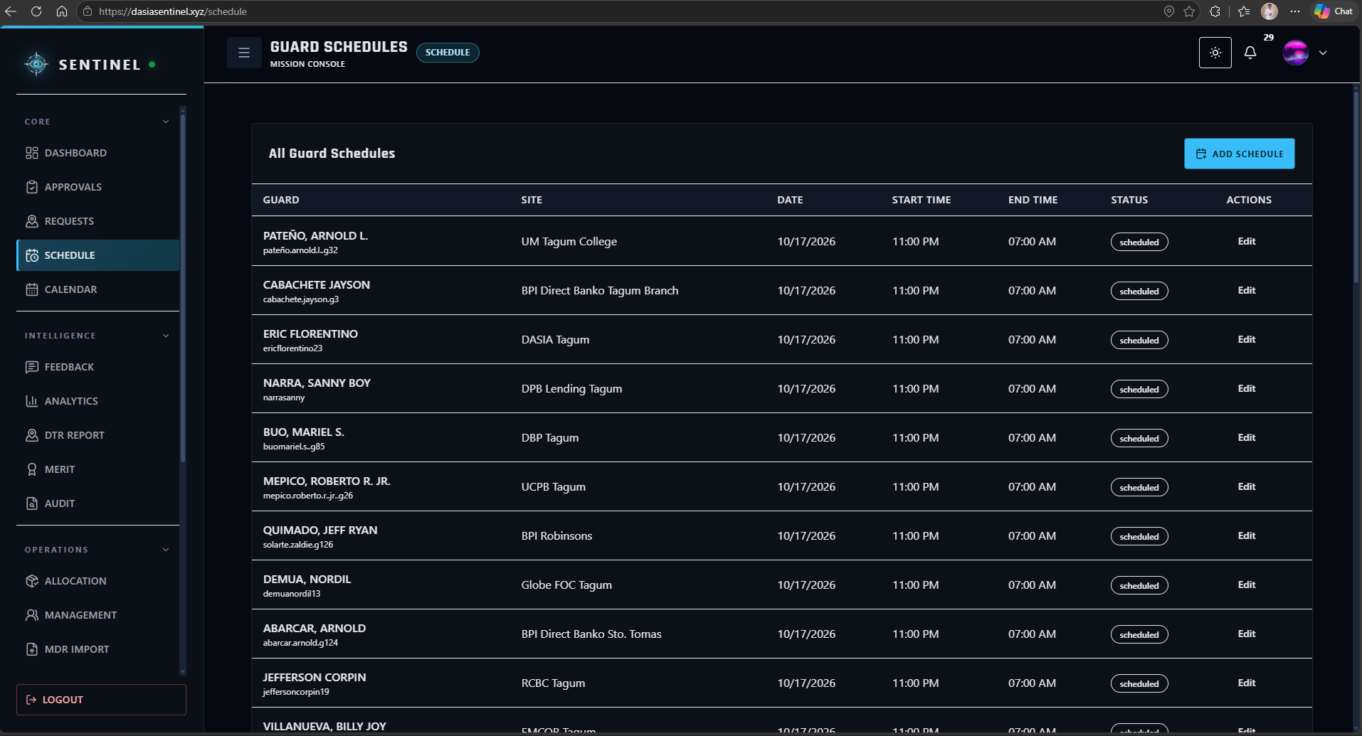
Figure 18. Scheduling Module

The Calendar Module provides a timeline-based view of Guard assignments and operational activities. It allows authorized users to review schedule distribution by date and helps improve visibility of upcoming duties, staffing coverage, and potential assignment conflicts.
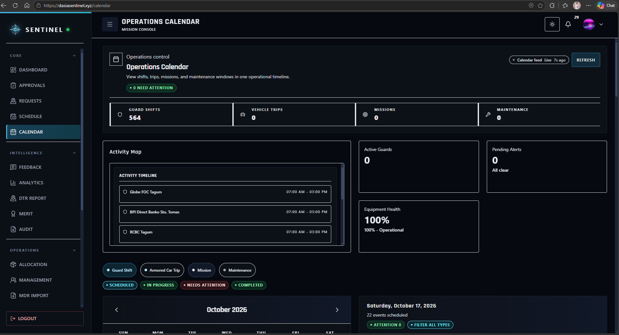
Figure 19. Calendar Module

The Operations Map Module serves as the geospatial monitoring workspace of SENTINEL. Authorized users can review client-site locations, deployment context, Guard-related location information, and available operational map data to support situational awareness and field coordination.
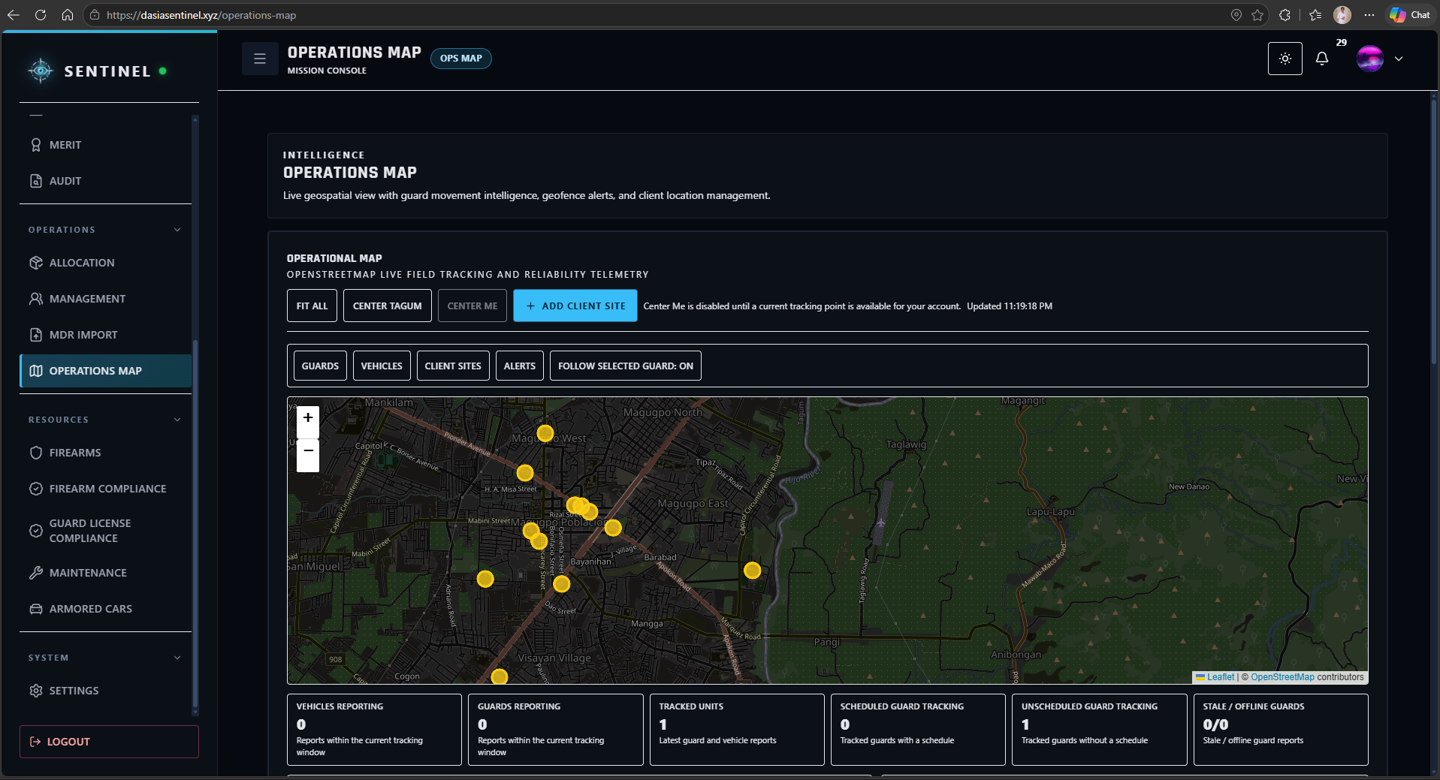
Figure 20. Operations Map Module

The Management Module serves as the centralized records workspace for authorized organizational resources. Depending on the user role, it provides access to personnel, firearms, vehicles, client sites, and other management records required for maintaining accurate operational information and administrative control.
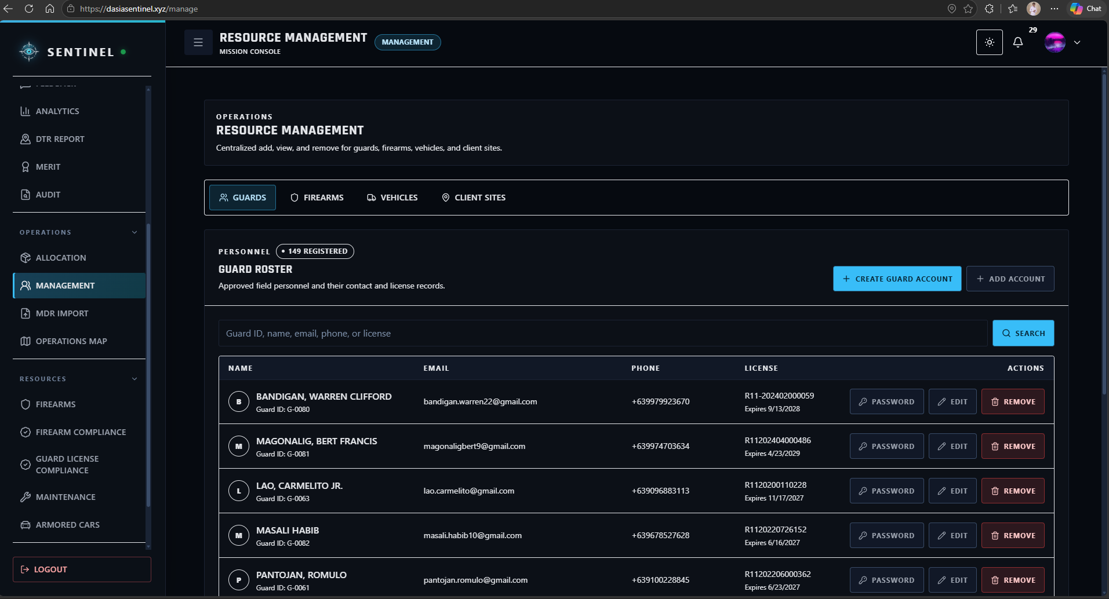
Figure 21. Management Module

The MDR Import Module serves as the controlled data-migration and cleansing workspace for existing DASIA records. It allows authorized users to upload structured Excel or MDR files, review imported data, identify inconsistent or incomplete entries, and prepare validated records for integration into SENTINEL. The feature reduces repetitive manual encoding and supports the transition of existing agency records into the centralized database.
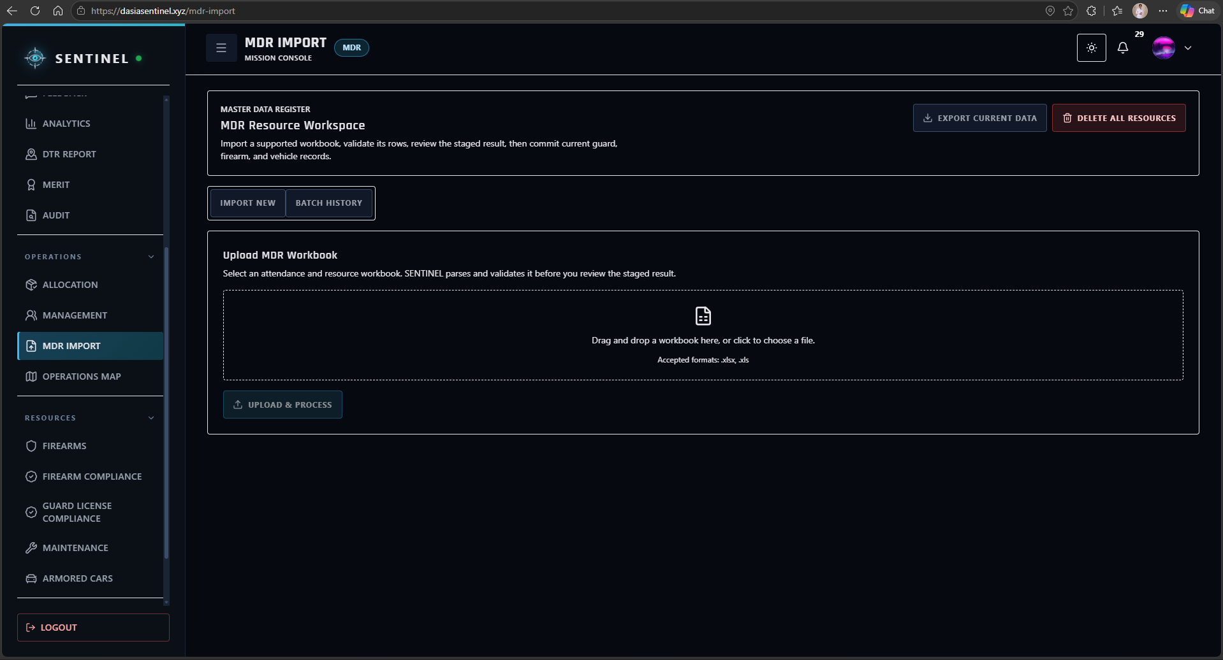
Figure 22. MDR Import Module

The Missions Module serves as the operational coordination workspace for mission-related assignments and activities. Authorized users can create and manage mission information, assign relevant personnel and resources, and monitor records associated with planned or ongoing operational activities.
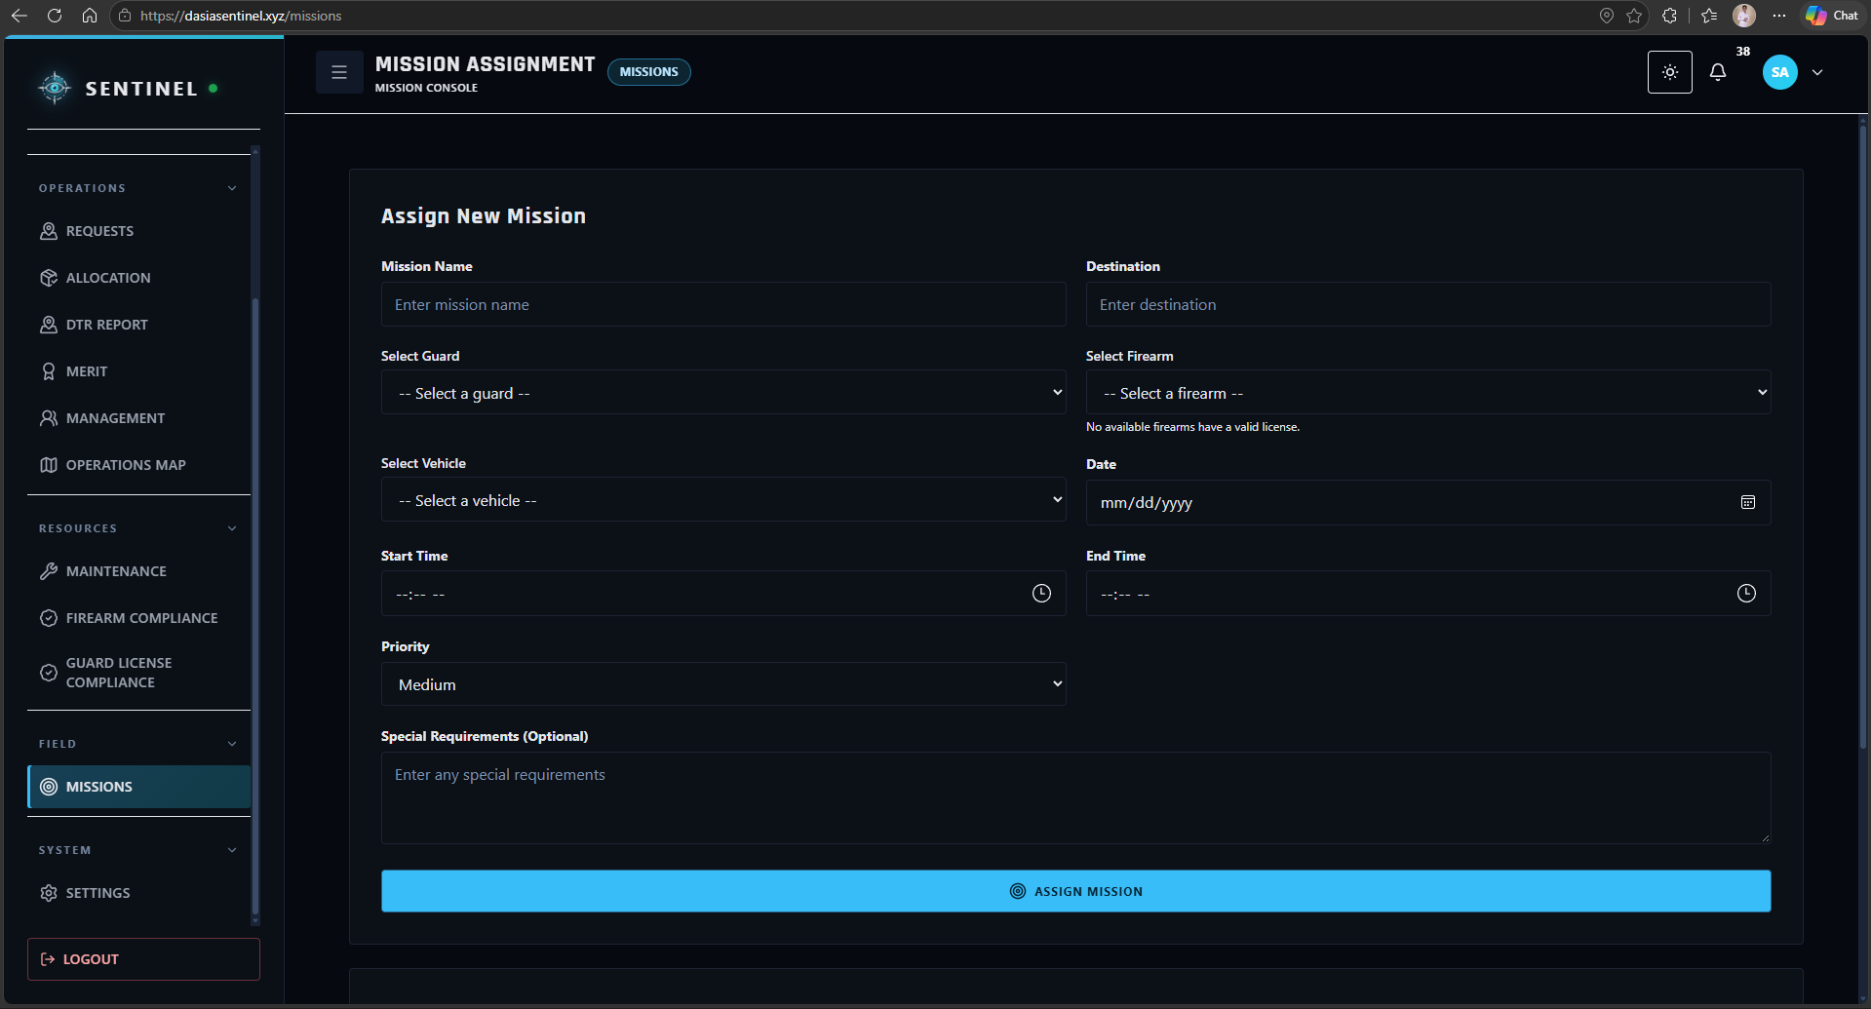
Figure 23. Missions Module
The Trips Module serves as the lifecycle monitoring workspace for authorized field and transport activities. It allows users to record and review trip information associated with operational movement, assigned personnel, vehicles, and other deployment-related details.
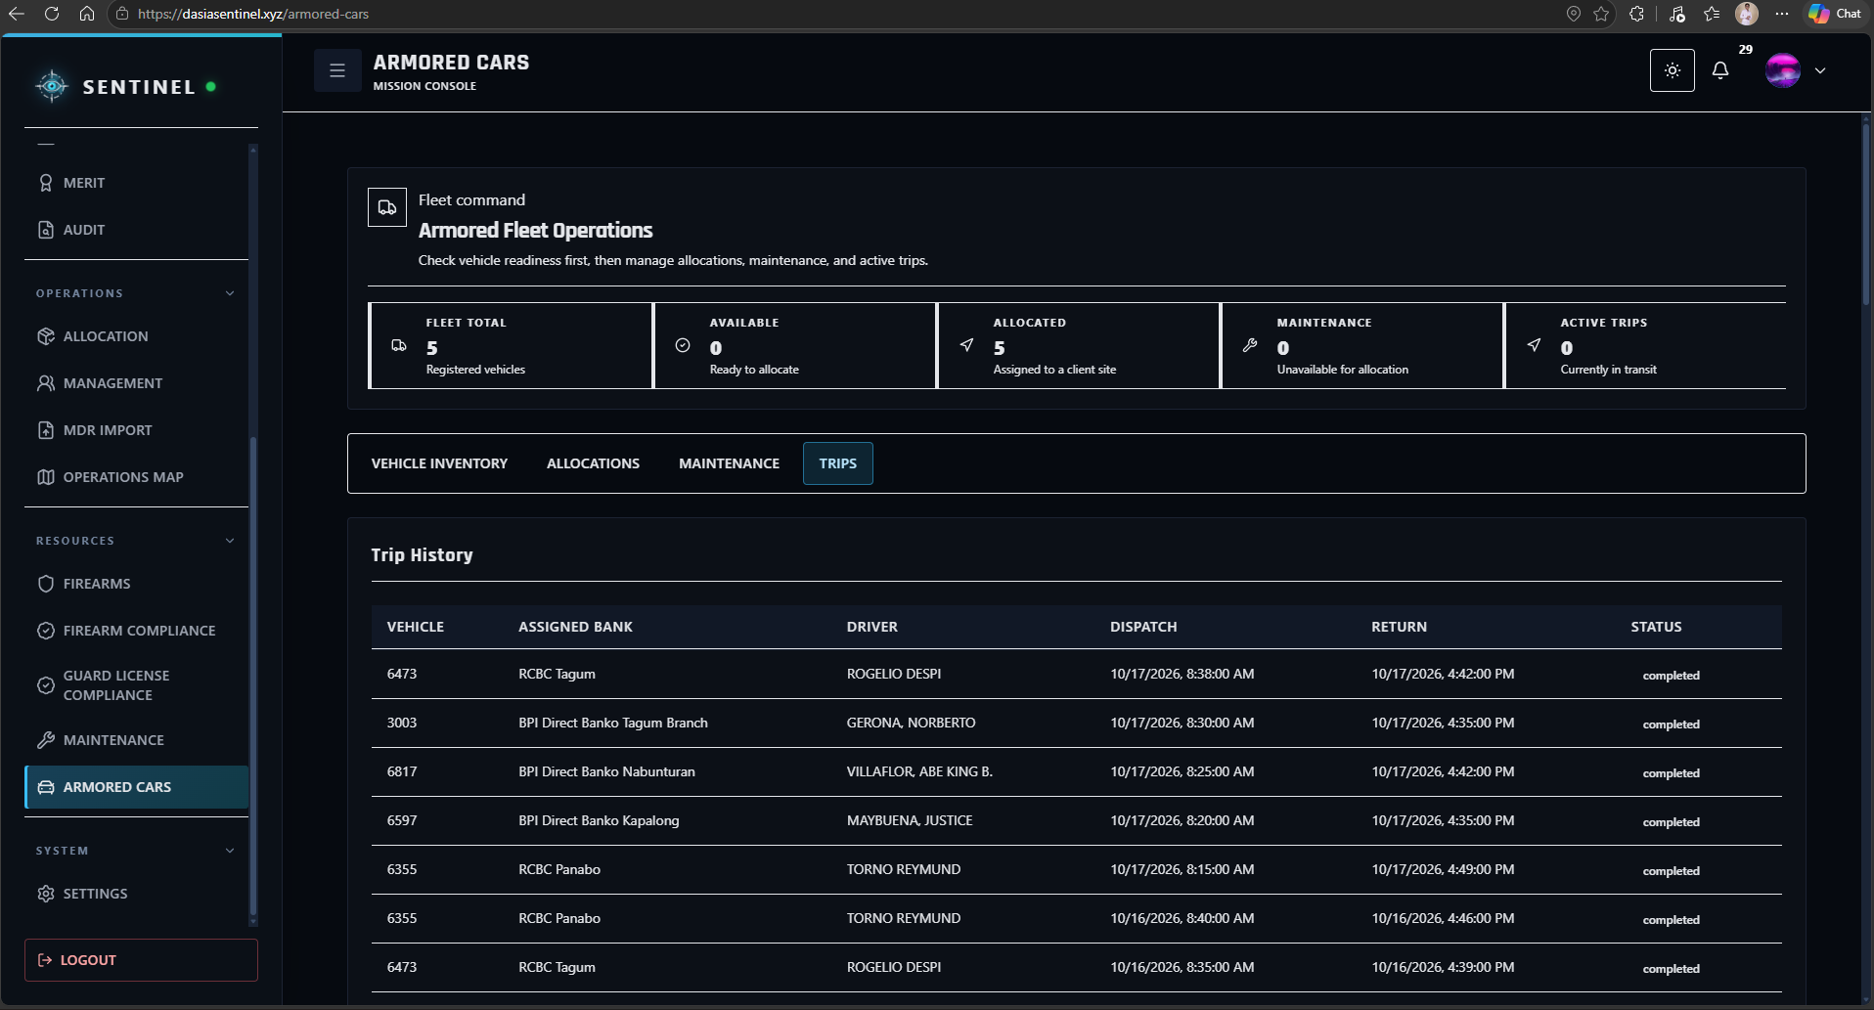
Figure 24. Trips Module
The Inbox Module serves as the centralized communication and quick-action workspace for operational messages and pending activities. It allows users to review notifications, requests, alerts, workflow updates, and other items requiring attention from a single interface.
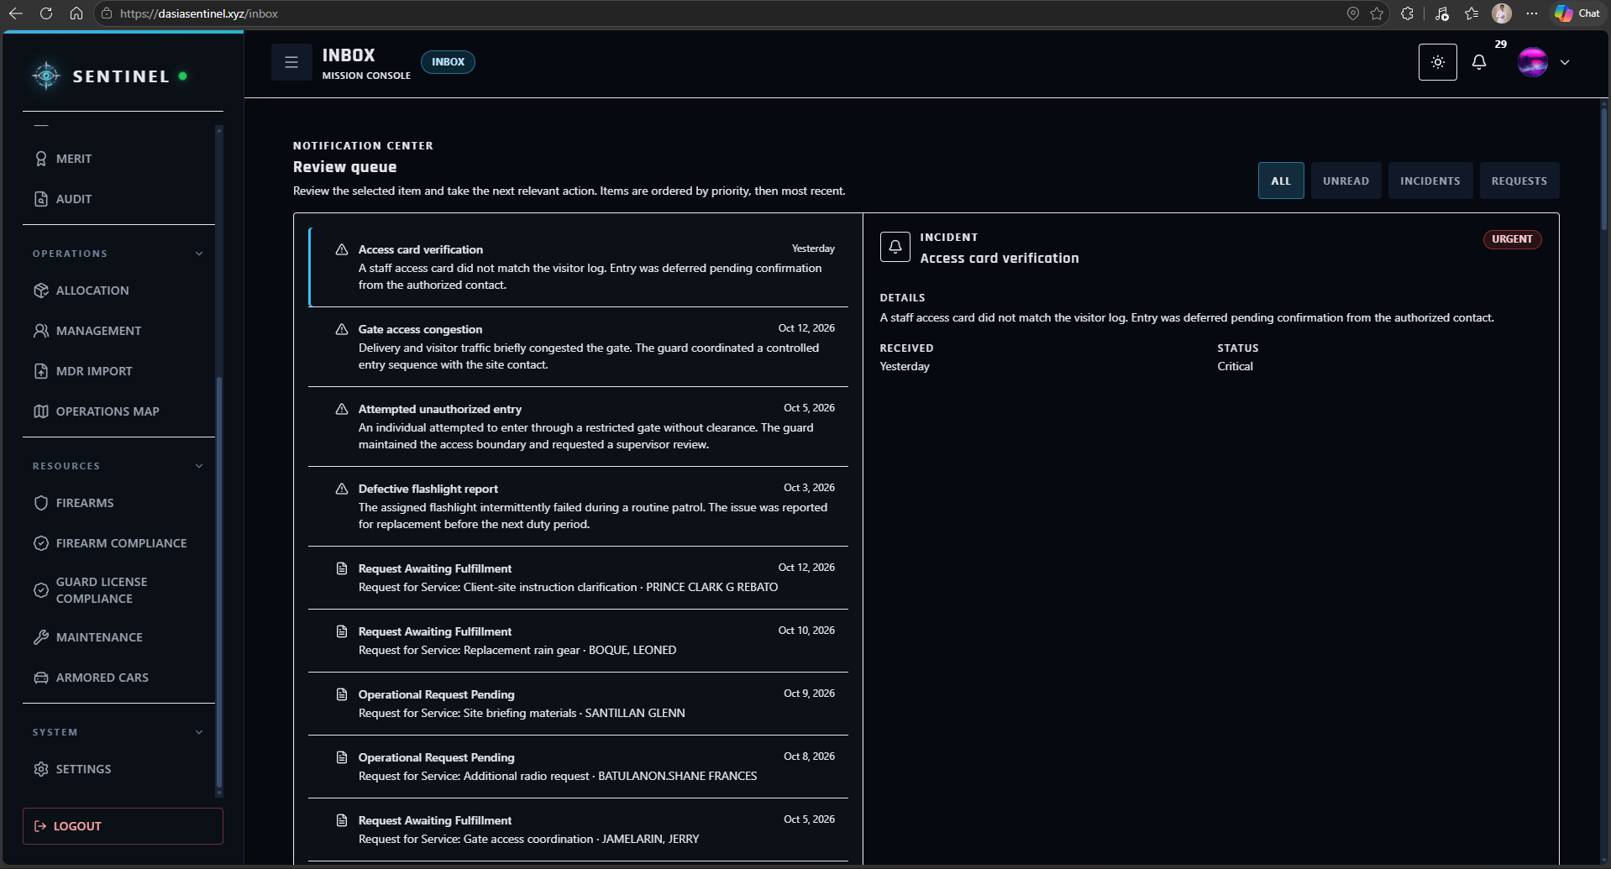
Figure 25. Inbox Module
The Support Module serves as the internal assistance channel for operational and system-related concerns. Users can submit support tickets, describe encountered issues, and review the status of their submitted requests until the concern is addressed or resolved.
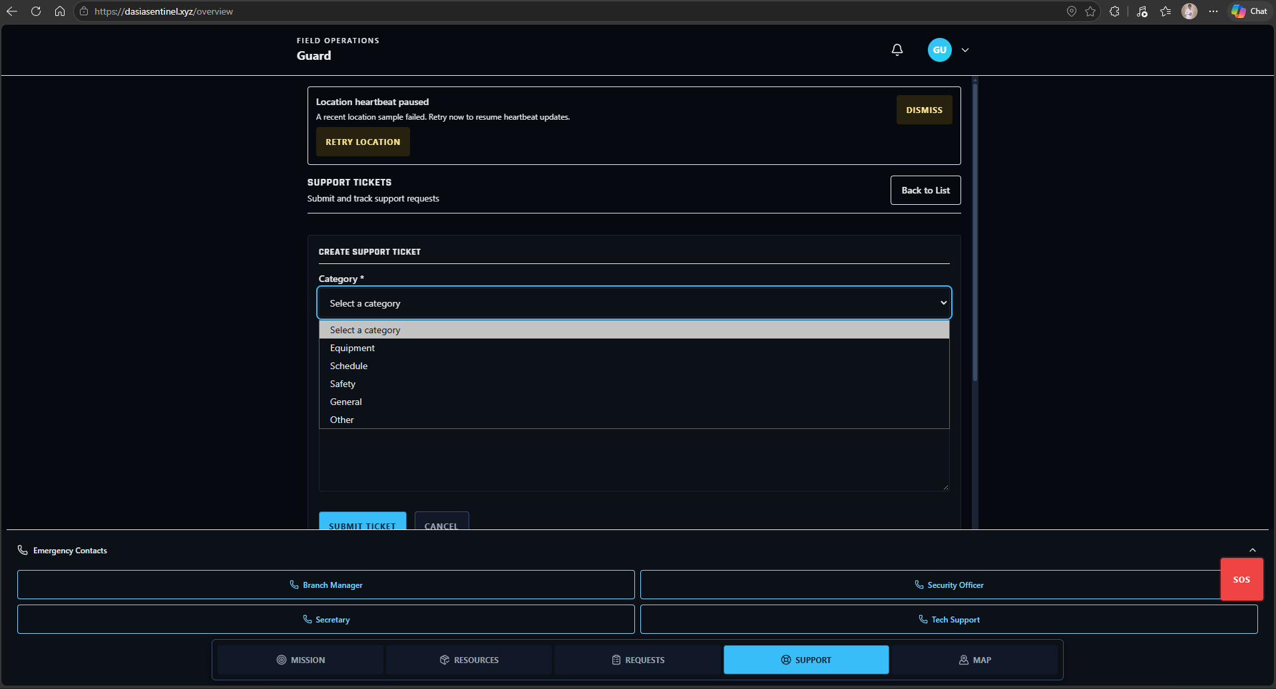
Figure 26. Support Module
The Feedback Submission Module provides users with a structured channel for submitting comments, ratings, concerns, and suggestions about their experience using SENTINEL. The collected feedback supports evaluation and continued refinement of the system.
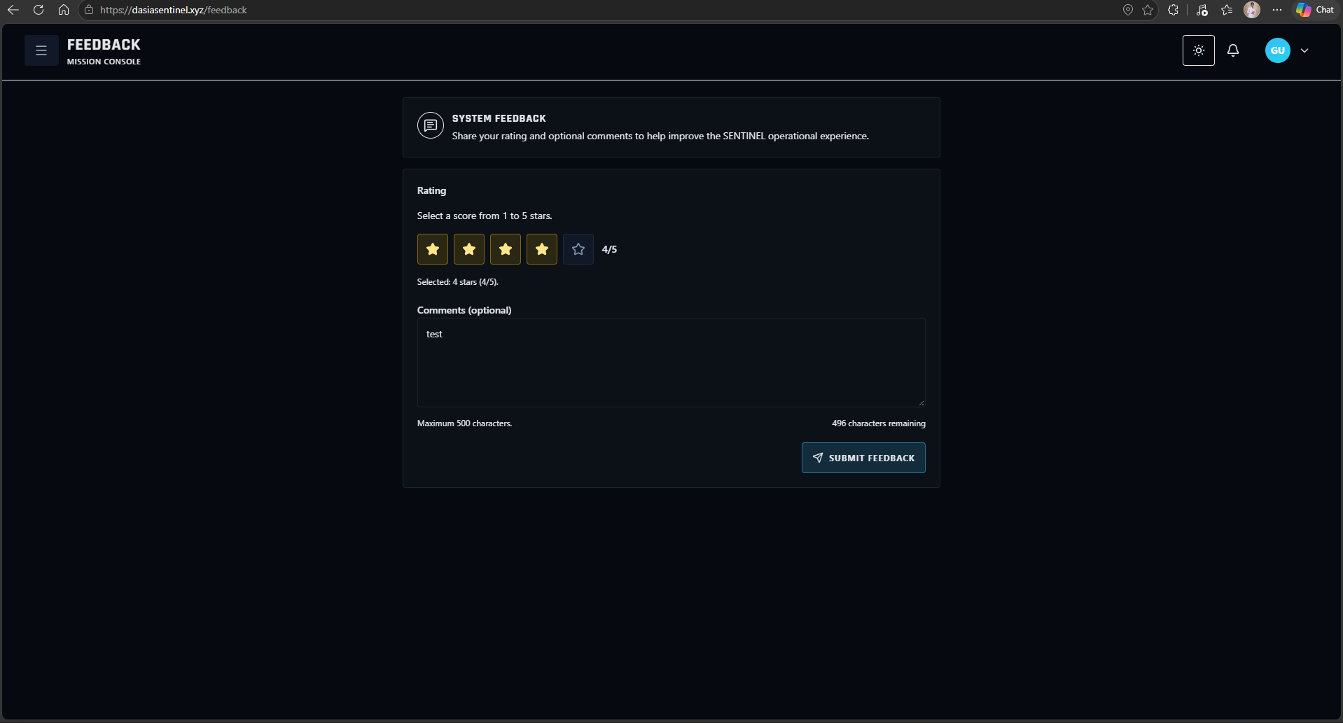
Figure 27. Feedback Submission Module
The Feedback Dashboard Module provides authorized command users with a consolidated view of submitted user feedback. It allows feedback records and ratings to be reviewed to identify recurring concerns, positive experiences, and areas that may require further system improvement.
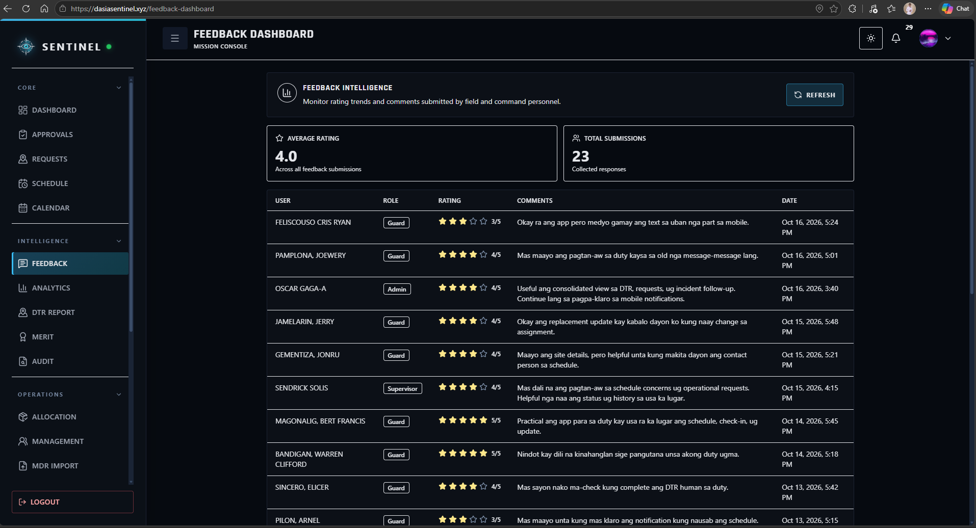
Figure 28. Feedback Dashboard Module
The Firearms Module serves as the centralized inventory workspace for agency firearms. Authorized users can review firearm records, serial information, status, condition, availability, and other information required for controlled asset monitoring.
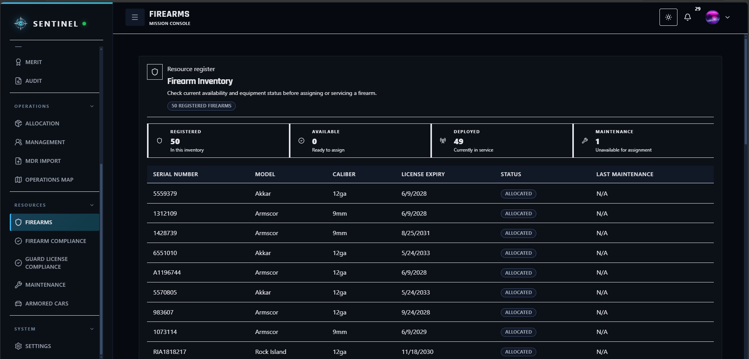
Figure 29. Firearms Module
The Firearms Allocation Module manages the controlled issuance and assignment of firearms to authorized personnel. It records firearm allocation information and helps preserve traceability between the firearm, assigned Guard, and corresponding operational records.
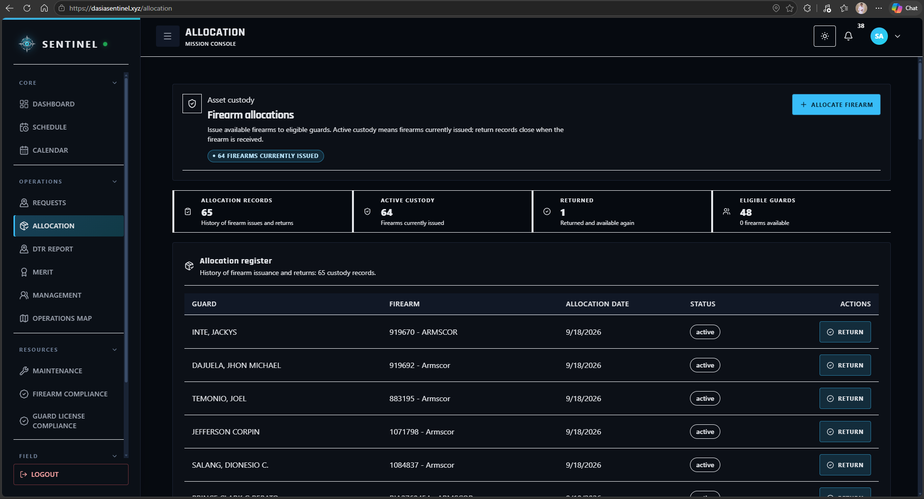
Figure 30. Firearms Allocation Module

The Firearms Permits Module serves as the compliance-monitoring workspace for firearm-related permits and documentation. Authorized users can review permit validity, expiration information, and related records to support compliance and prevent the operational use of assets with invalid documentation.
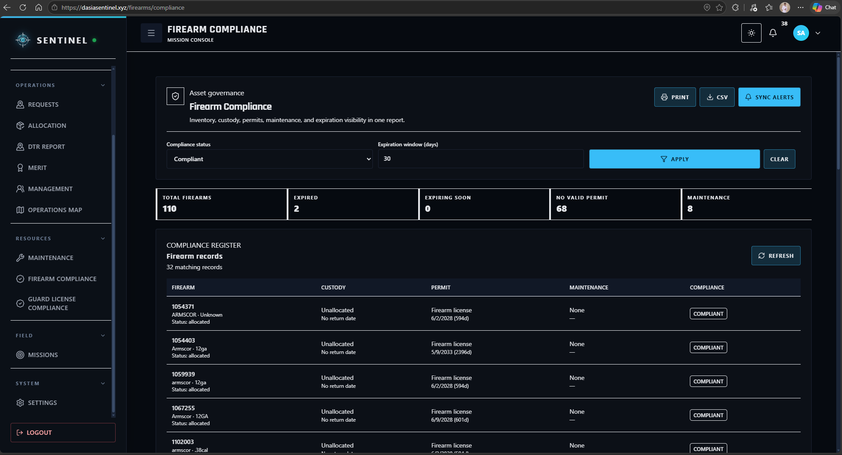
Figure 31. Firearms Permits Module

The Armored Cars Module serves as the centralized fleet-management workspace for armored vehicles. Authorized users can maintain vehicle records, monitor availability and operational status, and review information related to allocations, trips, and maintenance activities.
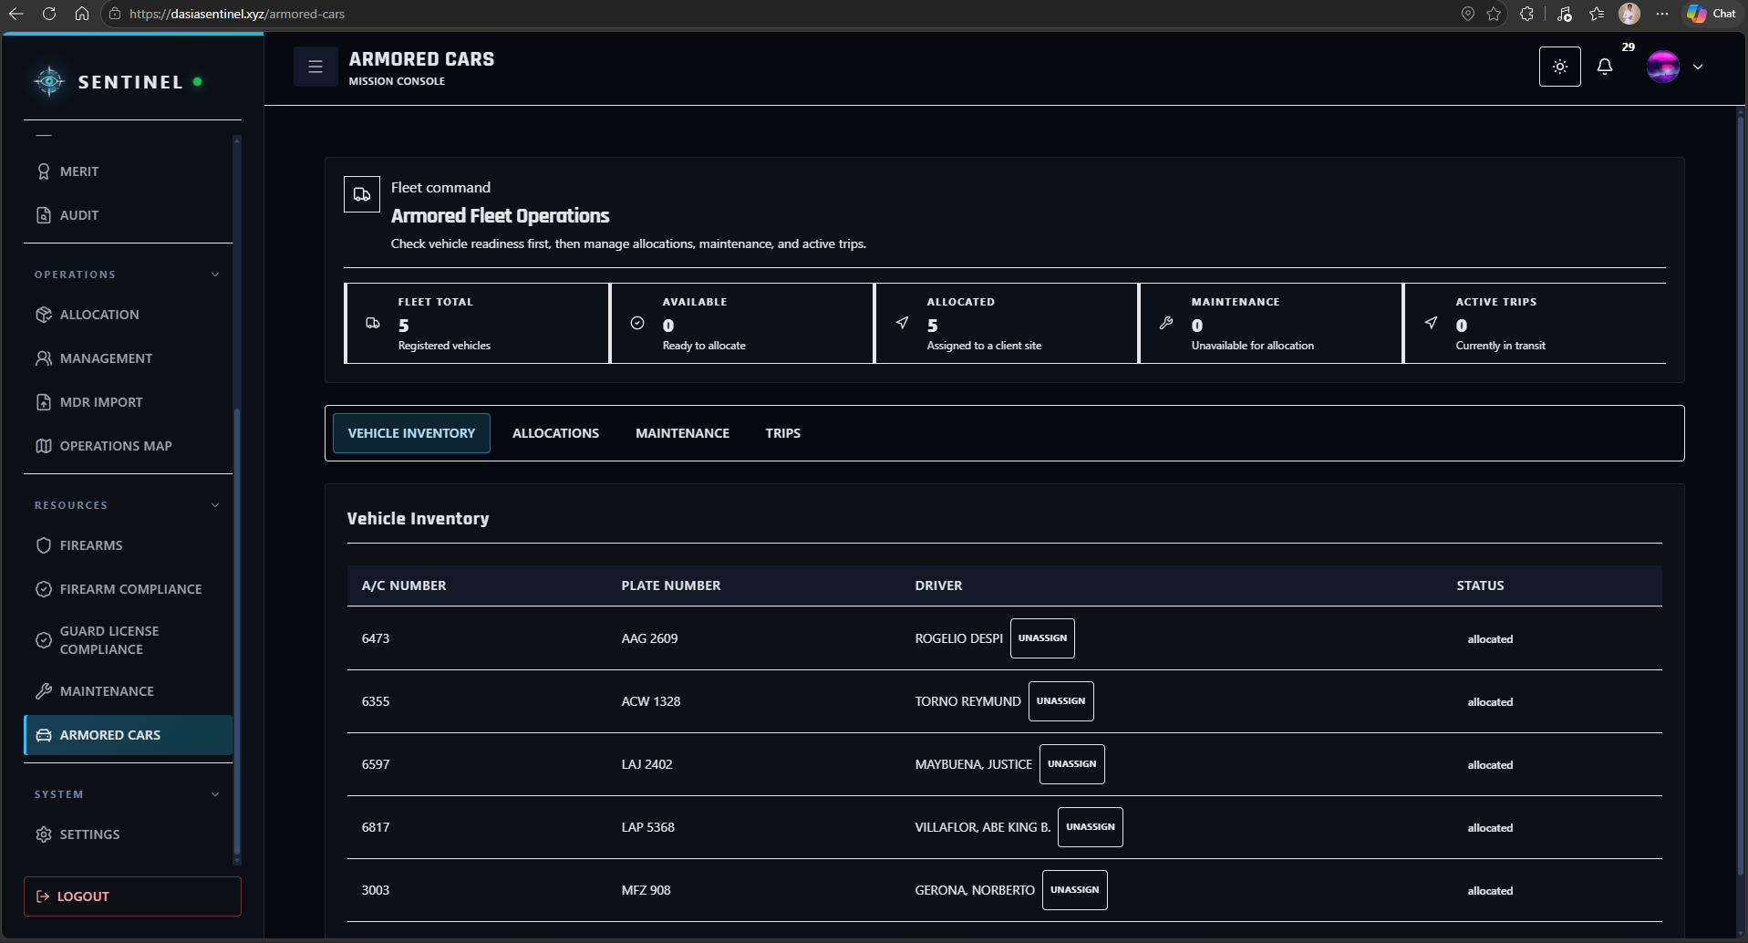
Figure 32. Armored Cars Module

The Maintenance Module provides authorized users with a workspace for monitoring maintenance activities involving operational assets. It supports the recording and review of maintenance schedules, service status, and maintenance history to help maintain asset readiness and reduce unexpected downtime.
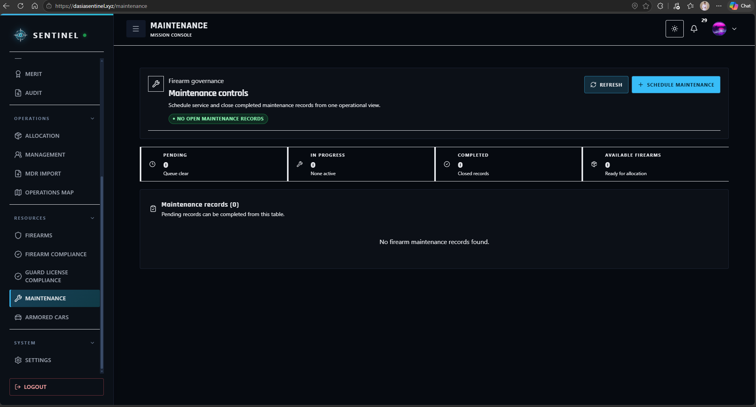
Figure 33. Maintenance Module

The Analytics Module serves as the performance and operational-analysis workspace of SENTINEL. It presents graphical summaries and indicators derived from attendance, punctuality, assignments, incidents, Guard performance, evaluations, and other operational records to support command-level assessment and decision-making.

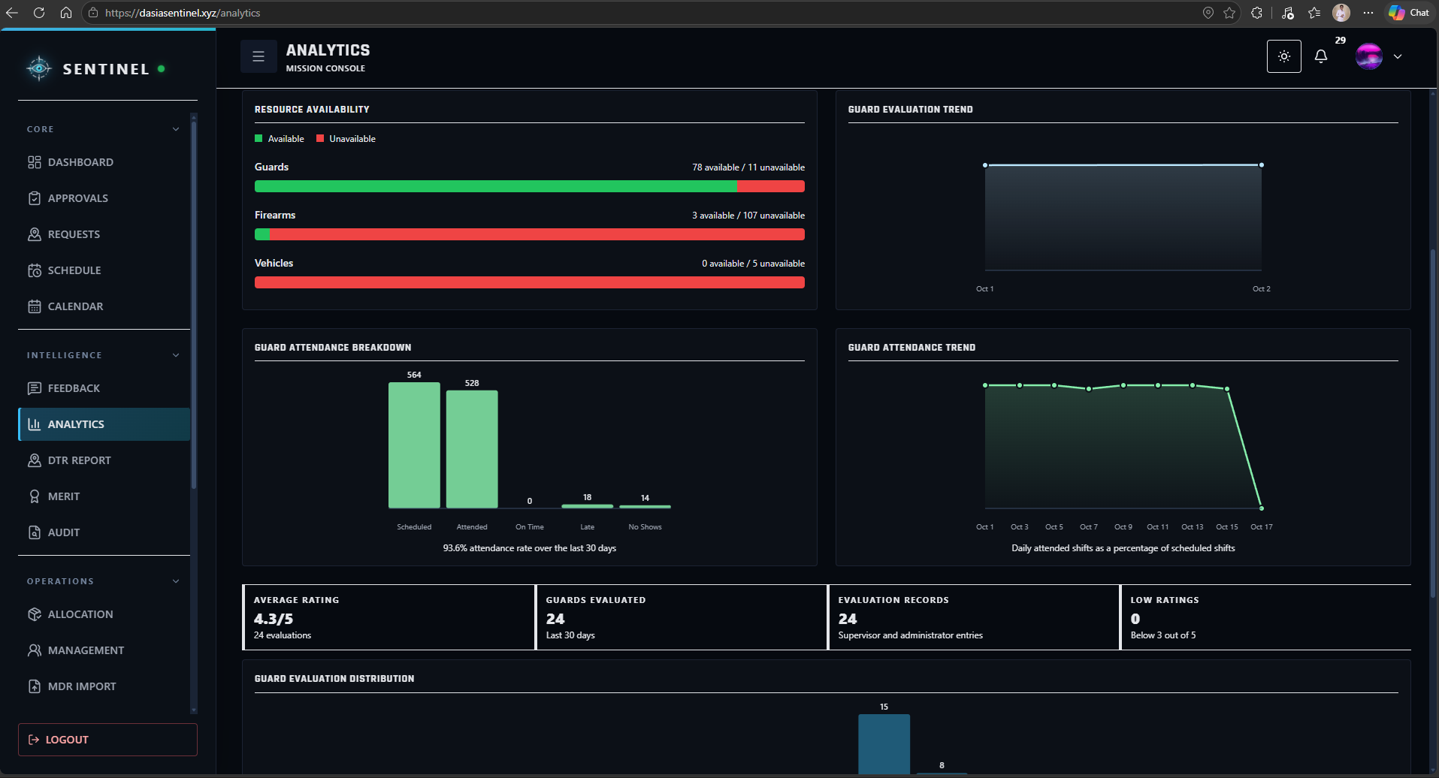
Figure 34. Analytics Module

The Audit Module serves as the accountability and traceability workspace for recorded system activity. Authorized users can review audit records, actors, actions, timestamps, security-related events, and operational activity to support governance, compliance review, and post-event investigation.
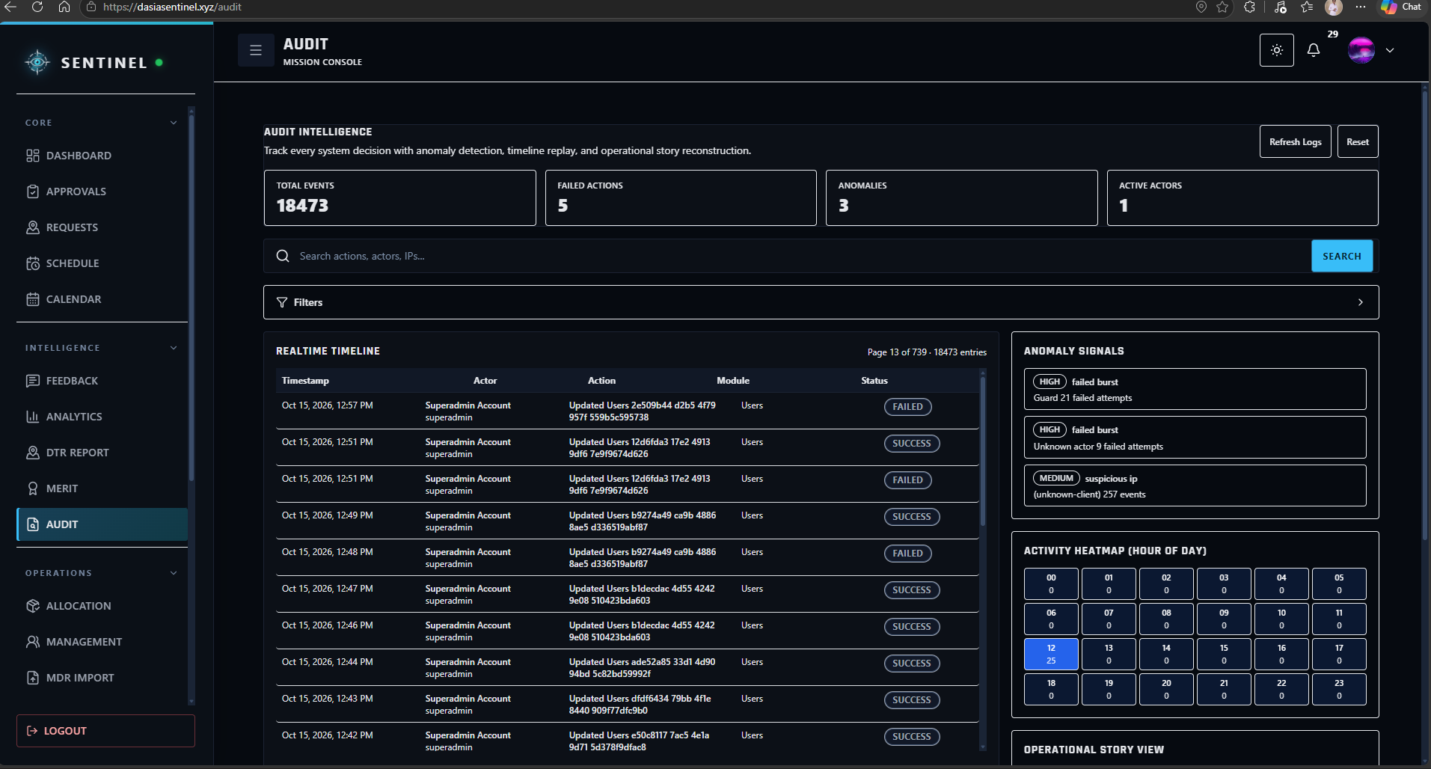
Figure 35. Audit Module

The Profile Module provides users with access to their account and identity information. Users can review and update permitted profile details while remaining subject to the access and security restrictions associated with their assigned role.
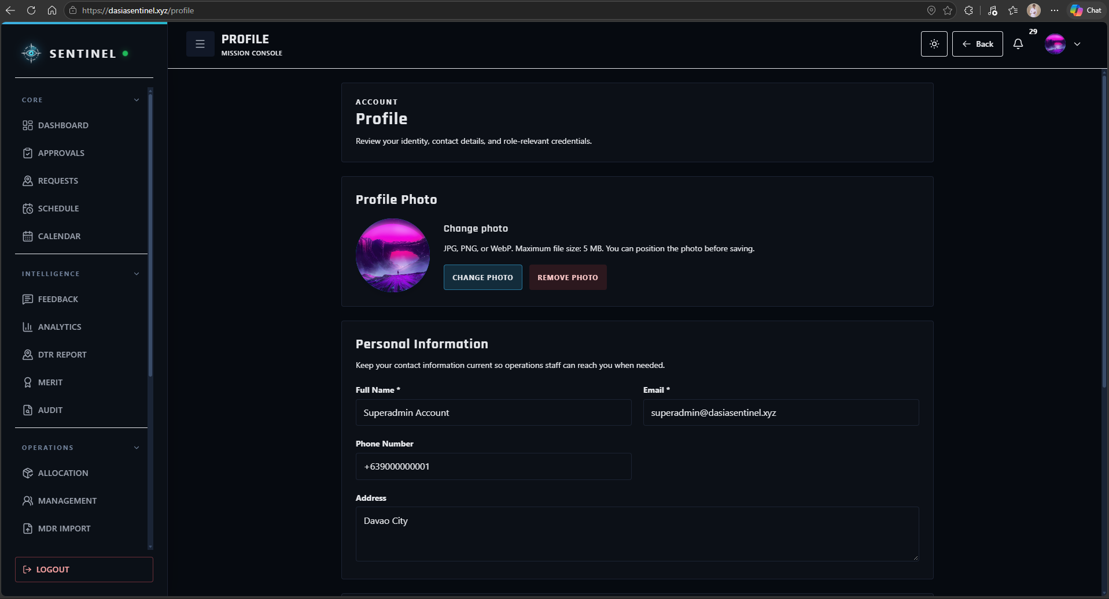
Figure 36. Profile Module
The Settings Module serves as the configuration workspace for available user and system preferences. Authorized users can manage applicable notification and interface settings according to the controls permitted for their role.
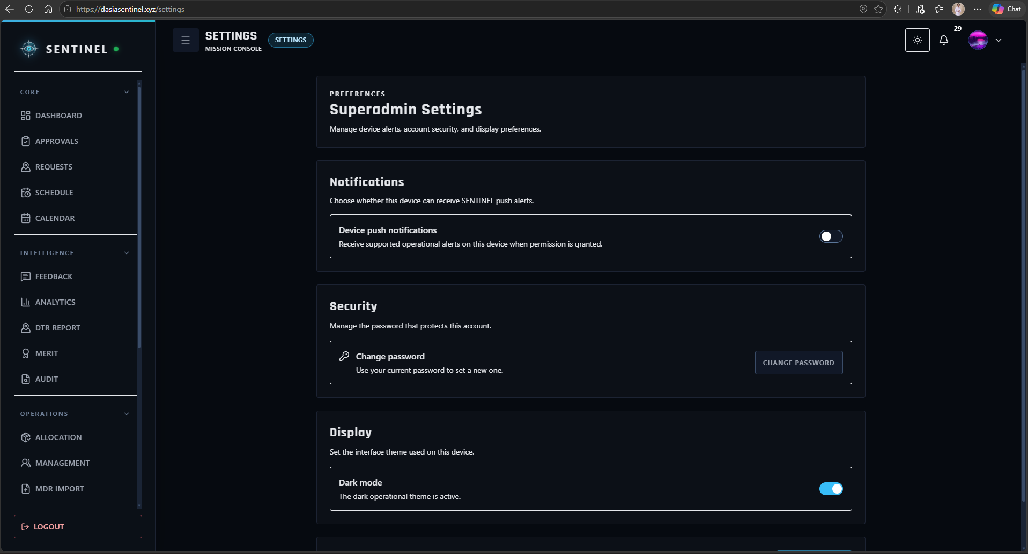
Figure 37. Settings Module

RESULTS AND DISCUSSION

Testing
The SENTINEL system underwent technical and operational validation to determine whether the integrated modules performed consistently and whether the deployed application remained available during normal use. Static TypeScript checking completed successfully, the frontend production build completed successfully after transforming 1,967 modules, and all 199 registered Jest unit and component tests passed across 56 test suites. The selected Playwright browser workflow run produced 16 passing tests. These results indicate that the core deployed application, its major frontend workflows, and the operational scheduling controls were functioning consistently during the final validation period.
Table 3. Summary of Technical Testing Results
Test / Validation | Result | Observed Outcome
TypeScript static check | PASS | Completed with no type errors.
Jest unit/component tests | PASS | 56 suites; 199 tests passed; 0 failed.
Frontend production build | PASS | Build completed; 1,967 modules transformed.
Selected Playwright workflows | PASS | 16 passed; 0 failed.
Public frontend/backend health | PASS | Frontend and backend returned HTTP 200; API/database operational.

Description of Prototype
SENTINEL is an integrated security operations management platform developed for Davao Security & Investigation Agency, Inc. The prototype consolidates personnel administration, scheduling, attendance and DTR, replacement coordination, incident and request handling, notifications, live location monitoring, firearm and armored vehicle accountability, maintenance, performance analytics, and audit review within a role-governed environment. The interface adapts to four primary user roles: Guard, Supervisor, Administrator, and Superadmin.
Guards use the platform for duty-oriented functions such as reviewing schedules, performing attendance actions, receiving field instructions, submitting incidents and support concerns, responding to eligible replacement opportunities, and accessing authorized location and map information. Supervisors use SENTINEL for workforce monitoring, scheduling coordination, replacement decisions, operational requests, incident review, and field visibility. Administrators manage personnel, approvals, schedules, client sites, assets, compliance records, and operational workflows. Superadmin users receive system-wide oversight through dashboards, audit information, reports, and governance controls. The interfaces presented in the preceding prototype figures illustrate the implemented role workspaces and major operational modules.

Implementation Plan
The implementation of SENTINEL was conducted in phases to ensure a smooth transition from DASIA’s existing manual and spreadsheet-based processes to the new system. The researchers initially deployed the live SENTINEL system on September 28, 2026. However, actual operational use by DASIA began on October 1, 2026 because the Security Officer, who serves as the system Supervisor, needed additional time to migrate the agency’s existing personnel and operational records from their Excel files. To make the migration easier and reduce the amount of manual encoding required, the researchers developed an import function within SENTINEL. The feature allows existing records to be imported into the system while applying data-cleansing procedures to help identify, organize, and correct inconsistent or incomplete information before the records are incorporated into the system.
Beginning October 1, SENTINEL was used by a total of 57 users composed of 55 Security Guards, one Administrator represented by the Branch Manager, and one Supervisor represented by the Security Officer. The users utilized the system according to their respective roles, including functions related to scheduling, attendance and DTR, Guard assignments and replacements, operational monitoring, requests, notifications, incident reporting, and other role-authorized activities. The implementation period allowed the researchers to observe how the system performed under the agency’s normal 24/7 security operations, including Sunday duties and stable site rosters with rotating Day, Evening, and Night duty periods.
On October 16, 2026, the researchers distributed the system evaluation questionnaires to the participating users to gather their assessment of SENTINEL after experiencing the system during the implementation period. The evaluation covered the system’s functional suitability, performance efficiency, compatibility, usability, reliability, security, and portability. The responses also provided comments and suggestions regarding practical concerns encountered during actual use, such as mobile connectivity, notification visibility, map loading, scheduling information, and interface readability. The collected evaluation results were then used as the basis for assessing the effectiveness of the implemented system and identifying areas that could be further improved in succeeding versions of SENTINEL.

Implementation Results
Implementation results show that the integrated modules were able to operate on a shared database and support the major workflows defined in the study objectives. During validation, SENTINEL maintained 55 participating Guards across 11 selected selected DASIA client sites in Davao del Norte using three rotating duty periods: 7:00 AM to 3:00 PM, 3:00 PM to 11:00 PM, and 11:00 PM to 7:00 AM. The schedule contained 561 base coverage slots and 564 tracked shift records after including three same-site relief replacements. A total of 528 attendance records were completed, while 33 shifts remained scheduled at the reference point. Punctuality records included 510 present/on-time records, 18 late records, and 3 absences. Validation found no overlapping assignments and no insufficient-rest violations.
Supporting workflows were also exercised across the system. The implementation contained seven incident records with corresponding severity classifications, nine operational requests with twenty-two request-history events, twenty-three notifications, ninety-six readiness checks, four absence-risk scenarios, seven support tickets, twenty-four client evaluations, and eighteen location-tracking points. These records allowed the researchers to verify the interaction of the major field, support, analytics, and monitoring functions while preserving the validated 24/7 workforce schedule.
Table 4. Operational Implementation Summary
Implementation Metric | Result
Selected client sites | 11
Participating Guards | 55
Tracked shifts | 564
Completed attendance / DTR records | 528
Scheduled shifts at reference point | 33
Punctuality records | 531
Late records | 18
Absences | 3
Smart replacements | 3
Sunday coverage slots | 66
Overlap violations | 0
Insufficient-rest violations | 0
Incidents / classifications | 7 / 7
Operational requests / events | 9 / 22
Notifications | 23
Readiness checks | 96
Support tickets | 7
Client evaluations | 24
Tracking points | 18
1. Secure Access and Approval-Governed User Management
The first objective focused on secure account access, approval controls, session protection, and role restrictions. The combined evaluation produced an AWM of 4.85, interpreted as Strongly Agree. The implemented authentication flow uses token-based sessions, account-state checks, password-recovery functions, legal-policy acceptance, and role-aware frontend and backend controls. The results indicate that respondents considered the account and access-governance functions clear, secure, and appropriate for their assigned roles.
Figure 38 presents the SENTINEL login interface used by authorized personnel to access the system. The interface serves as the entry point for secure authentication and routes users to the workspace permitted by their assigned role.
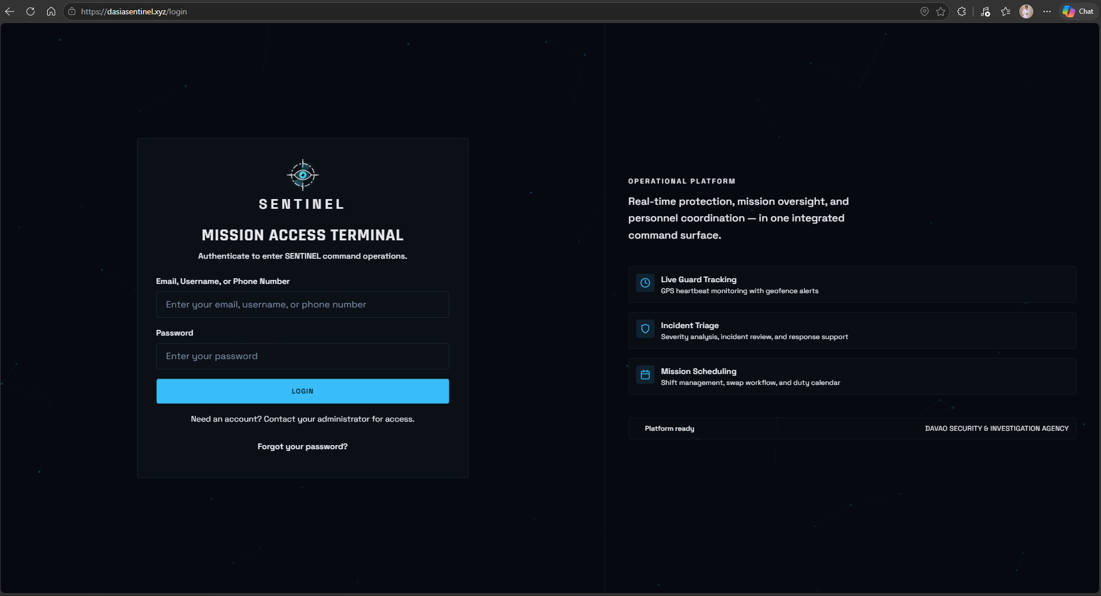
Figure 38. User Login and Secure Access Interface
Figure 39 presents the approval and user-management functions used to review account records, control access, and maintain role-governed user information. These functions support the first objective by keeping account onboarding and access decisions under authorized administrative control.
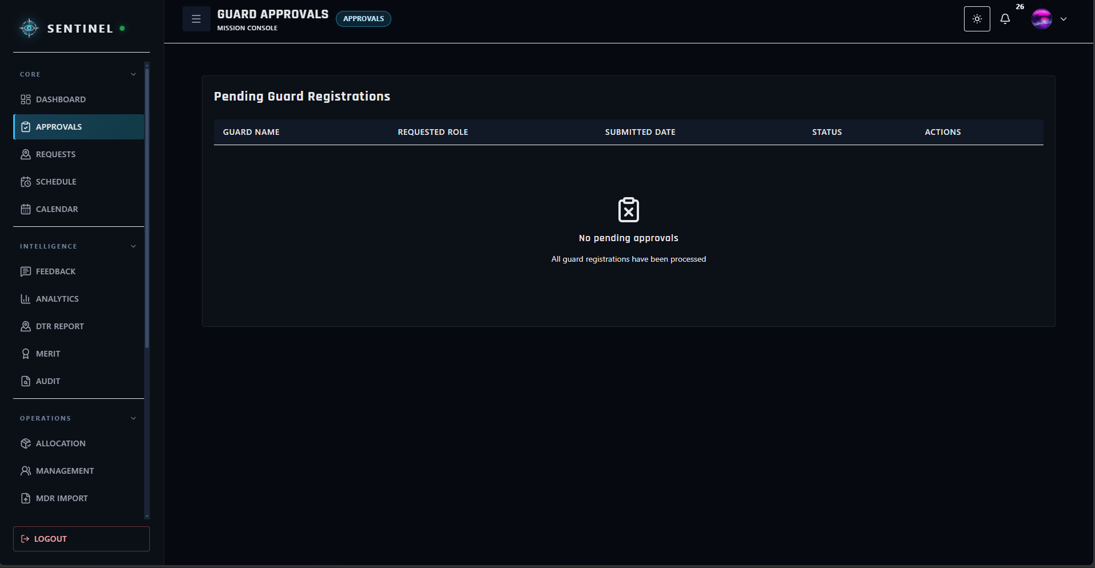
Figure 39. Approval and User Management Interface

Table 5. Summative Evaluation Results for Objective 1
Sub-objective | Assessment Area | Applicable Ratings | AWM | Descriptive Equivalent
1.1 | Secure account authentication, verification, approval, and recovery | 52 | 4.83 | Strongly Agree
1.2 | Role-governed access and account restrictions | 26 | 4.85 | Strongly Agree
1.3 | Session protection, revocation, and legal-policy acceptance | 39 | 4.90 | Strongly Agree
2. Personnel Operations, Attendance, Scheduling, and Replacement
The second objective addressed personnel operations such as scheduling, attendance, DTR, no-show monitoring, and replacement coordination. This objective obtained an AWM of 4.82, interpreted as Strongly Agree. Operational validation supported the same finding: the 24/7 schedule maintained continuous coverage across the selected sites, recorded 528 completed attendance entries, identified 18 late records and 3 absences, and completed three same-site replacement scenarios without producing overlapping shifts or insufficient-rest violations. The results show that the system can centralize workforce information while supporting continuity when attendance exceptions occur.
Figure 40 presents the scheduling interface used to manage Guard duty assignments across client sites and rotating shifts. The populated schedule provides command users with a centralized view of personnel coverage and assigned duty periods.
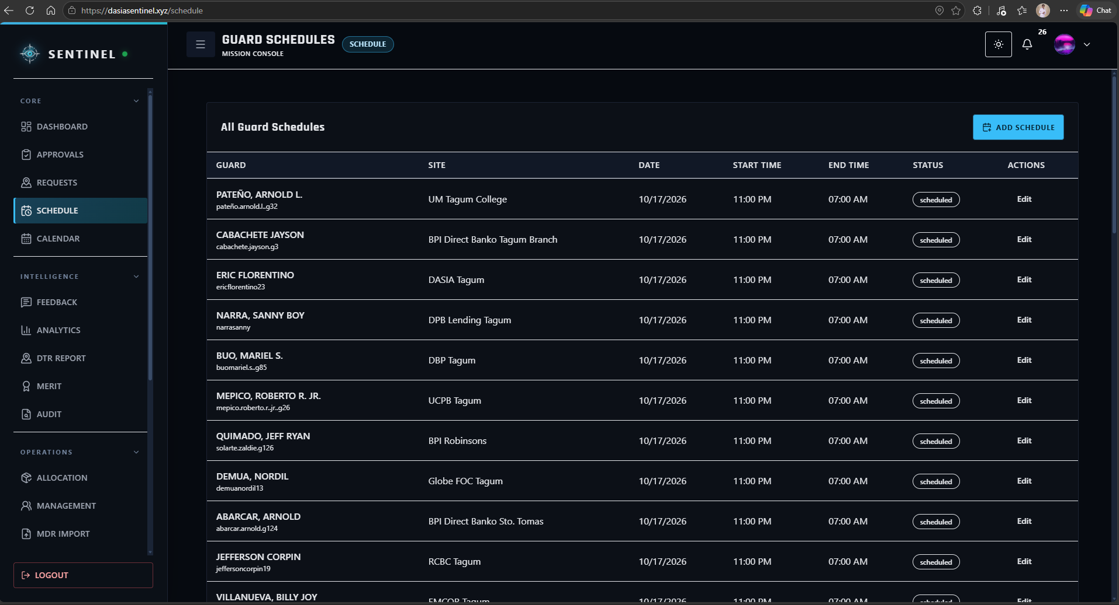
Figure 40. Guard Scheduling Interface

Figure 41 presents the attendance and Daily Time Record interface, where authorized users can review scheduled duty, actual check-in and check-out records, late information, rendered duty hours, and attendance status.
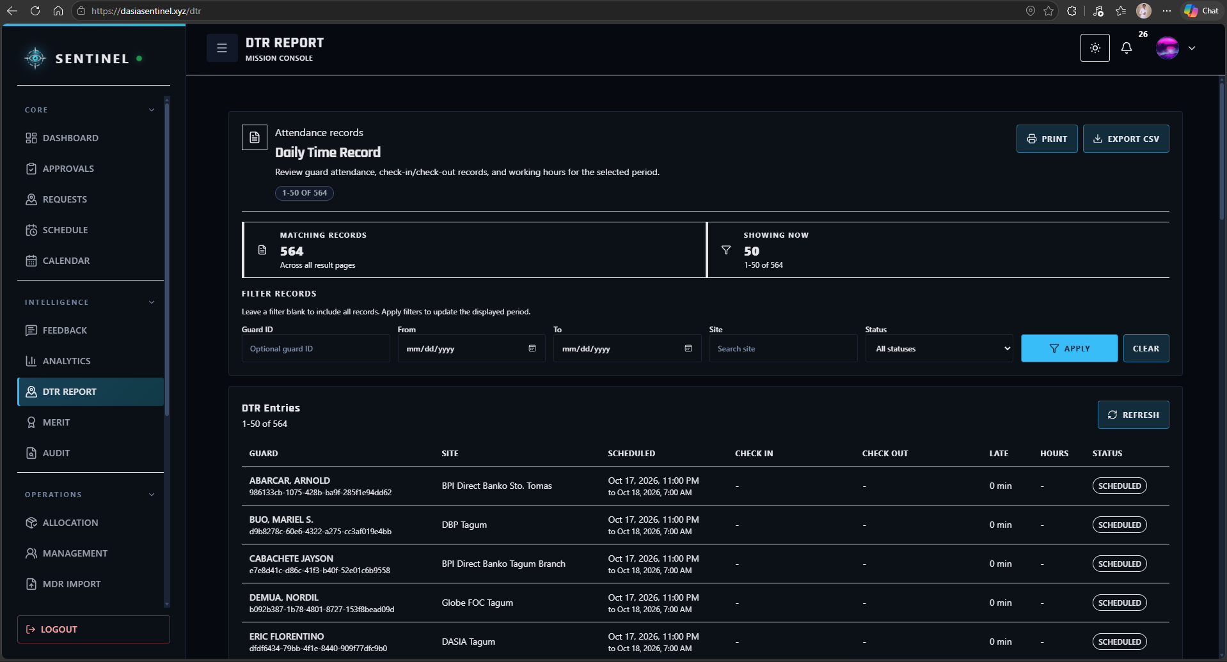
Figure 41. Attendance and DTR Interface

Figure 42 presents the Guard replacement workflow used when a scheduled Guard becomes unavailable or is recorded absent. The interface supports the review of eligible replacements and confirmed reassignment while preserving shift continuity.
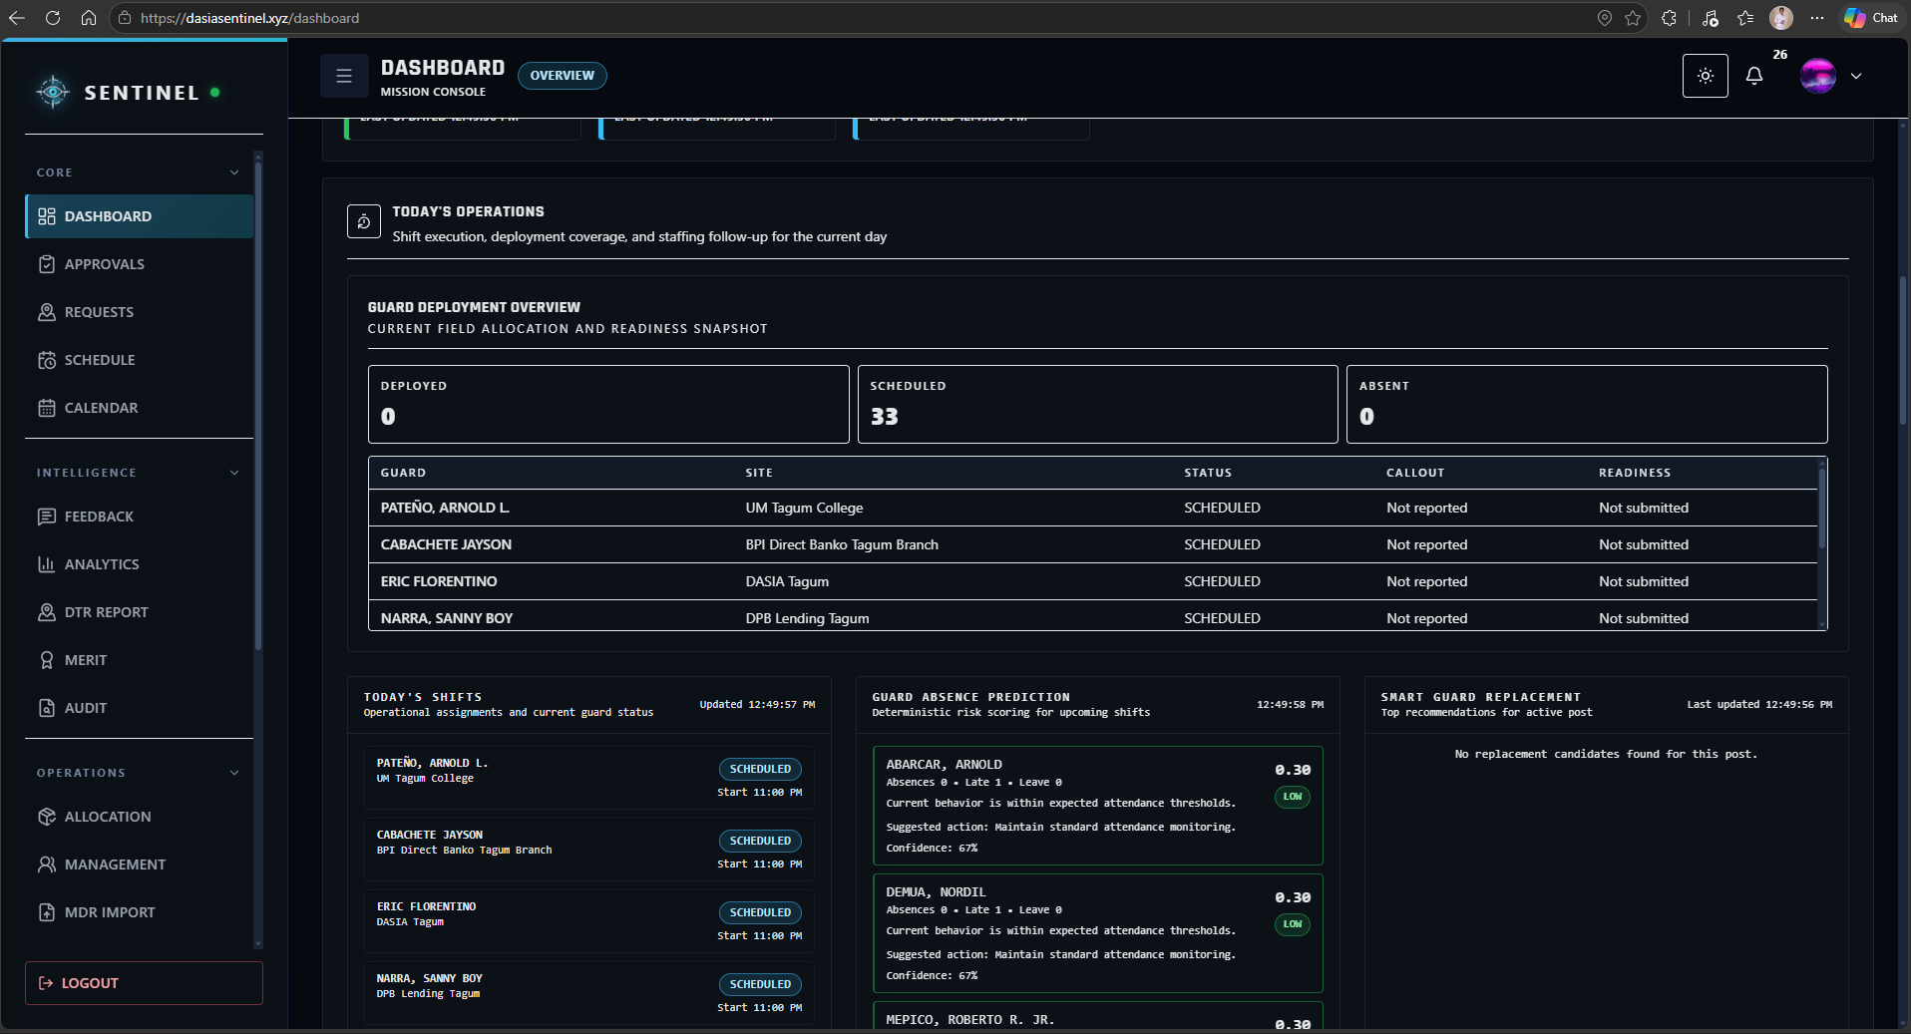
Figure 42. Guard Replacement Interface
Table 6. Summative Evaluation Results for Objective 2
Sub-objective | Assessment Area | Applicable Ratings | AWM | Descriptive Equivalent
2.1 | Guard records, schedules, client sites, and availability | 9 | 4.78 | Strongly Agree
2.2 | Attendance, check-in/check-out, DTR, conflicts, and no-show monitoring | 48 | 4.85 | Strongly Agree
2.3 | Guard replacement recommendations and reassignment coordination | 48 | 4.79 | Strongly Agree
3. Firearm, Permit, Vehicle, and Asset Accountability
The third objective focused on firearm, permit, vehicle, and operational asset accountability. It received an AWM of 4.92, interpreted as Strongly Agree. The current implementation provides inventory, allocation, custody, return, permit, training, vehicle, driver, trip, and maintenance monitoring capability through role-governed workflows. Respondents rated the organization, clarity, protection, and availability of these records very highly, indicating that the asset-management functions support traceability and compliance-oriented review.
Figure 43 presents the firearm inventory and allocation functions used to maintain firearm records, monitor availability, and preserve assignment traceability between controlled assets and authorized personnel.
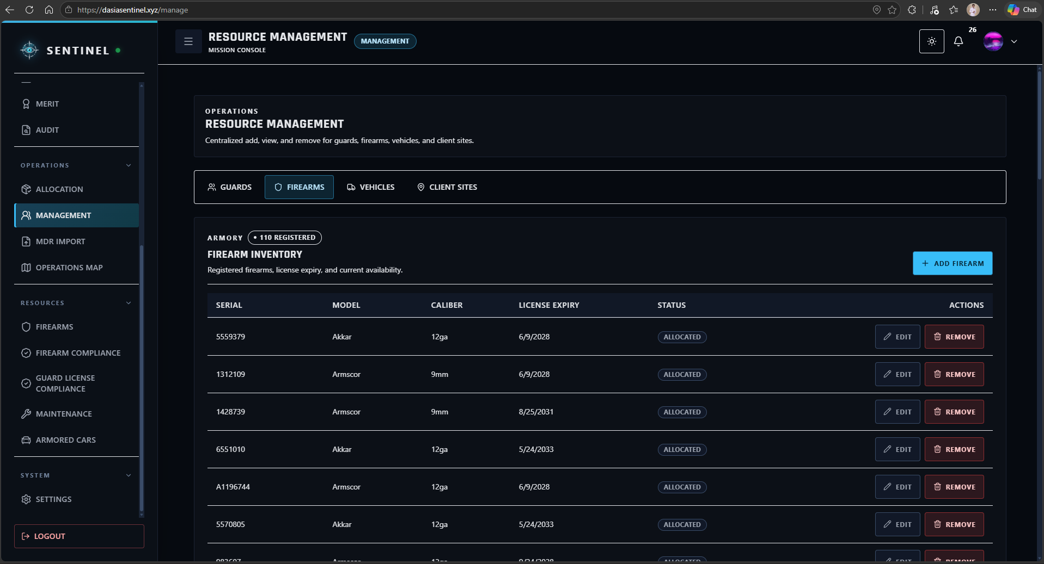
Figure 43. Firearm Inventory and Allocation Interface

Figure 44 presents the permit and compliance view used to monitor firearm-related documentation and validity information. This supports the agency in reviewing asset eligibility and compliance-related records before and during operational use.
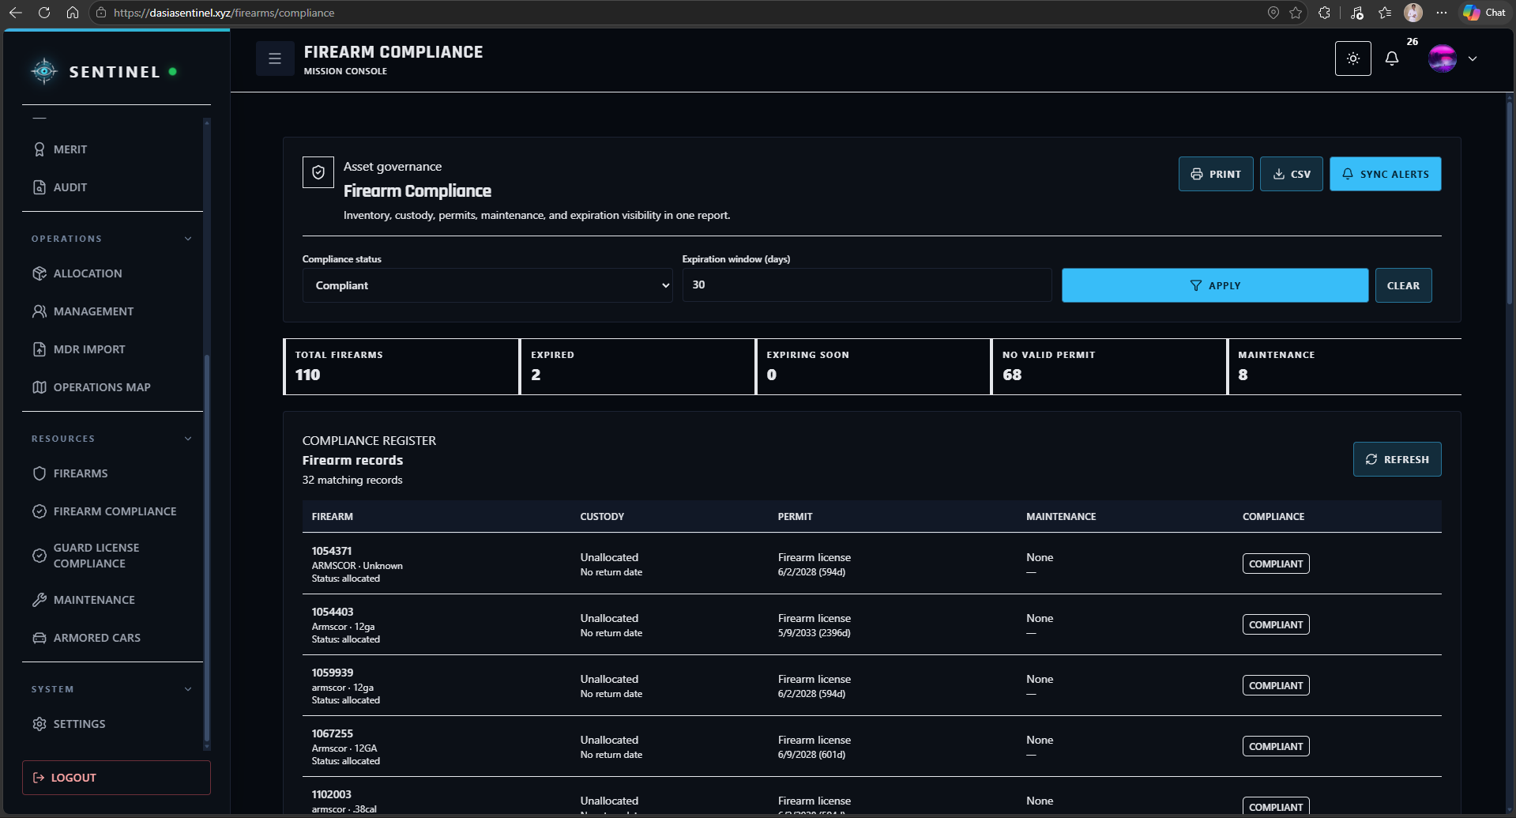
Figure 44. Firearm Permit and Compliance Interface
Figure 45 presents the armored vehicle and maintenance functions used to maintain fleet information, assignment-related records, trip readiness, and maintenance status for operational assets.
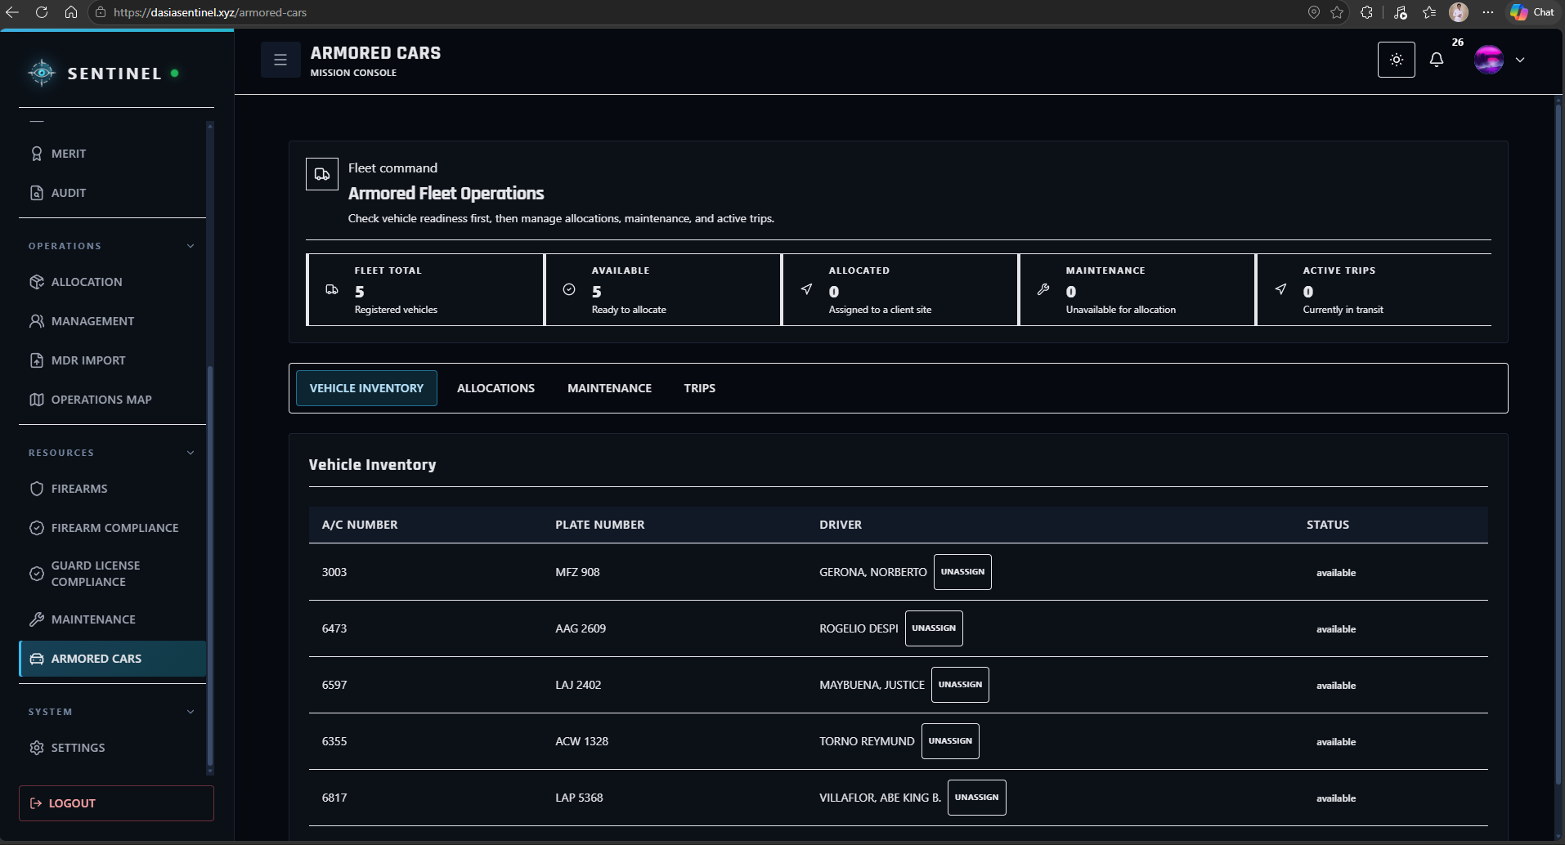
Figure 45. Armored Vehicle and Maintenance Interface

Table 7. Summative Evaluation Results for Objective 3
Sub-objective | Assessment Area | Applicable Ratings | AWM | Descriptive Equivalent
3.1 | Firearm, permit, vehicle, driver, trip, and asset management | 12 | 4.92 | Strongly Agree
3.2 | Firearm issuance, custody, permit, training, and availability tracking | 12 | 4.92 | Strongly Agree
3.3 | Expiration, maintenance, asset status, alerts, and reporting | 12 | 4.92 | Strongly Agree
4. Field Operations, Incident Handling, Notifications, and Live Monitoring
The fourth objective covered incidents, support requests, emergency escalation, notifications, location tracking, geofencing, and field monitoring. The objective obtained an AWM of 4.85, interpreted as Strongly Agree. Implementation results included seven incidents, nine operational requests with twenty-two event-history records, twenty-three notifications, seven support tickets, and eighteen tracking points. Respondent comments also identified practical field considerations, particularly slower map loading under weak data conditions and the need for more noticeable alerts, showing that connectivity and notification visibility remain important areas for continued refinement.
Figure 46 presents the Operations Map used by authorized command users to review deployment locations and field context. The map supports situational awareness by combining client-site information with available location and operational data.
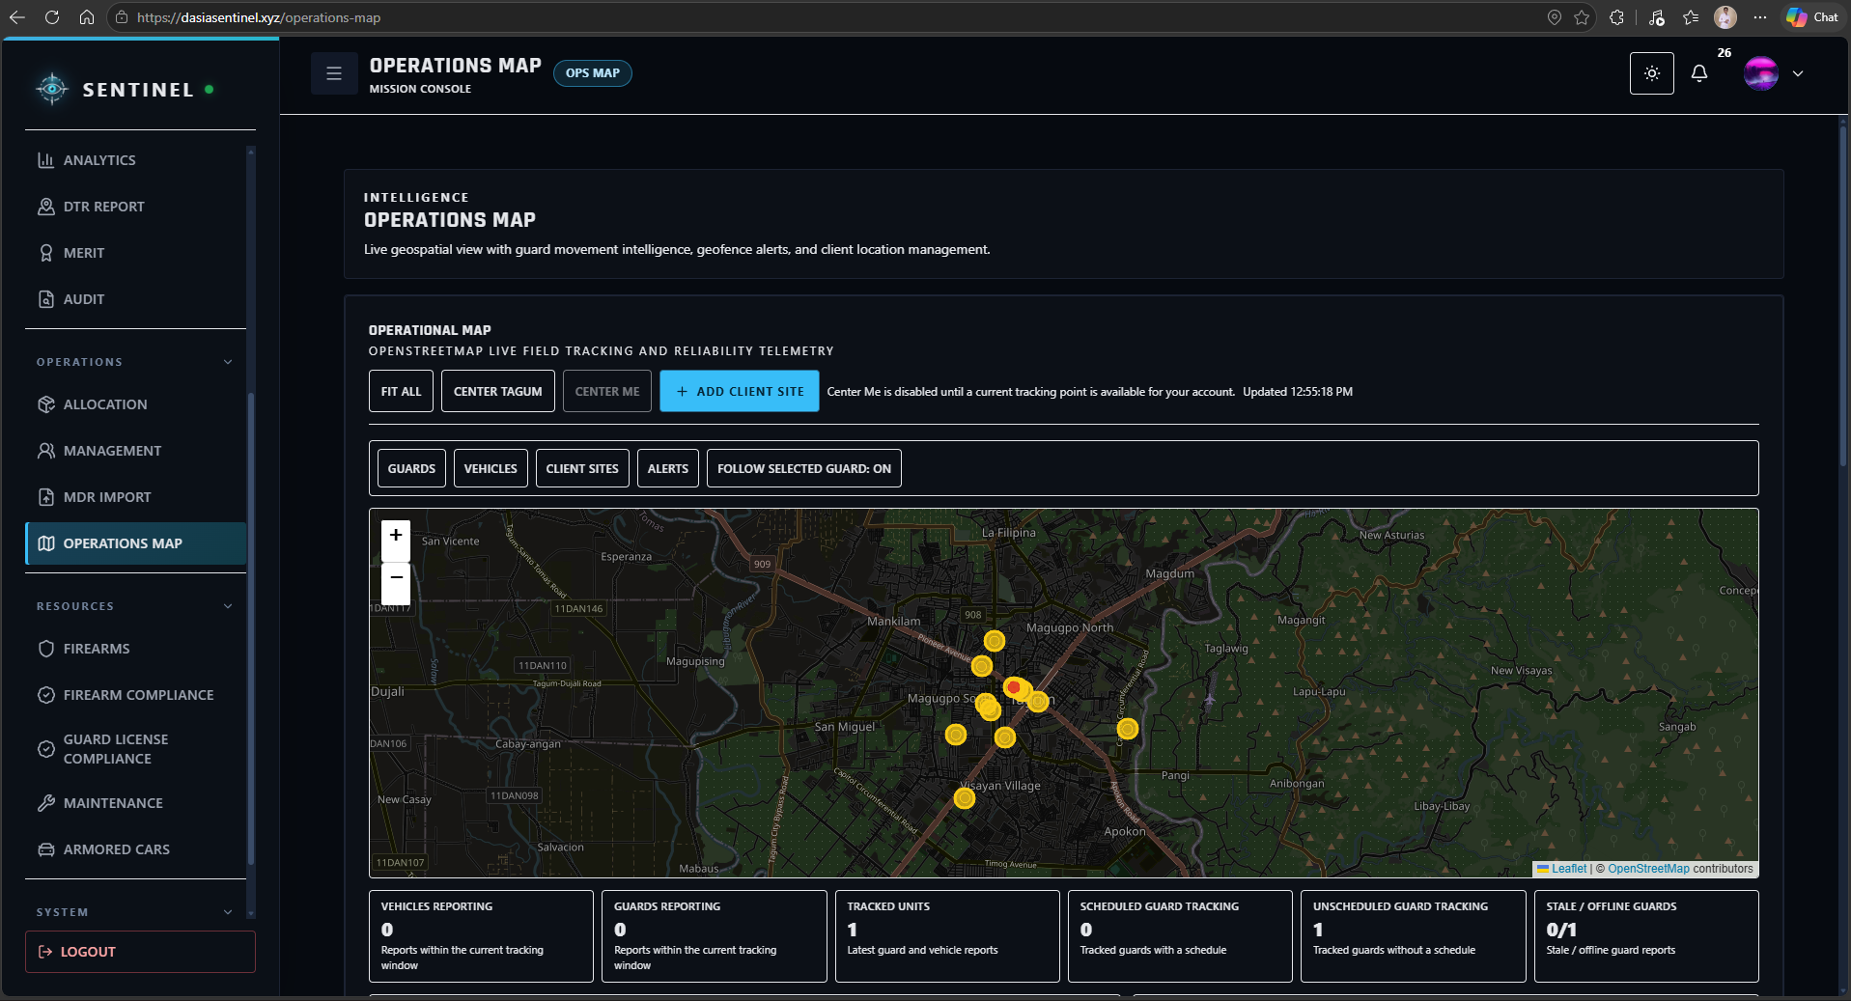
Figure 46. Operations Map and Live Monitoring Interface

Figure 47 presents the incident workflow used to record and review field events. Incident records provide structured information that can be classified, monitored, and followed up by authorized personnel.
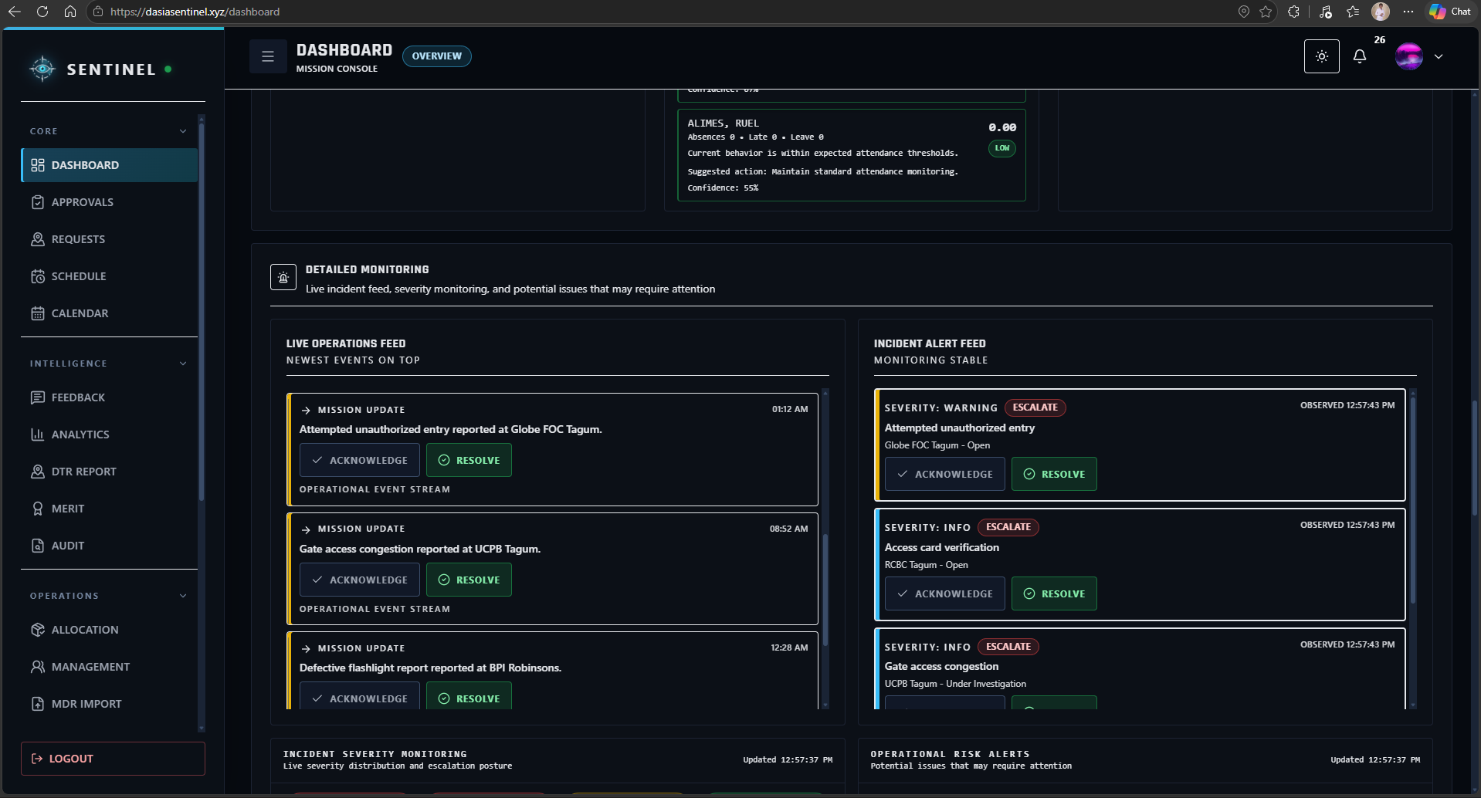
Figure 47. Incident Reporting and Review Interface

Figure 48 presents the communication and support functions used to surface operational notifications, pending items, supervisor messages, and support-related concerns. These functions provide users with a centralized channel for field coordination and follow-up.
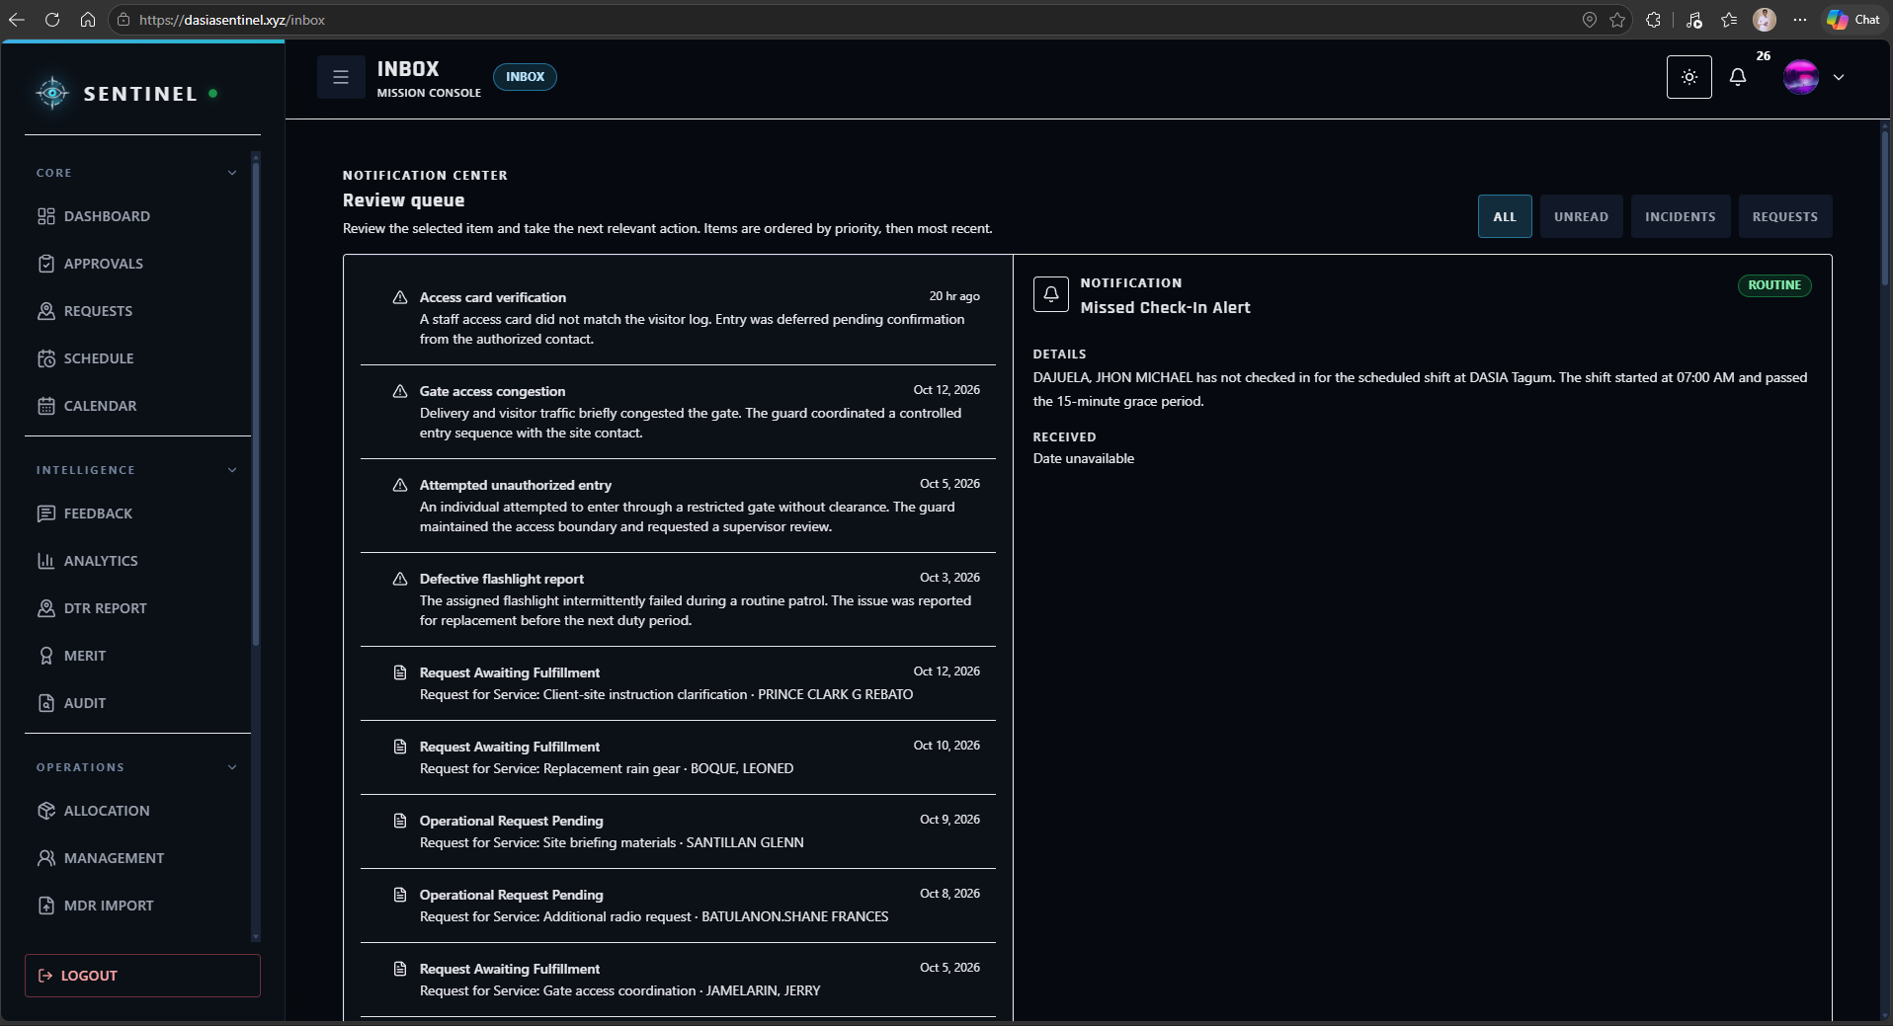
Figure 48. Inbox, Notification, and Support Interface
Table 8. Summative Evaluation Results for Objective 4
Sub-objective | Assessment Area | Applicable Ratings | AWM | Descriptive Equivalent
4.1 | Incidents, support requests, emergency alerts, and panic/SOS workflows | 48 | 4.81 | Strongly Agree
4.2 | Location tracking, movement history, geofencing, and Operations Map | 78 | 4.94 | Strongly Agree
4.3 | Notifications, Inbox workflows, missions, and operational updates | 52 | 4.75 | Strongly Agree
5. Performance Evaluation and Analytics
The fifth objective addressed performance reporting, rule-based scores, risk information, and analytical dashboards. It received an AWM of 4.85, interpreted as Strongly Agree. The system generated 55 merit scorecards, 24 client evaluations, punctuality records, and four rule-based absence-risk scenarios derived from recorded information. These outputs provide decision support for operational review; however, the predictive-style outputs are rule-based rather than validated machine-learning models and should be interpreted as transparent decision-support indicators.
Figure 49 presents the Analytics dashboard used to review attendance, punctuality, assignment, incident, and Guard-performance information. The visual summaries support command users in identifying patterns and reviewing operational conditions from centralized records.
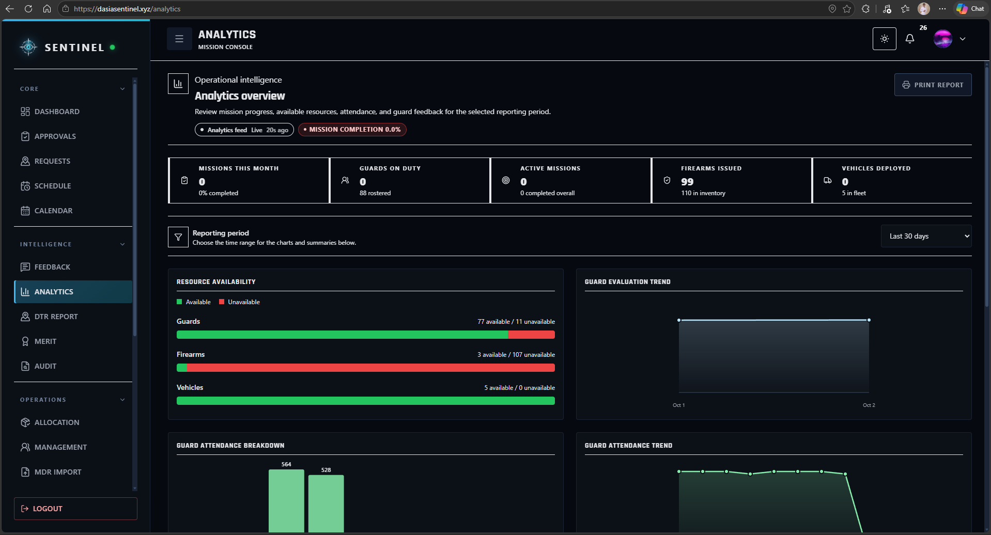
Figure 49. Performance Analytics Dashboard

Figure 50 presents the performance and evaluation information used to review Guard merit indicators, client evaluations, and related decision-support outputs. These records provide a structured basis for personnel assessment and supervisory review.
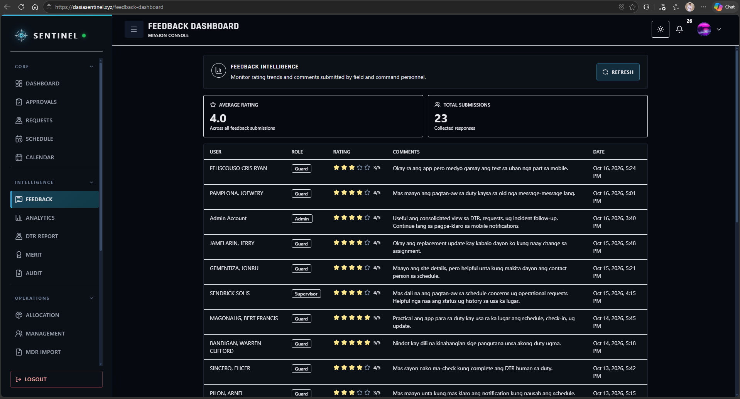
Figure 50. Guard Performance and Evaluation Interface
Table 9. Summative Evaluation Results for Objective 5
Sub-objective | Assessment Area | Applicable Ratings | AWM | Descriptive Equivalent
5.1 | Attendance, incident, assignment, and Guard-performance reports | 9 | 4.89 | Strongly Agree
5.2 | Rule-based scores, risks, alerts, and replacement recommendations | 9 | 4.89 | Strongly Agree
5.3 | Dashboards and analytical information for decision-making | 9 | 4.78 | Strongly Agree
6. Traceable Multi-Platform Delivery and Operational Reporting
The sixth objective focused on traceable multi-platform delivery, auditability, and operational reporting. It obtained an AWM of 4.90, interpreted as Strongly Agree. The web application was verified as publicly available through dasiasentinel.xyz, and the backend health endpoint confirmed API and database availability. Windows desktop and Android wrappers are configured through Tauri and Capacitor, respectively. Respondents rated portability and traceability highly, although packaged desktop and Android runtime validation remains a recommended final verification activity.
Figure 51 presents the Audit interface used by authorized users to review recorded system actions, security events, and traceable operational activity. The audit workspace supports accountability, governance review, and post-event investigation.
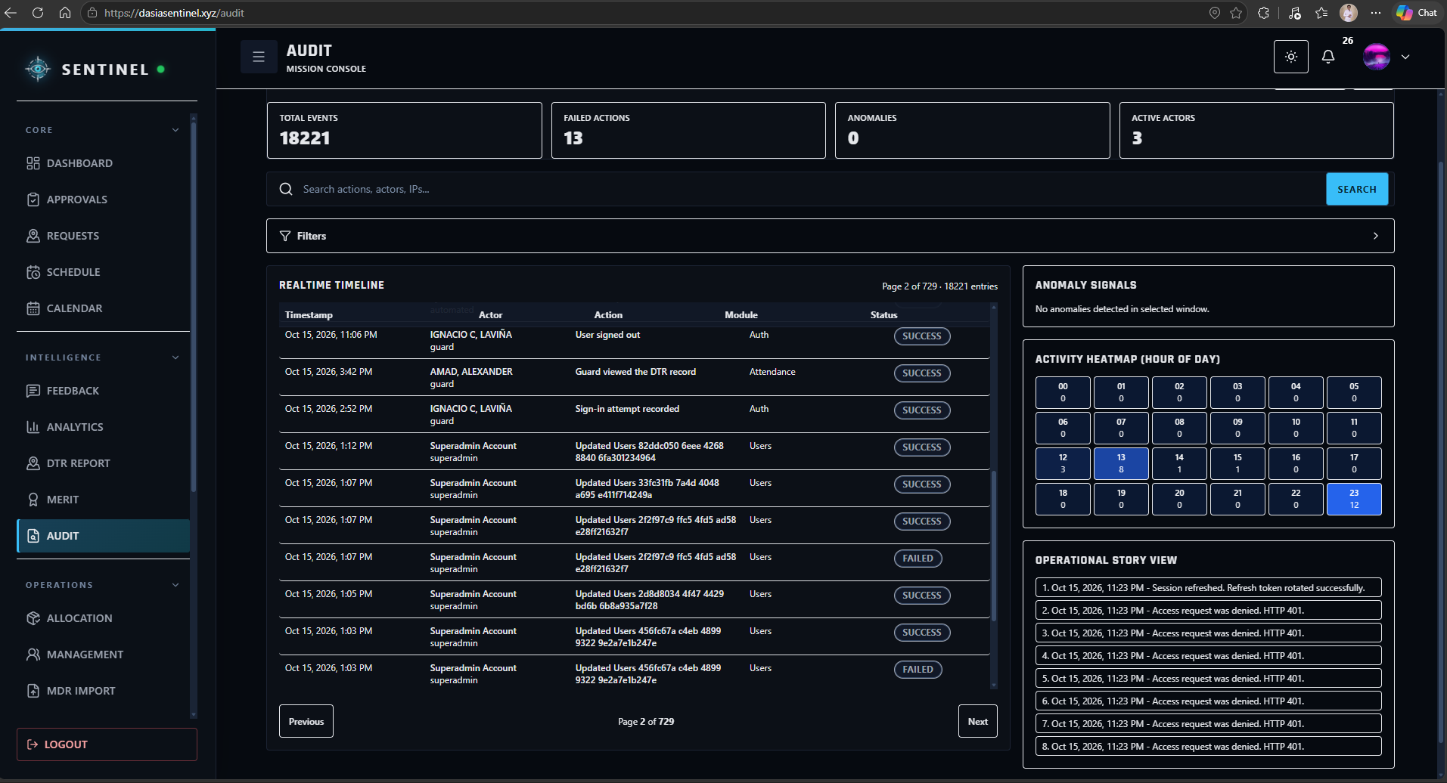
Figure 51. Audit and Traceability Interface

Figure 52 presents the reporting or export function used to produce operational records in a form suitable for review, documentation, and institutional monitoring. This supports the objective of maintaining traceable operational and compliance information.
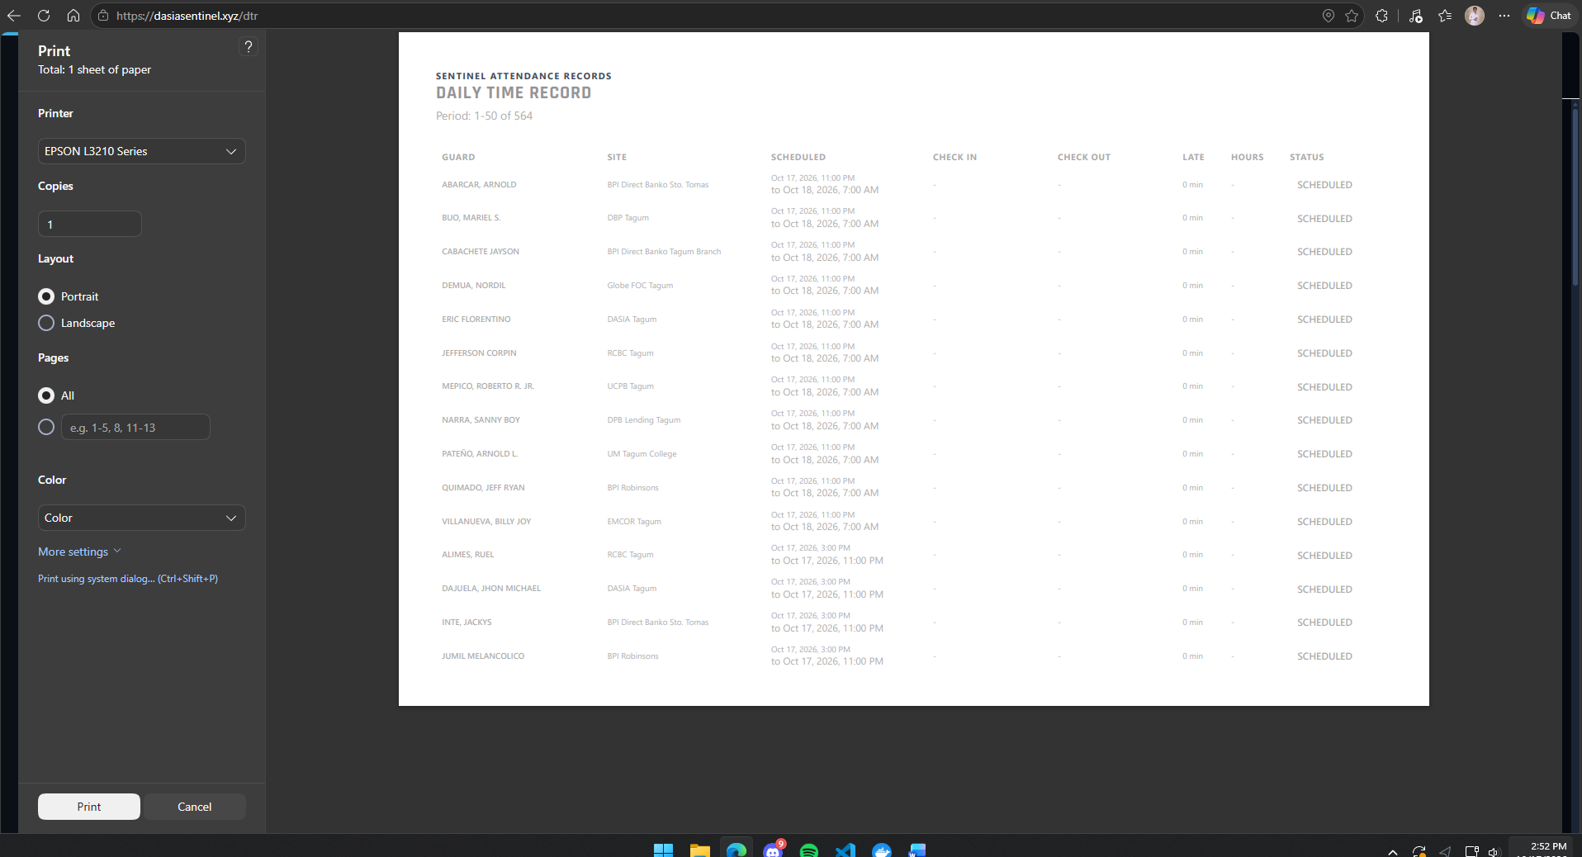
Figure 52. Operational Report and Export Interface
Figure 53 presents SENTINEL from a mobile or packaged client view, showing that the role-governed interface remains accessible outside the primary desktop browser layout. The interface demonstrates the system’s cross-platform delivery approach while preserving the same centralized operational data and access controls.
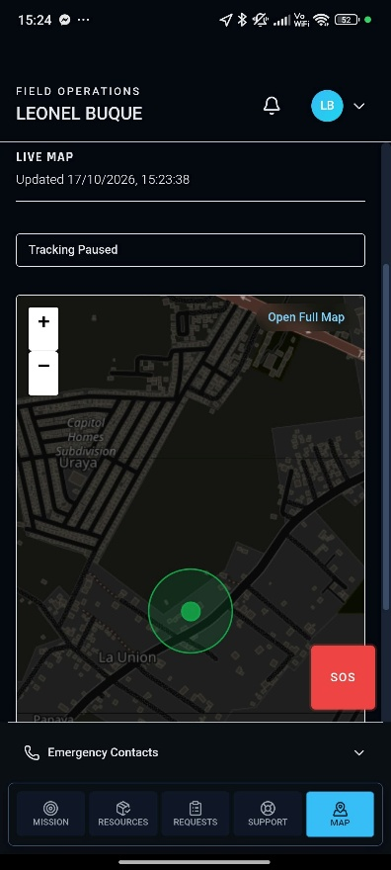
Figure 53. Mobile or Cross-Platform Guard Interface

Table 10. Summative Evaluation Results for Objective 6
Sub-objective | Assessment Area | Applicable Ratings | AWM | Descriptive Equivalent
6.1 | Access through supported Web, Windows desktop, and Android targets | 91 | 4.89 | Strongly Agree
6.2 | Audit logs, approval history, security events, and action traceability | 6 | 5.00 | Strongly Agree
6.3 | Operational and compliance reports and traceable records | 12 | 4.92 | Strongly Agree

Evaluation of System Quality Attributes
The respondents also evaluated SENTINEL according to seven system-quality attributes. All attributes obtained Average Weighted Mean scores within the Strongly Agree range. Compatibility and Portability obtained the highest overall means at 4.92, followed by Functional Suitability at 4.88. Security obtained 4.86, Reliability 4.85, Usability 4.84, and Performance Efficiency 4.83. The overall weighted mean across 572 applicable item ratings was 4.86, interpreted as Strongly Agree. These results indicate a consistently positive assessment across both functional and quality-oriented criteria.
Table 11. Summative Evaluation of SENTINEL System Quality Attributes
Quality Attribute | Guard AWM | Supervisor | Administrator | Superadmin | Overall AWM | Equivalent
Functional Suitability | 4.89 | 4.88 | 4.83 | 4.87 | 4.88 | Strongly Agree
Performance Efficiency | 4.83 | 4.78 | 4.89 | 4.83 | 4.83 | Strongly Agree
Compatibility | 4.90 | 5.00 | 5.00 | 5.00 | 4.92 | Strongly Agree
Usability | 4.86 | 4.80 | 4.80 | 4.83 | 4.84 | Strongly Agree
Reliability | 4.85 | 4.85 | 4.86 | 4.82 | 4.85 | Strongly Agree
Security | 4.88 | 4.89 | 4.80 | 4.80 | 4.86 | Strongly Agree
Portability | 5.00 | 4.00 | 5.00 | 5.00 | 4.92 | Strongly Agree
Overall |  |  |  |  | 4.86 | Strongly Agree

Respondent Comments and Observed Areas for Improvement
The written comments generally supported the quantitative results while also identifying practical improvements. Guards described check-in, DTR, schedules, assignments, and replacement information as easy to understand and useful during daily duty. Several respondents noted that map loading and some updates could become slower when the mobile data signal was weak. Other comments requested clearer or stronger notifications for duty changes and supervisor messages, larger text on some mobile screens, and faster appearance of the latest alerts without requiring a refresh.
The Supervisor similarly reported that scheduling and replacement information made it easier to identify available personnel, while weak connectivity could slow map loading. The Administrator highlighted easier access to DTR, schedules, and requests, but suggested making pending approval notifications more visible. The Superadmin noted that reports and access controls were clear and useful for monitoring operations, while recommending faster loading of dashboards as data volume increases. These comments show that the primary improvement areas are not the availability of core functions, but responsiveness under weak connectivity, visibility of notifications, mobile readability, and interface refinement.
Table 12. Major Themes from Respondent Comments
Theme | Observed Feedback | Implication for Improvement
Attendance and DTR | Check-in and DTR were described as easy to use and easier than repeated manual logging. | Maintain simple attendance flow and continue validating DTR clarity.
Scheduling and Assignments | Respondents found schedules, site assignments, and replacement information clear and useful. | Preserve stable scheduling views and make duty-change indicators more prominent.
Notifications | Some alerts were not immediately noticed; pending approvals and supervisor messages could be more visible. | Strengthen notification prominence and status indicators.
Connectivity and Maps | Map and update loading could slow when signal or mobile data was weak. | Improve graceful loading, caching, and low-bandwidth behavior.
Mobile Readability | One respondent requested larger text on mobile. | Review responsive typography and accessibility settings.
Dashboard Performance | The Superadmin noted that loading could slow as data volume grows. | Continue query, pagination, and rendering optimization for larger datasets.

Conclusion
The results of the study indicate that SENTINEL achieved the primary objective of providing an integrated security operations management platform for Davao Security & Investigation Agency, Inc. The implemented system centralizes account governance, personnel scheduling, attendance and DTR, guard replacement, incident and request handling, notifications, location-based monitoring, firearm and vehicle accountability, performance analytics, and audit-oriented traceability within a unified role-governed environment.
The respondent evaluation produced an overall Average Weighted Mean of 4.86, interpreted as Strongly Agree. All six study objectives and all seven evaluated quality attributes were rated within the Strongly Agree range. The operational implementation also demonstrated continuous 24/7 scheduling across selected DASIA client sites in Davao del Norte, stable guard rosters, attendance and punctuality monitoring, same-site replacement coordination, and supporting incident, notification, request, readiness, evaluation, and tracking workflows without detected schedule-overlap or insufficient-rest violations.
The study also identified areas that require continued refinement. Weak mobile connectivity can affect map and update responsiveness, some notifications need stronger visual emphasis, mobile text can be improved for readability, and larger operational datasets may require additional dashboard optimization. One automated browser assertion involving the Guard profile/settings heading also remains for investigation. Despite these areas for improvement, the combined technical validation and respondent evaluation show that SENTINEL provides a practical foundation for improving visibility, accountability, coordination, and traceability in security-agency operations.

Recommendation
The researchers recommend continuing the deployment and refinement of SENTINEL through a broader and longer operational evaluation involving additional Guards, supervisors, administrative users, and client sites. Continued use will provide more opportunities to evaluate workflow consistency across different shifts, connectivity conditions, and operational scenarios while allowing the development team to prioritize improvements based on actual user experience.
Interface improvements should focus on notification prominence, mobile text readability, map and dashboard responsiveness, and low-bandwidth behavior. Caching, progressive loading, pagination, and retry handling should be reviewed to reduce the effect of weak mobile data connections. The identified Guard profile/settings browser regression should also be corrected and added to the automated regression suite to prevent recurrence.
For cross-platform delivery, the configured Windows desktop and Android packages should undergo complete installation and runtime acceptance testing on representative devices before being treated as fully validated production channels. Security and deployment practices should also continue to be strengthened by removing legacy scripts containing sensitive configuration, maintaining controlled database migrations and backups, and reviewing scheduler coordination if the backend is expanded to multiple production replicas.
Finally, the researchers recommend maintaining the system's rule-based analytical outputs as transparent decision-support tools and validating any future predictive or machine-learning capability separately before operational reliance. Continued attention to auditability, access governance, data quality, and user feedback will help SENTINEL remain aligned with the operational and compliance requirements of DASIA as the platform grows.

REFERENCES

Abad, R. (2025). How Effective Is Your Security Guard? An Inquiry into the Philippine Private Security Industry. Retrieved from https://doi.org/10.13140/RG.2.2.30981.41442
Aguinis, H. (2022). Performance Management (5th ed.). SAGE Publications. Retrieved from https://edge.sagepub.com/aguinispm5e
Al-Khafajiy, M., et al. (2022). Enabling high performance fog computing through fog-2-fog coordination model. Future Generation Computer Systems. Retrieved from https://doi.org/10.1016/j.future.2022.06.012
Atlam, H. F., & Yang, Y. (2025). Enhancing Healthcare Security: A Unified RBAC and ABAC Risk-Aware Access Control Approach. Retrieved from https://doi.org/10.3390/fi17060262
Department of Information and Communications Technology (DICT). (2024). National Cybersecurity Plan 2023-2028: A Whole-of-Nation Roadmap. Retrieved from https://dict.gov.ph/national-cyber-security-plan
GetApp. (2026). Guardhouse 2026 Pricing, Features, Reviews & Alternatives. Retrieved from https://www.getapp.com/operations-management-software/a/guardhouse/
Guardhouse. (2026). 2026 Pricing, Features, Reviews & Alternatives. Retrieved from https://www.getapp.com/operations-management-software/a/guardhouse/
Hardcat. (2025). Law Enforcement Equipment & Armory Management System: Challenges in Managing Firearms Securely. Retrieved from https://hardcat.com/police-equipment-inventory-tracking/
Jur.ph. (2025). The Private Security Services Industry Act: Law Summary and IRR. Retrieved from https://jur.ph/law/summary/the-private-security-services-industry-act
Khinvasara, T., Shankar, A., & Wong, C. (2024). Survey of Artificial Intelligence for Automated Regulatory Compliance Tracking. Retrieved from https://doi.org/10.9734/jerr/2024/v26i71217
NashTech. (2025). Building High-Performance Web Services with Rust and Axum. Retrieved from https://blog.nashtechglobal.com/building-high-performance-web-services-with-rust-and-axum/
NEDA XI. (2024). Davao Regional Development Plan 2023-2028. National Economic and Development Authority. Retrieved from https://rdc11.neda.gov.ph/rdc-xi-approves-davao-regional-development-plan-2023-2028/
Nguyen, R. (2025). PostgreSQL ACID In-Depth: Reliability and Consistency in Modern Transactions. Retrieved from https://medium.com/engineering/postgresql-acid-in-depth
NODE Magazine. (2026). Why 2026 is the Year Businesses Must Finally Address Admin Overload. Retrieved from https://www.node-magazine.com/thoughtleadership/why-2026-is-the-year-businesses-must-finally-address-admin-overload
Ondos, M. U., & Origines, D. V. (2025). Android-Based Guard Monitoring and Site Surveillance System. Retrieved from https://www.ojs.udb.ac.id/icohetech/article/view/5657
PIA. (2025). Davao City Maintains Top Safety Ranking in Southeast Asia. Philippine Information Agency. Retrieved from https://pia.gov.ph/news/davao-city-maintains-top-safety-ranking-in-southeast-asia/
PostgreSQL Global Development Group. (2025). PostgreSQL 17 Documentation: Data Integrity and ACID Compliance. Retrieved from https://www.postgresql.org/docs/17/acid.html
PNP-SOSIA. (2022). Implementing Rules and Regulations of Republic Act No. 11917. Retrieved from https://www.scribd.com/document/691228276/Approved-IRR-RA-11917
Republic Act No. 11917. (2022). The Private Security Services Industry Act. Retrieved from https://elibrary.judiciary.gov.ph/thebookshelf/showdocs/2/95597
Scofield, M. B. (2025). Rust Axum Web Development: Build High-Performance APIs and Services. Retrieved from https://www.amazon.com/Rust-Axum-Web-Development-High-Performance/dp/B0CX7N4K6J
Securitas. (2026). Control Security from Anywhere - MySecuritas Product Overview. Retrieved from https://www.securitas.com/en/security-solutions/mysecuritas/
Securitas Technology. (2025). 2026 Global Technology Outlook Report: The State of Security Technology. Retrieved from https://www.securitastechnology.com/news/securitas-technology-releases-2026-global-technology-outlook-report
Shiyanbola, J. O., et al. (2023). A Workforce Capacity Optimization Model for Lean Environments. Retrieved from https://www.irejournals.com/paper-details/1704408
Tan, K., et al. (2024). The digital transformation of security and the role of AI. Securitas White Paper. Retrieved from https://www.securitas.ie/news-insights/whitepapers/the-digital-transformation-of-security-and-the-role-of-ai/
TrackTik. (2025). Top 5 End-to-End Security Guard Management Software for 2025. Retrieved from https://www.tracktik.com/resources/blog-articles/top-5-end-to-end-security-guard-management-software-for-2025/
TrackTik. (2025). Physical Security Operations Benchmark Report 2025. Retrieved from https://www.tracktik.com/wp-content/uploads/2025/10/2025BenchmarkReport-1.pdf

